Дидактические материалы к уроку:

Приложение 1.
Прилагательные и предложения для подстановки.(для парной работы)
Careful | He’s _________ and thinks before doing anything.
Considerate | She’s ________________ -she thinks about other people’s feelings.
Helpful | She’s ________ and always ready to land a hand.
Reliable | I like _____________ people who do what they say they’re going to do.
Careless | He’s ____________ and his work is full of unnecessary mistakes.
Selfish | You’re _________ you only think about yourself.
Unreliable | She’s ____________ - never doing what she says she’ll do.
Приложение 2.
Association chart.
I associate myself with… because…
Colour
Furniture
Plant
Animal
Приложение 3.
Фотография Анны Франк.
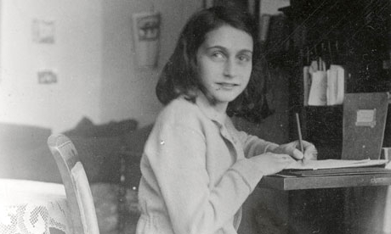
Фотография Хелен Келлер. 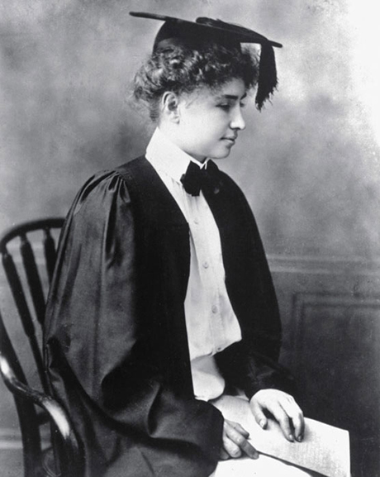
Приложение 4.
Карточка на словообразование:
1.Use the ending below to make adjective from the group of words (A-K)_. Some groups can have more than one ending.
-y, -ed, -ing, -full, -(i)ous, -ish, -(i/a)ble, -less, -al, -(t)ic, -istic, - (e/a)nt, -ive
A mood, stuff, happiness, cloud
B hope, care, help
C practice, nature, logic
D ideal, real, individual
E decision, create, imagination
F importance, tolerate, difference
G mystery, ambition, danger
H romance, sympathy, science
I like, rely, sense
J interest, tire, bore
K self, child

2.Make adverbs from the adjectives in A,B and C. Then try to add more adjectives and adverbs to each group. Check spellings.

3.Put the underlined words in the correct form.
I have some very 1 please memories of my 2 child. We lived in a 3 romance cottage in the country with 4 love view of Lake Windermere. We had a 5 wonder garden with lots of animals. However, I 6 memory one year 7 extreme well. I was eight and one of my 8 favour animals was a goose called Mabel. After coming back from school, I used to 9 food Mabel. With me, she was 10 usual very quite and 11 friend. With everybody else though, Mabel was very nasty and 12 aggression. That winter was very cold and the snow was nearly a metre 13 depth. On Christmas Day, we had a 14 tradition lunch – goose and Christmas pudding. I was 15 cheer until I realized that the goose was … Mabel! My 16 happy immediately disappeared and I spent the rest of the meal in tears.

Приложение 5.
Useful phrases for comparing pictures.
These two photographs are … similar, alike, comparable
They both show people VERB + ing
I think the common theme here is …
One similarity (which stands out) is ..
Another similarity is ....
….. seems…
….looks…
…..is obviously….
…..might be….
….looks like…
I get the impression that….
My initial impression is….
….could (possibly)…
I’m pretty confident that….
I think I’m justified in saying that…
These photographs are different.
The most obvious difference between … and… is…
Compared to…, ..
One more difference is ….
I’m not sure exactly but …
I’m fairly sure…
I get the impression that
…could..
..possibly…
I believe…
Pesonally….
In my opinion…
Let’s have a final look at…
All in all, it’s evident…
To sum it up I’d like to say..
To draw to the conclusion I’d like to say that..
Summarizing, I may say that…

Приложение 6.
Background information about the texts.
Ann Frank (1929-1945) Ann’s Jewish family moved from Germany to Holland when Hitler came to power. Then, in 1942, the Germans began interning Jews and the Franks went into hiding at the top of the house where Mr Frank had his office.They were helped by some Dutch friends and employees of Mr Frank. The entrance to their “Secret Annexe” was hidden by a moving bookshelf. They were joined by another family with their son, Peter. Ann was thirteen at the time and stayed there for over two years where she wrote her diary. In August 1944, they were found by Germans. Ann and her family were deported to Auschwitz and to Bergen-Belsen, where she died shortly before her 16th birthday.

Helen Keller (1880-1967) was deaf, blind and severely speech-impaired when she met her teacher Ann Sullivan. Sullivan taught her to communicate by finger-spelling words. Helen Keller learnt French, German and Latin and graduated from Radcliffe College in the USA. As an adult, Helen Keller wrote and lectured for the deaf and blind. Her autobiography, “The Story of My Life”, was published while she was at university.
Литература
УМК “New Opportunities” Russian edition, Upper Intermediate, Michael Harris, David Mower, Anna Sikorsynska, Irina Larionova, Oksana Melchina, Irina Solokova,Pearson Edition Limited, 2006
Бодоньи М.А. «Английский язык. Подготовка к ЕГЭ: устная часть. Задания по новой демоверсии на 2015 год.», Легион, 2015

