Приложения
Дополнительные материалы

В прологе звучит песня «Золушка» слова И. Резника, музыка И. Цветкова. (Перевод выполнен совместно с учащимися).
Just Imagine,
Just believe me,
But it was a lovely dream!
Charming prince has just appeared
And it was a dance with him!
I was happy, I was laughing,
It was like a fairy tale
And the ball was so charming
Like a song of nightingale!

Текст пьесы (вторая часть. В первой части использован текст из Верещагина И.Н., Притыкина Т.А., Английский язык. Книга для чтения. 3 класс. М., 2014 С. 21-22, 37-41)

King: Welcome, welcome to our ball!
Queen: We are so happy to see you
Prince: And remember about our golden rule:
Let us try to be polite
In everything you do
All together: Remember always to say please
And don’t forget « Thank you»!
Queen: The ball is on, let’s dance and play!
King: Let’s have a lot of fun today!
(Входит Золушка)
King: She’s so nice and so slim
Prince: Hello, let’s dance, you are my dream
( песня из учебника Верещагина Верещагина И.Н., Притыкина Т.А. Английский язык. Come my friend)
Cinderella: Its 12 o’clock and I must run! Good bye, I had a lot of fun!
King, Queen: Oh, stop her! Catch her! I want my son to be happy!
Postman: All people of our Kingdom! People of our Kingdom! Everybody who knows anything about beautiful Cinderella may ask everything he wants! Everything she wants!
Prince: I want to try on this shoe to all girls in the world!
Postman: May you try on this shoe! (обращается к сестрам Золушки)
Pat: Too loose!
Liz: Too small!
Cinderella: May I?
Stepmother, Pat, Liz: You didn’t go to the ball! (Золушке)
Father: Give her this shoe! Her feet is small! (Принцу)
Prince: I’m happy that I found you! I love you and I’d like to merry you!
Cinderella: Oh, Yes, my Prince, I love you too!
Prince: It’s our advice
Cinderella: Read fairy tales
Prince, Cinderella: And let your life be nice!
Stepmother: This tale for you.
Father: This song for us
All together: Enjoy yourself and sing with us!
Stepmother: We don’t want to say you good bye, our friends! We want to say you hello!
(песня The Beatles Hello, Goodbye)

характера героя

с другими персонажам

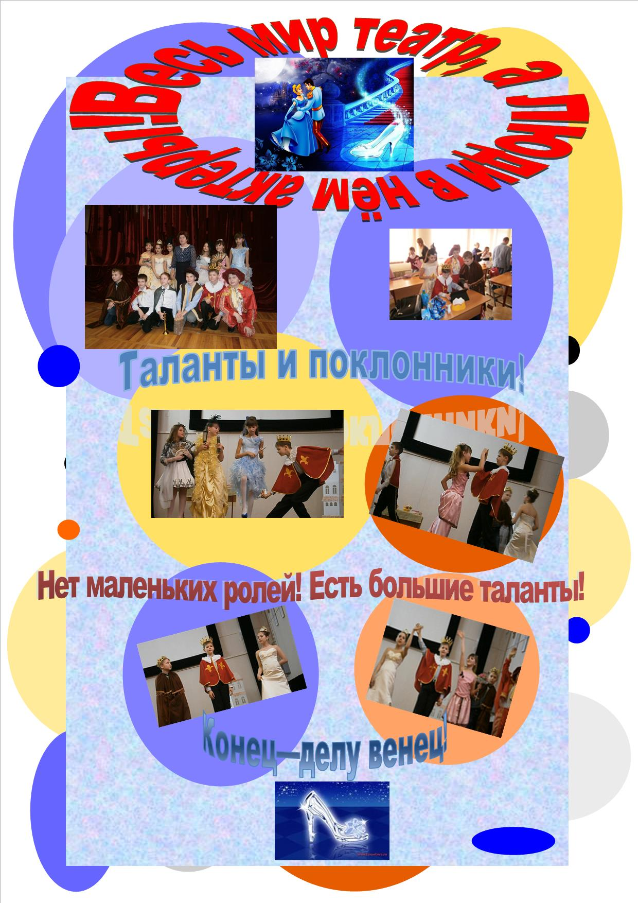

∗ Разобрать с учащимися, какие ассоциации возникают у них при упоминании слова «Золушка»
∗ Смысловой анализ сюжета сказки:
⇒ Какой информацией мы располагаем (варианты экранизации сказки, мультфильмы про Золушку, музыка к спектаклю)
⇒ Подбор музыки и текста к театральной постановке
⇒ Роль и значение костюма, декораций, подбор реквизита
⇒ Распределение ролей
⇒ Значение мимики и жестов для раскрытия образа и внутреннего мира героя
∗ Свободное письмо. Написать эссе — свой вариант окончания сказки
