Приложение 1
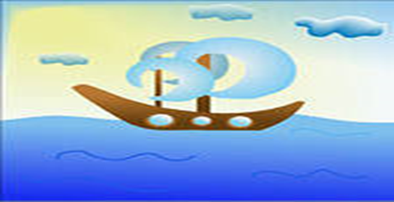
WHERE IS WATER ON THE EARTH?

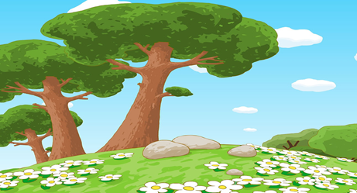
WHAT IS THERE ON
THE EARTH?

WHAT IS THERE IN THE SKY?

