**Приложение №2**

[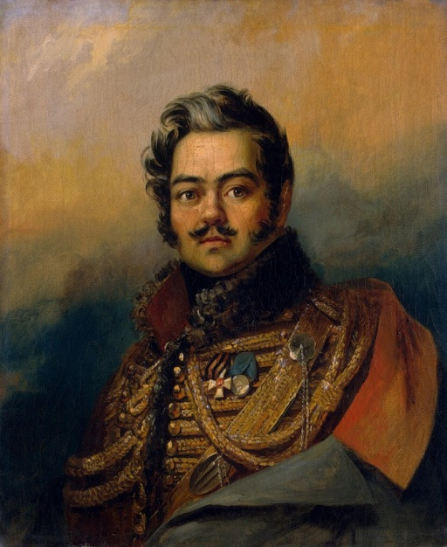](http://img-fotki.yandex.ru/get/3513/georgs53.3c/0_2ef35_10d50465_XL) [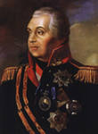](http://images.yandex.ru/yandsearch?img_url=www.opoccuu.com/kut1.jpg&iorient=&icolor=&site=&text=%D0%BA%D1%83%D1%82%D1%83%D0%B7%D0%BE%D0%B2&wp=&pos=3&isize=&type=&recent=&rpt=simage&itype=&nojs=1)

[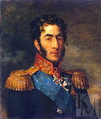](http://images.yandex.ru/yandsearch?img_url=youedu.ru/uploads/posts/2009-10/1254532247_bagration.jpg&iorient=&icolor=&site=&text=%D0%B1%D0%B0%D0%B3%D1%80%D0%B0%D1%82%D0%B8%D0%BE%D0%BD&wp=&pos=2&isize=&type=&recent=&rpt=simage&itype=&nojs=1) [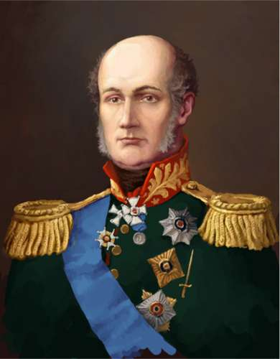](http://www.russedina.ru/images/images/images_444/dbabd990018375b75b0dc3120d8165a1big.jpg)

[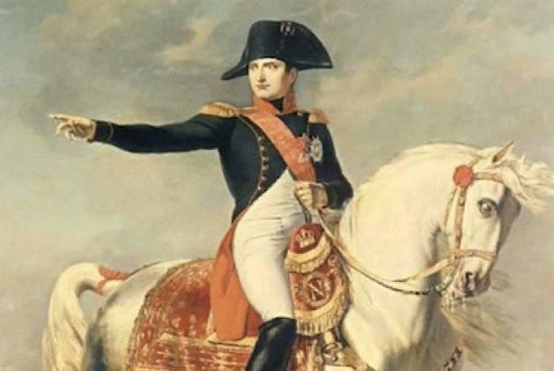](http://amerikabulteni.com/wp-content/themes/blognews2/timthumb.php?src=http://amerikabulteni.com/wp-content/uploads/2012/01/napoleon.jpg&q=90&w=629&zc=1)

[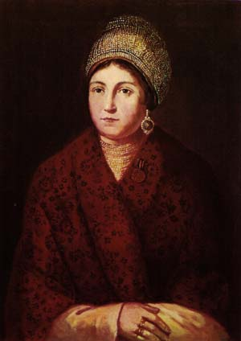](http://philatelia.ru/pict/cat1/dir1/293ru.jpg)