Appendix 7
Royal Oak Day

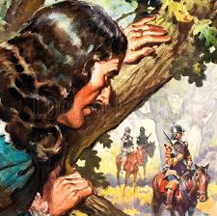
The battle of Worchester was the final battle of the English Civil War.
Oliver Cromwell and the Parliamentarians defeated the Royalist forces under command of Charles (whose father King Charles II was executed in 1649, at the climax of the English Civil War) on September 3, 1651at Worchester, England.
It is said that King Charles' life was saved after the battle, when he escaped from Cromwell’s army by hiding in a huge oak tree in Staffordshire forest. After the defeat Charles succeeded to escape to the Continent. Later, in 1660 the Monarchy was restored and Charles was crowned
Charles II, King of England and Ireland. To commemorate the restoration of the English monarchy May the 29th, the King’s birthday, was ordered to be kept as Royal Oak Day (Oak Apple Day). Although the public holiday was abolished in 1859, Oak Apple Day continues to be celebrated in parts of England today. In Castleton, for example, to mark the restoration of Charles II “ The Garland King” - a wooden frame of 3 feet high to which small bunches of wild flowers and leaves are tied has been made for hundreds of years. It is worn by a man dressed in Stuart costume.
Today the Oak tree is considered to be a national English tree.

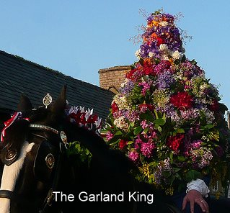
- under the command of Charles - под предводительством Чарльза
- to execute - казнить
- hide ( hid, hidden) - прятаться
- to succeed - удаваться
-to commemorate - чтить память, праздновать
- restoration - восстановление, реставрация
- to be abolished - быть отменённым

