Автор: Важенина Ольга Владимировна
Идентификатор: 219-162-155
Игра “Bingo”

Bingo  On the Move |  |  | Bingo  On the Move
You can’t go here. | 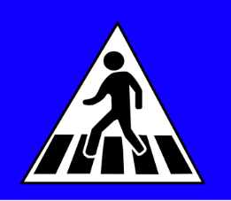  You can cross the street here. | 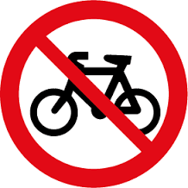  You can’t ride a bike here. | 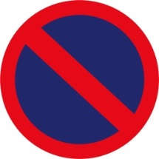  You can’t park here. | 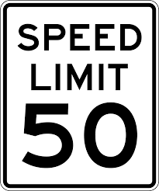  You can’t drive over 50 mph. | 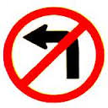  You can’t turn left.
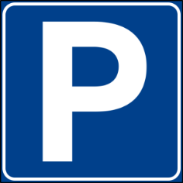  You can park here. | 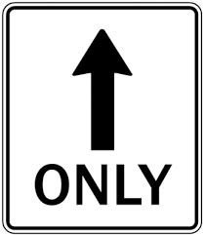  You can only go straight on. | You can’t park here. | 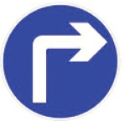  You can turn right. | You can cross the street here. | 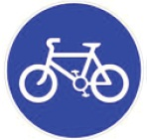  You can ride a bike here.
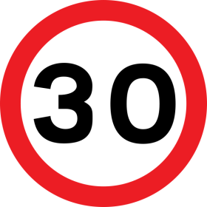  You can drive at 25 mph. | 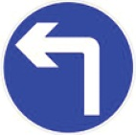  You can turn left. | You can ride a bike here. | You can’t ride a bike here. | You can only go straight on. | You can’t go here.
Bingo  On the Move |  |  | Bingo  On the Move
You can’t ride a bike here. | 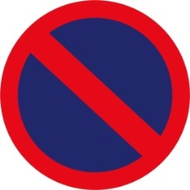  You can’t park here. | 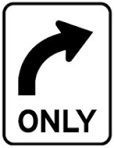  You can only turn right. | 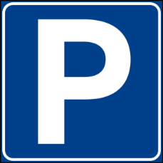  You can park here. | 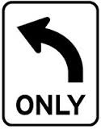  You can only turn left. | 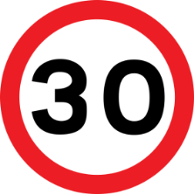  You can drive at 25 mph.
You can’t turn left. | You can cross the street here. | You can drive at 25 mph. | You can ride a bike here. | You can’t go here. | You can’t ride a bike here.
You can’t drive over 50 mph. | You can park here. | You can only go straight on. | You can turn left. | You can cross the street here. | 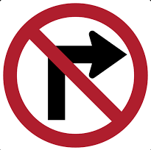  You can’t turn right.
Bingo  On the Move |  |  | Bingo  On the Move
You can’t drive over 50 mph. | You can’t turn right. | You can ride a bike here. | You can’t turn left. | You can’t go here. | You can only turn right.
You can’t go here. | 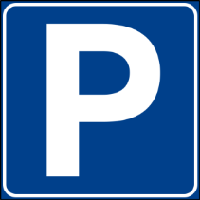  You can park here. | You can only go straight on. | 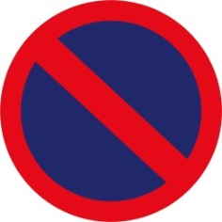  You can’t park here. | You can ride a bike here. | 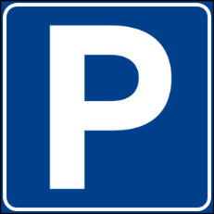  You can park here.
You can cross the street here. | You can only turn left. | You can’t ride a bike here. | You can only go straight on. | You can cross the street here. | You can drive at 25 mph.
Bingo  On the Move |  |  | Bingo  On the Move
You can cross the street here. | You can’t turn left. | You can’t ride a bike here. | You can turn left. | 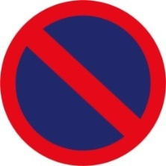  You can’t park here. | You can’t drive over 50 mph.
You can’t go here. | You can drive at 25 mph. | You can’t park here. | You can cross the street here. | You can’t turn right. | You can park here.
You can only go straight on. | 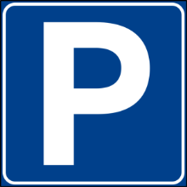  You can park here. | You can ride a bike here. | You can only turn left. | You can’t ride a bike here. | You can’t go here.
Bingo  On the Move |  |  | Bingo  On the Move
You can’t ride a bike here. | You can ride a bike here. | You can drive at 25 mph. | You can’t park here. | You can cross the street here. | You can turn left.
You can only turn right. | 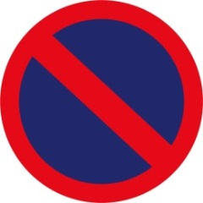  You can’t park here. | You can park here. | You can’t turn right. | You can’t go here. | You can drive at 25 mph.
You can cross the street here. | You can turn right. | You can’t turn left. | You can ride a bike here. | 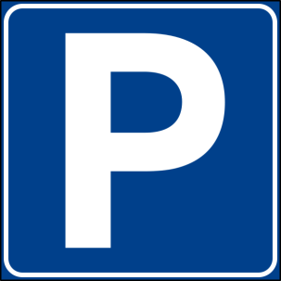  You can park here. | You can only go straight on.
Bingo  On the Move |  |  | Bingo  On the Move
You can’t go here. | You can cross the street here. | You can’t ride a bike here. | You can’t park here. | You can’t drive over 50 mph. | You can’t turn left.
You can park here. | You can only go straight on. | You can’t park here. | You can turn right. | You can cross the street here. | You can ride a bike here.
You can drive at 25 mph. | You can turn left. | You can ride a bike here. | You can’t ride a bike here. | You can only go straight on. | You can’t go here.
Bingo  On the Move |  |  | Bingo  On the Move
You can’t ride a bike here. | You can’t park here. | You can only turn right. | You can park here. | You can only turn left. | You can drive at 25 mph.
You can’t turn left. | You can cross the street here. | You can drive at 25 mph. | You can ride a bike here. | You can’t go here. | You can’t ride a bike here.
You can’t drive over 50 mph. | You can park here. | You can only go straight on. | You can turn left. | You can cross the street here. | You can’t turn right.
Bingo  On the Move |  |  | Bingo  On the Move
You can’t drive over 50 mph. | You can’t turn right. | You can ride a bike here. | You can’t turn left. | You can’t go here. | You can only turn right.
You can’t go here. | You can park here. | You can only go straight on. | You can’t park here. | You can ride a bike here. | You can park here.
You can cross the street here. | You can only turn left. | You can’t ride a bike here. | You can only go straight on. | You can cross the street here. | You can drive at 25 mph.
Bingo  On the Move |  |  | Bingo  On the Move
You can cross the street here. | You can’t turn left. | You can’t ride a bike here. | You can turn left. | You can’t park here. | You can’t drive over 50 mph.
You can’t go here. | You can drive at 25 mph. | You can’t park here. | You can cross the street here. | You can’t turn right. | You can park here.
You can only go straight on. | You can park here. | You can ride a bike here. | You can only turn left. | You can’t ride a bike here. | You can’t go here.
Bingo  On the Move |  |  | Bingo  On the Move
You can’t ride a bike here. | You can ride a bike here. | You can drive at 25 mph. | You can’t park here. | You can cross the street here. | You can turn left.
You can only turn right. | You can’t park here. | You can park here. | You can’t turn right. | You can’t go here. | You can drive at 25 mph.
You can cross the street here. | You can turn right. | You can’t turn left. | You can ride a bike here. | You can park here. | You can only go straight on.





