Автор: Чемакина С.Н.

Идентификатор: 277-226-448

Приложение к уроку

Song

Dashing through the snow,
In a one-horse open sleigh,
Over the fields we go,
Laughing all the way.
Bells on bob-tails ring,
Making spirits bright,
What fun it is to ride
And sing a sleighing song tonight.
Chorus:
Jingle bells, jingle bells, jingle all the way!
O what fun it is to ride in a one-horse open sleigh.
Jingle bells, jingle bells, jingle all the way!
O what fun it is to ride in a one-horse open sleigh.

Words «Christmas»
English | Transcription | Russian
Christmas | ['krɪsməs] | Рождество
an angel | ['eɪndʒəl] | ангел
a Christmas tree | ['krɪsməs] [triː] | елка
holly | ['hɔlɪ] | остролист (вечнозелёное растение с красными ягодами)
mistletoe | ['mɪsltəu] | омела (традиционное украшение на Рождество)
a carol | ['kær(ə)l] | весёлая песня
a carol service | ['kær(ə)l] ['sɜːvɪs] | рождественское богослужение с гимнами
on Christmas Eve | ['krɪsməs] [iːv] | в канун Рождества
a stocking | ['stɔkɪŋ] | чулок
a chimney | ['tʃɪmnɪ] | труба
Santa Claus | [ˌsæntə'klɔːz] | Санта Клаус, Дед Мороз
to celebrate | ['selɪbreɪt] | праздновать
to decorate | ['dekəreɪt] | украшать
to give presents | [gɪv] ['preznts] | дарить подарки
to receive presents | [rɪ'siːv] ['preznts] | получать подарки

Text: Christmas Day
(1) The most popular holiday in Great Britain is Christmas. People prepare for Christmas Day, December 25, very carefully. They decorate their houses in the traditional way. Christmas trees are set up in houses, in the streets and churches. The trees are always decorated with fairy lights, angels and small toys. Besides the Christmas tree, holly and mistletoe are used to decorate the house.
(2) Every year the people of Norway give the city of London a present. It's a big Christmas tree and it stands in Trafalgar Square.
(3) Before Christmas, groups of singers or children go from house to house. They sing carols, traditional Christmas songs. People give children candies, nuts, pies and so on, to thank them for carol singing. Many churches hold a carol service on Sunday before Christmas.
(4) On the 24th of December, which is known as Christmas Eve, children hang their stockings at the end of their beds. They hope that Santa Claus will come down the chimney during the night and fill them with toys and sweets.
(5) Christmas is a family holiday. A typical Christmas dinner includes turkey and pudding. Usually a coin or two are hidden inside the pudding and part of the fun is to see who finds it. Traditionally all relatives and friends give and receive presents. Christmas is a merry family holiday for all the people of Great Britain.
Mark the sentences T (true) or F (false).
- Christmas is the most popular holiday in Great Britain. (True)
- The English don’t prepare carefully for Christmas Day. (False)
- Streets, churches and houses are beautifully decorated. (True)
- Every year a big Christmas tree comes to London from France. (False)
- For carol singing children get candies, nuts and pies. (True)
- Children put their stockings under the Christmas tree. (False)
- Santa Claus comes at night. (True)
- The English never give presents. (False)
- At Christmas, the English usually find a coin in the turkey. (False)
- Christmas is a traditional family day. (True)

Card
Column A | Column B
1) Christmas Day begins … | a) … a merry family holiday.
2) The main Christmas tree … | b) … fills the stockings with presents, fruit and nuts.
3) At Christmas people usually decorate … | c) … and receive presents.
4) Before Christmas people sing … | d) … send greeting cards.
5) The 24th of December … | e) … carols, traditional Christmas songs.
6) Children hang up … | f) … roast turkey and Christmas pudding.
7) Santa Claus comes down the chimney and … | g) … stands in Trafalgar Square.
8) The traditional dinner consists of … | h) … their stockings at the end of their beds.
9) All relatives and friends give … | i) … a Christmas tree with toys, angels and coloured balls.
10) For all the people of Great Britain Christmas is … | j) … on the 25th of December.
 | k) … is called Christmas Eve.

Key: 1- j, 2 – g, 3 – i, 4 – e, 5 – k, 6 – h, 7 – b, 8 – f, 9 – c, 10 – a. The odd ending is d.

Song
I’m a dancing Christmas tree.
Everybody dance with me.
Shake your head.
Kick your legs.
Wave your arms.
Jump up and down.
Turn around.

Cards
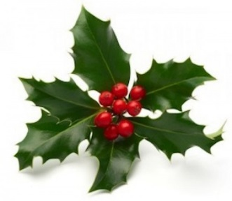 | 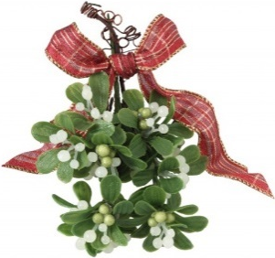
A class survey

Question | Yes | No
- Do you stay at home at Christmas?
- You invite relatives and friends, don’t you?
- Do you eat any special food?
- Do you have fireworks displays?
- You sing some songs at Christmas, don’t you?
- Do children make presents for their parents?
- Does Santa Claus put Christmas presents into children’s stockings?

Test «Merry Christmas»
1. When is Christmas celebrated?
a. On the 24th of December | b. On the 25th of December | c. On the 31st of December | d. On the 1st of January

2. What do people like to exchange at Christmas?
a. candies | b. special dishes | c. presents | d. Christmas trees

3. Составьте словосочетание со словом «carol».
a. present | b. tree | c. gift | d. service

4. Какое слово не образует словосочетание со словом «Christmas»?
a. Eve | b. family | c. dinner | d. tree

5. Как переводится словосочетание «Christmas Eve»?
a. Рождественская песня | b. Рождество | c. Канун Рождества | d. Новый год

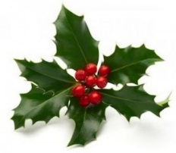
6. Посмотрите на картинку и заполните пропуск в предложении.
At Christmas the houses are decorated with … .

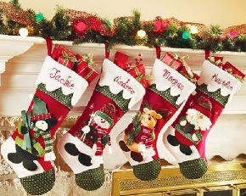
7. Посмотрите на картинку и заполните пропуск в предложении.
The children hang … at the end of their beds.

- Составьте из букв слово «праздновать».
RCETLEBAE

- Составьте из букв слово «украшать».
ERECDTAO

- Составьте предложение из слов: Claus, down, the chimney, Santa, comes.

Key: 1- b, 2 – c, 3 – d, 4 – b, 5 – c, 6 – holly, 7 – stockings, 8 – celebrate, 9 – decorate, 10 – Santa Claus comes down the chimney.

Лист оценивания «Christmas tree»

Home task (Cards)
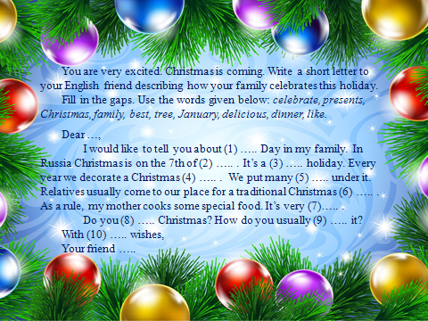 | KEY:  1) Christmas, 2) January,  3) family,  4) tree,  5) presents,  6) dinner,  7) delicious,  8) like,  9) celebrate,  10) best.
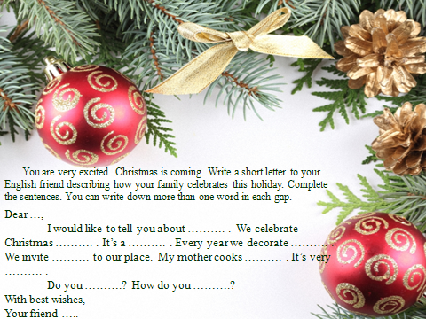
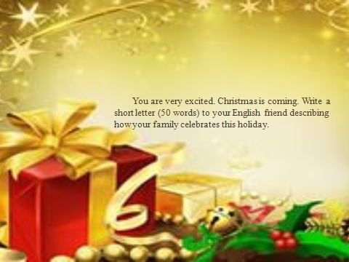
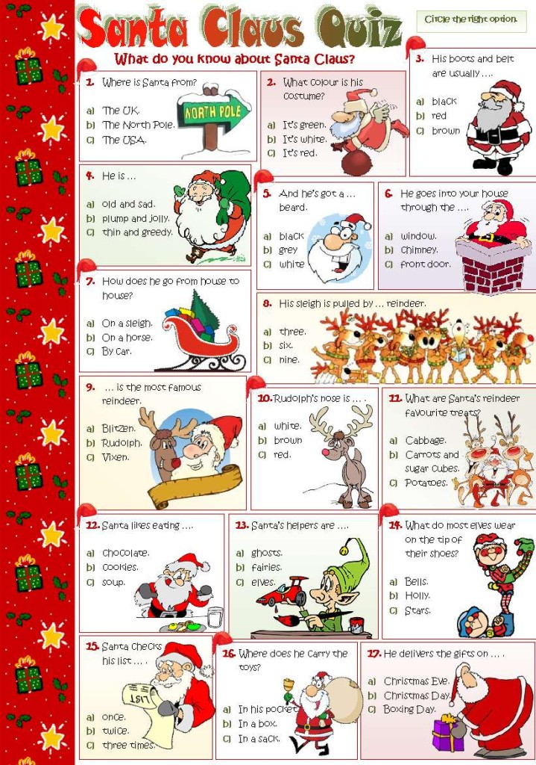
Quiz

