Казаченко В.В.
238-574-685
Материал для ксерокопирования:
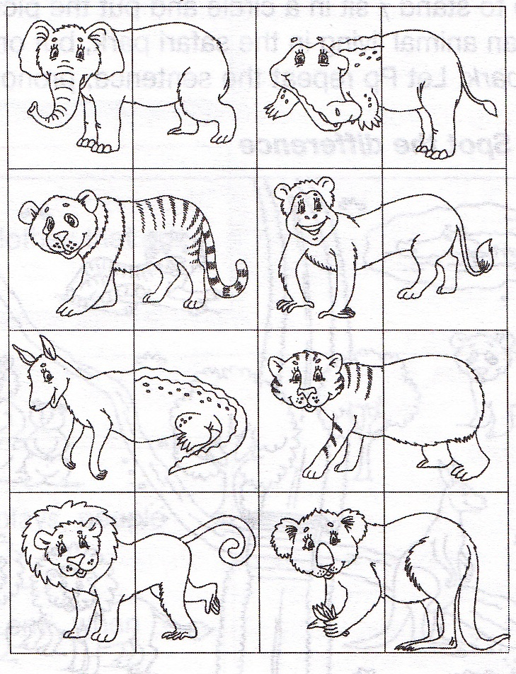
- _______________ has got ____________
- _______________ can _______________
- _______________ eats ______________
- _______________ usually hunts _______

- _______________ has got ____________
- _______________ can _______________
- _______________ eats ______________
- _______________ usually hunts _______

- _______________ has got ____________
- _______________ can _______________
- _______________ eats ______________
- _______________ usually hunts _______

- _______________ has got ____________
- _______________ can _______________
- _______________ eats ______________
- _______________ usually hunts _______

- _______________ has got ____________
- _______________ can _______________
- _______________ eats ______________
- _______________ usually hunts _______

- _______________ has got ____________
- _______________ can _______________
- _______________ eats ______________
- _______________ usually hunts _______

- _______________ has got ____________
- _______________ can _______________
- _______________ eats ______________
- _______________ usually hunts _______

- _______________ has got ____________
- _______________ can _______________
- _______________ eats ______________
- _______________ usually hunts _______

