Приложение 1

Activity Sheet

Good luck!

Activity 1
Listen to the text and fill in the table.

The inventors of the cinema
They came from
The year of the first film demonstration
The length of the film
The name of the film

Activity 2 (National Examination Format)

Task 1 Read the text “How It All Began” and say how the brothers called their device for the demonstration of films.
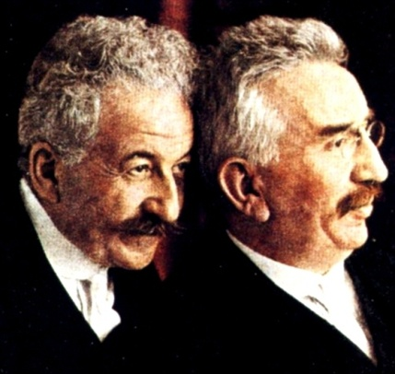
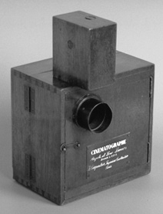

HOW IT ALL BEGAN
Auguste and Louis Lumiere are famous for the world’s first public film demonstration on December 28, 1895. The showing of ten short films lasting only twenty minutes in total was held in the Grand Café on the Boulevard des Capucines in Paris and would be the very first public demonstration of their device they called the Cinematograph which effectively functioned as camera, projector and printer all in one. Their work consisted mainly of moving images from scenes of everyday life. Ironically, as we look back in retrospect, in comparison to what film has developed into today, the Lumiere brothers believed it to be a medium without a future. They suspected that people would get bored of images that they could just as easily see by walking out into the street. However, their film sequence of a train pulling into the station reportedly had audiences screaming and ducking for cover as they believed that the train itself was about to plow into the theatre.
Born in the Haute-Saone District in1862 and 1864, with Auguste being the elder, the Lumiere family eventually settled in Lyon in 1870 where the brothers attended the largest technical school. Their father Antoine ran a photographic firm and both brothers worked for him: Louis as a physicist and Auguste as a manager. Louis made some improvements to the still-photograph process which was a major step towards moving image. Later the brothers patented a number of significant processes leading up to their first camera.
The Lumiere brothers have shot 1,425 different short films. Their first films are often called the primitive documentaries. The brothers also made the first steps towards comedy films.

Task 2 For sentences A15 –A20 choose the best answer from the suggested. Put a circle round
the number of the best answer.

A15 The Lumiere brothers are famous for …
1 the first ten films lasting only twenty minutes.
2 effective function of cinematograph.
3 the first public film demonstration.
A16 The cinematograph is a … device.
1 two-in-one
2 three-in-one
3 four-in-one
A17 The first film was about …
1 screaming audiences.
2 audiences ducking for cover.
3 a train pulling into the station.
A18 Auguste Lumiere was born in …
1 1864.
2 1862.
3 1870.
A19 Louis Lumiere worked for his father’s firm as a …
1 physiologist.
2 physicist.
3 physician.
A20 … years passed after the first film demonstration.
1 a hundred and eighteen
2 a hundred and eighty
3 a hundred and eight

Activity 3
Look through the text on page 184 of the textbook. Complete the spider graph.

Films
Studios

Hollywood

Genres

Activity 4
Do the crossword and read the name of A. Rou’s fairy tale.
a) one of the two Russian cities in which the Lumiere brothers’ film was demonstrated in
1896
b) the director of the films “A Slave of Love”, “Burnt by the Sun”, “The Barber of
Siberia”
c) the director of the films “Andrei Rublev”, “Solaris”, “Stalker”
d) one of the most famous directors who created fairy tales
e) the founder of the first film studios
f) the creator of children’s films
g) the star of silent films in the ‘20s
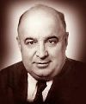
b
a |  | c | e |  | f g
 |  |  | d

THANK YOU FOR YOUR WORK!

