Card №2

You have several idioms connected with our topic and sentences which can help you understand the meaning of the idioms. So, try and translate the sentences writing down the Russian translation of the idioms.
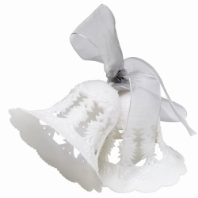

clear as a bell- _________________
I have already accomplished the task. It is clear as a bell.

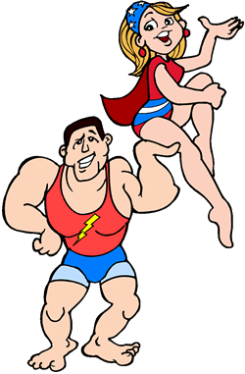
fit as a fiddle-__________________
He ran the 5 km race.
He is fit as a fiddle.

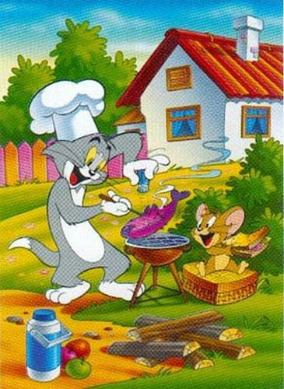
and all that jazz- ______________
They like cooking and all that jazz.

Change your tune! -___________________
-You are absolutely wrong! Change your tune!

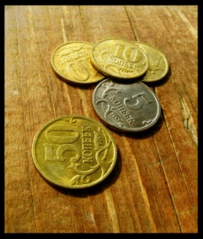

for a song - ________________
You can buy it for a song.

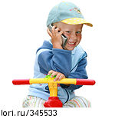
music to one’s ears - _________________
-Are you going to marry her? Oh, it’s music to my ears!

It takes two to tango!-____________________
- Who is guilty?
- It takes two to tango.

