MY FAMILY

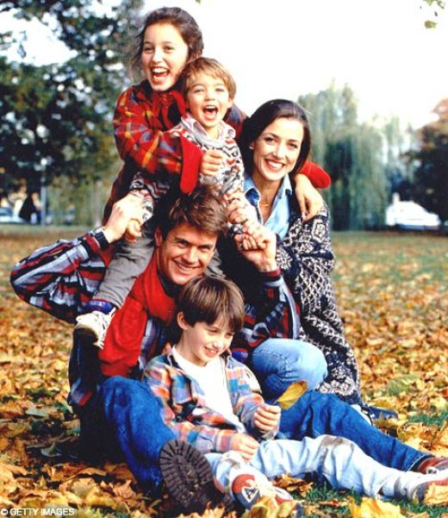

Hello my friends!
My name is Nick. I am 6.
Meet my family!
This is my mummy Helen.
This is my daddy Alex.
I have got a big sister Alice. She is 10.
I have got a big brother Sam. He is 8.
This is my grandpa Frank.
This is my grandma Jane.
I love my family!
My FAMILY.

MY FAMILY.

Hello my dear friends!
My name is Ann. I am 6.
Meet my family!
This is my daddy Tim.
This is my mummy Vera.
I have got a big sister Kate. She is 9.
I have got a little sister Mary. She is 7.
This is my grandma Tina.
This is my grandpa Jim.
I love my family!

MY FAMILY.
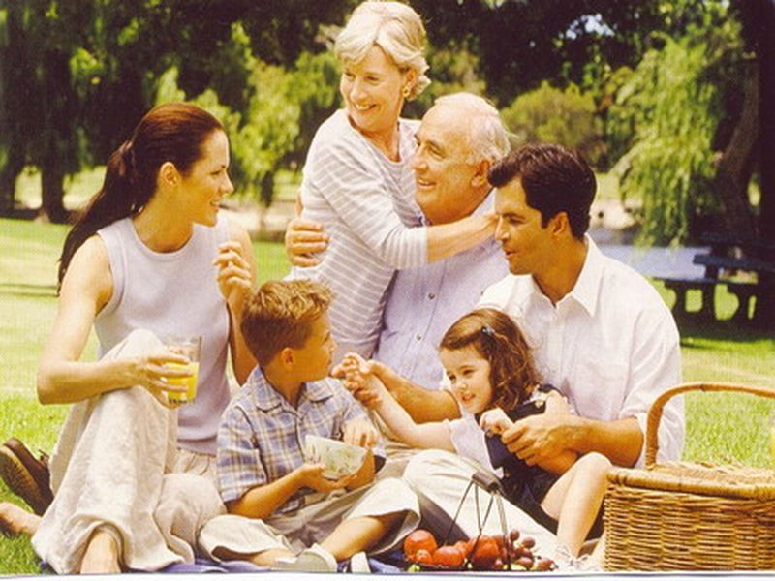

Hello my dear friends!
My name is Tom. I am 7.
Meet my family!
This is my mummy Mary.
This is my daddy Mark.
I have got a little sister Lulu. She is 4.
This is my grandma Liz.
This is my grandpa Bill.
I love my family!

