The Great Fire
1666 was the year of the Great Fire of London. In those days people usually built houses of wood, and they often were near one another. Sometimes there were fires in the city, but they were usually very small.
On Saturday, the 2nd of September 1666 there was a strong wind from the river and a big fire began. It started in the house of the king’s baker, near London Bridge. Soon the next house started burning and then the next and the next… The fire burnt for four days. Many houses in London were burnt.
People built a new city after the Fire. The famous architect Sir Christopher Wren took part in its rebuilding.

Card
Choose the right answer.

- When did the Great Fire start?
- on the 2nd of September b) on the 2nd of December c) on the 10th of February

- Where did it start?
- In Trafalgar Square b) in the house of the king’s baker c) in St Paul’s Cathedral

- How long did the fire burn?
- 4 days b) 10 days c) 1 day

- Who took part in rebuilding of London after the fire?
- William the Conqueror b) Sir Christopher Wren c) Admiral Nelson

Card 2
Read the first part of the sentence in A and find the second part in B.
A | B
1.The British Museum | a) is not far from the Tower of London.
2.The Tower of London | b) is one of the best picture galleries in the world.
3.St Paul’s Cathedral | c) stands a monument to Admiral Nelson.
4.In the middle of Trafalgar Square | d) was founded in 1753.
5. The National Gallery | e) was a fortress, a palace, a prison and the King’s Zoo and now it is a museum.

Card 3
Put in the article “the” where it is possible.

- William … Conqueror built … Tower of London in the eleventh century.
- … British Museum is one of the famous museums in London.
- English architect … Sir Christopher Wren built … St Paul’s Cathedral in the seventeenth century
- … National Gallery is in front of the monument to … Admiral Nelson in … Trafalgar Square.

Card 1
Write the name of the place of interest under the picture.
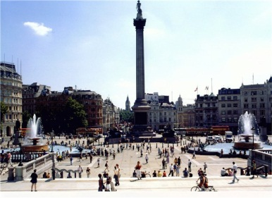  ______________________ | 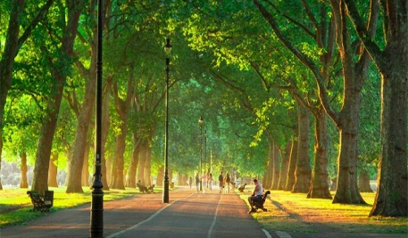  _____________________________
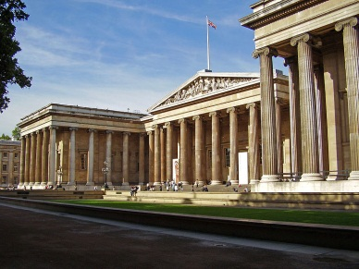  ___________________________ | 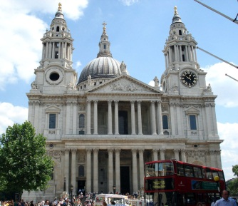  _______________________________
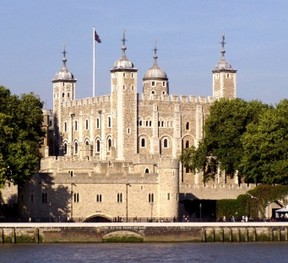  __________________________ | 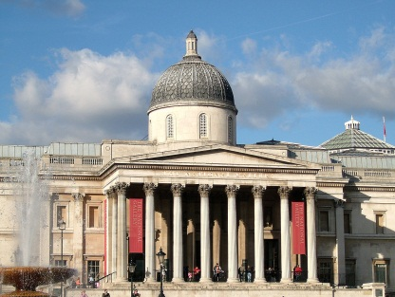  __________________________

Hyde Park
St Paul’s Cathedral
Trafalgar Square
the British Museum
the Tower of London
the National Gallery

Hyde Park
St Paul’s Cathedral
Trafalgar Square
the British Museum
the Tower of London
the National Gallery

Sir Christopher Wren
Admiral Nelson
double-decker

Hyde Park

St Paul’s Cathedral

Trafalgar Square

the British Museum

the Tower of London

the National Gallery

Диалог
P1: Excuse me. Could you help me?
P2: Of course. What do you want?
P1: Where is 42 Green Street, please?
P2: Oh, that’s easy. Walk to the corner and then turn to the left.
P1: To the corner and then to the left?
P2: That’s right. And then walk two blocks to the traffic lights. And you are in Green Street.
P1: Thank you.

