## Supplementary Materials

## Picture 1 Vocabulary Net

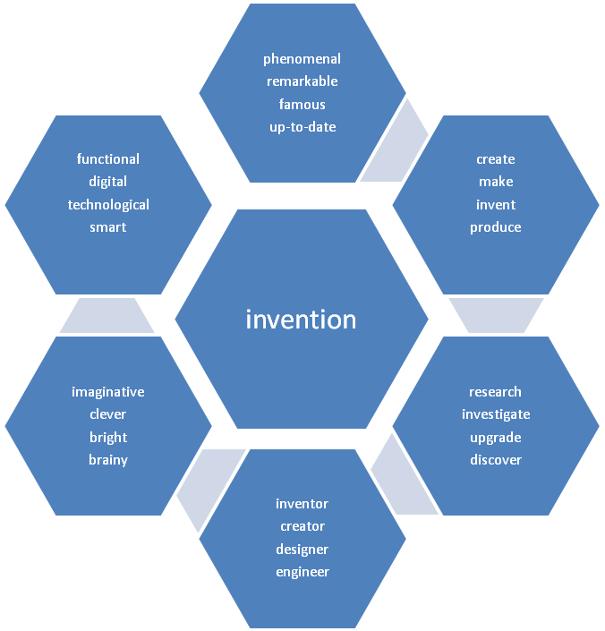

## Text “Creativity Tips”

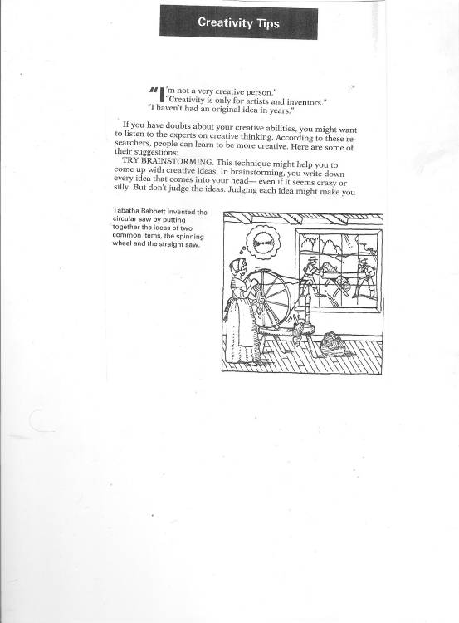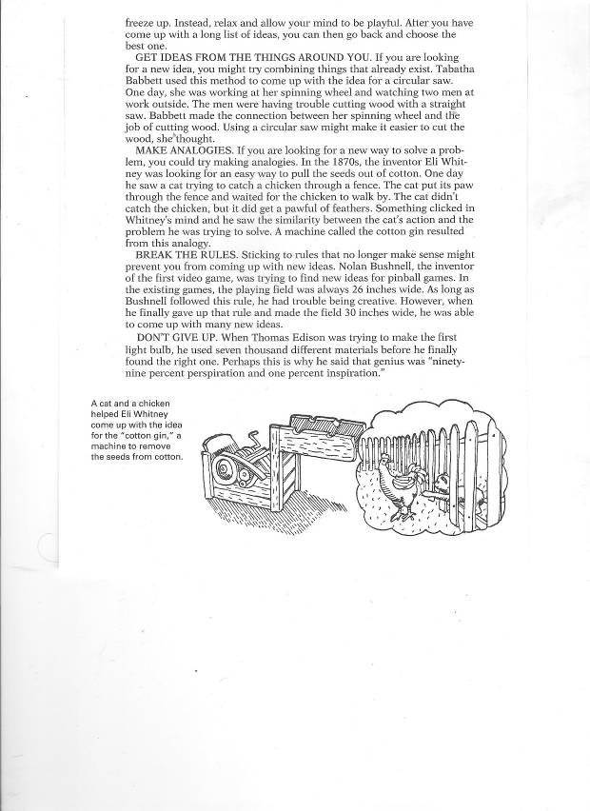

## Text ‘The cartoon by Rube Goldberg”

