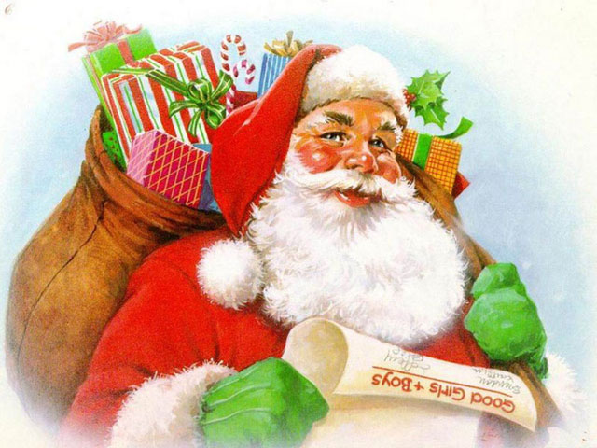
SANTA’S STORY
Fill in the blanks with words from the box:
clean, get, put, go, have, wash, fill, read, get up

Yesterday I (1) ……………….. very early. I (2) ………………. my face and (3) ………………… my teeth. Then I (4) ………………….. breakfast. After breakfast I (5) ……………………. the children’s letters. Then I (6) …………………. the Christmas presents into the beg and (7) …………………. into the sleigh. I (8) …………………. down the chimney and (9) ………………….. the stockings with presents and candies. What a busy day!

