a)Write what you would say in these situations, using the third conditional.

1. You have made some soup for dinner. Your brother comes back with three friends. He didn’t tell you he was going to do this and you don’t have enough soup for everyone. What do you say to your brother?

2. You were in the shower when the telephone rang, so you didn’t answer it. Your mother told you later that it was her on the phone and wondered why you hadn’t answered it. What do you say to her?

3. A friend has just reminded you that there is a party on Saturday night. You nearly forgot about it. What do you say to your friend?

4. A friend is upset because when you visited his home town last week you didn’t have enough time. What do you say to him?

5. Your younger sister took a photo of her best friend, but, unfortunately, she stood too close, so the photo wasn’t very good. What do you say to her?

6. A company offered you a job, but the salary was very low. You didn’t take the job. Your father wonders why. What would you tell him?

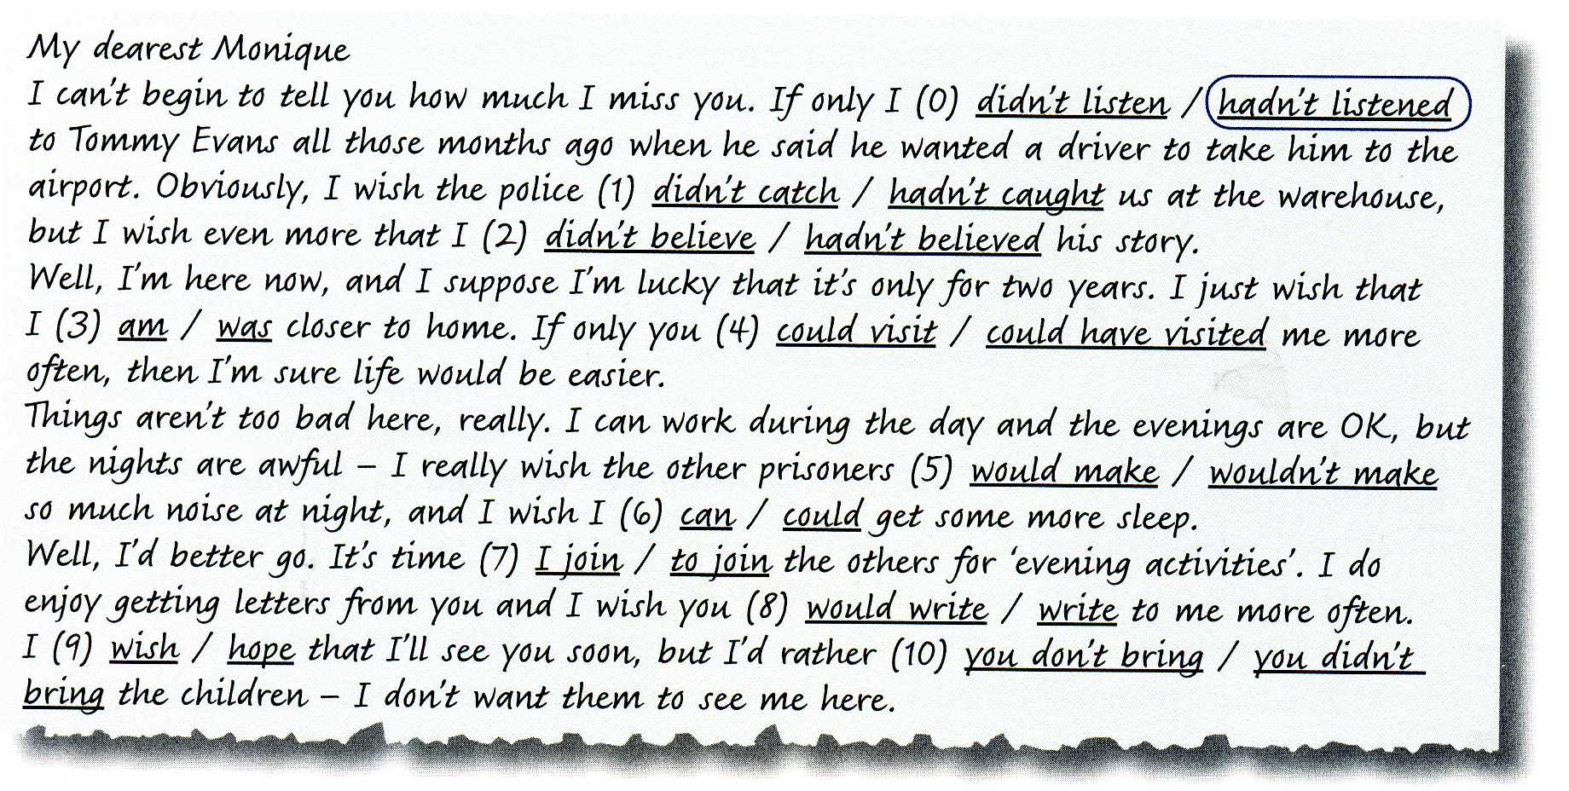
b)Read the letter from a man in prison to his wife. Choose the correct underlined words.

The key:

1. hadn’t caught
2. hadn’t believed
3. was
4. could visit
5. wouldn’t make
6. could
7. to join
8. would write
9. hope
10. you didn’t bring

