Попова Татьяна Николаевна 238-791-782

How the British Relax.
Gardening is a well-known British hobby. As the weather in Britain is mild, British people can do gardening all the year round. They grow vegetables and fruit, plant different trees. They like growing flowers, especially roses. In fact, the size of the garden is not very big, but the British can always find plenty to do in it. Mowing* grass is also very important.
Mowing ['məuɪŋ] grass-кошение травы
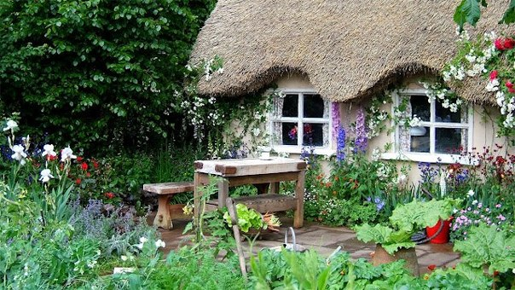
Walking is also very popular. Expect for dry summer days, the beautiful British countryside is very muddy*, so you need a good pair of walking boots to enjoy your walk. It is a good way to discover local sights of interest with a group of like-minded people and a good guide.
muddy ['mʌdɪ грязный
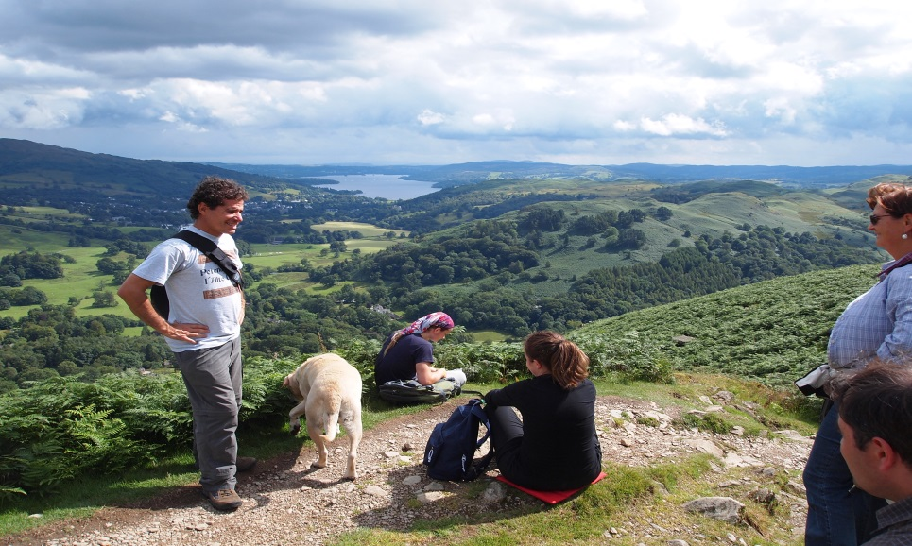
Попова Татьяна Николаевна 238-791-782

Cycling is another popular activity. Many people find quiet country roads and spend their whole holidays exploring their homeland on their bikes.
And, of course, the famous British unusual sport is extreme ironing*. Extreme ironing is a serious sport where teams of people compete at who can do their ironing in more extreme conditions. It is now an international sport with serious competitions and organized events.
Ironing- ['aɪənɪŋ]-глажка, утюжка

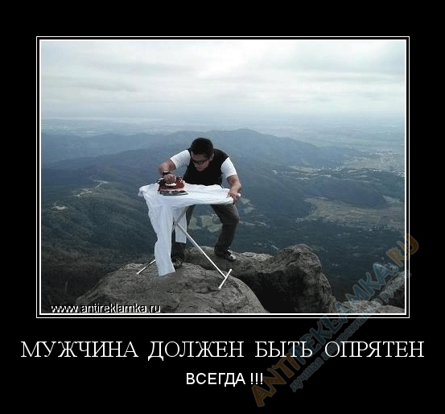

Попова Татьяна Николаевна 238-791-782

It is normal to be polite

Polite words or phrases such as ‘Please’, ‘Thank you’ and ‘Excuse me’ are used very often in Britain. Queuing* is a national habit. At bus stops and cinemas, in shops, banks and post offices and in lots of other places you’ll have to join the queue and wait for your turn. People in Britain will expect you to be polite in the way that is normal to them.

Queuing [kjuː ɪŋ]-формирование очереди

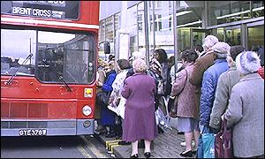

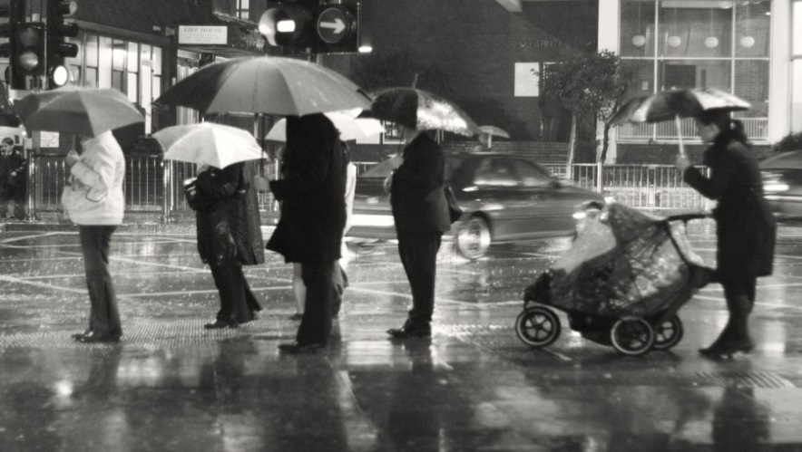

Попова Татьяна Николаевна 238-791-782

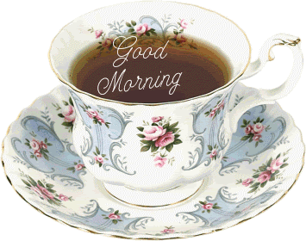

Great tea drinkers

When you are in England, you have tea for breakfast, then you have tea at 11 o’clock in the morning, then after lunch , then you have tea for tea, then after supper, and again at 11 o’clock at night.
You must not refuse any cups of tea under the following circumstances: if it is hot, if it cold, if you are tired, if you are sad, if you are happy, before you go out, if you have just returned home, if you feel like drinking tea, if you don’t feel like drinking tea, if you have had no tea for some time, if you have just had a cup.

