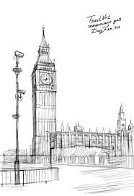

DIPLOMA

You can read and write

26 English letters

Name ____________

DATA____________