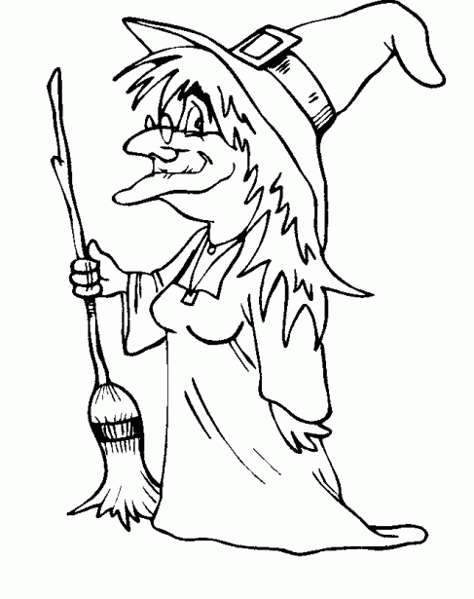

black

brown

green

orange

pinck

black

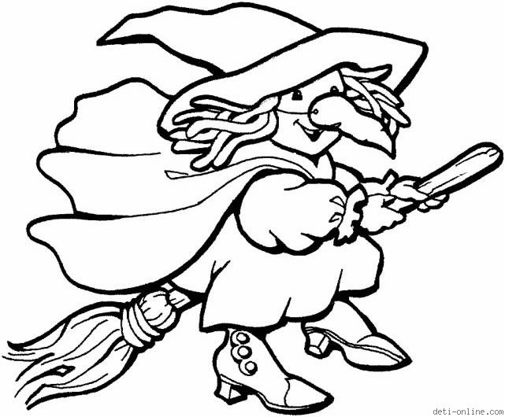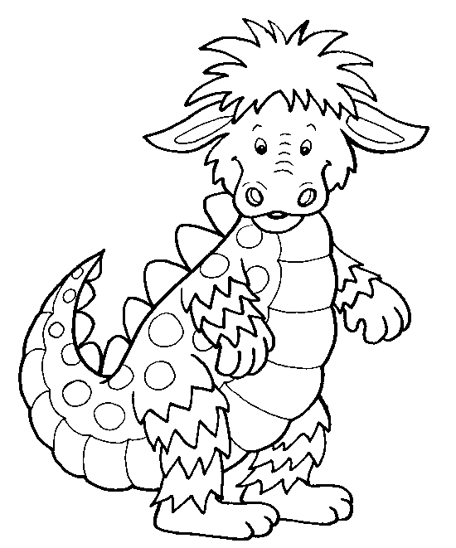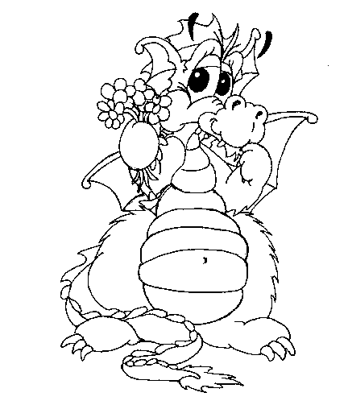

Brown

Yellow

Orange

Red

Pink

Green

Brown

Pink

Orange

Green

Yellow

Yellow

Green

Pink

Orange