 | is anything that can have a negative impact on the community and disrupt the peace and quiet of the people that live around you |  | 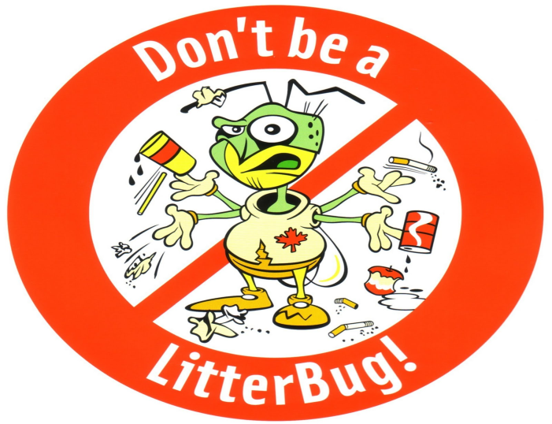
 | Definition
- Vandalism, graffiti  - The buying or selling of drugs in public  Examples  - Street drinking  - Environmental damage including littering, dumping of rubbish  - Begging and vagrancy  - Fireworks misuse  - Inappropriate use of vehicles  - Noise in the street  - Loud noise coming from a house  - Going on to other people's property without permission  - Allowing animals to mess without clearing it up, keeping an aggressive dog | 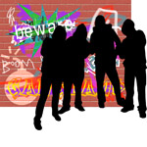  Anti-sociable behaviour  Sings in personality  Measures  Reasons |  | - Behaves impulsively, thoughtlessly about the safety of himself and others.  - Is manipulative, and often lies  - Does not follow rules, and enjoys breaking the law.  - Borrows money with no intention of repaying it.  - Steals.  - Is overly aggressive, often picking fights.  - Is willing to hurt others emotionally or physically without showing remorse.  - Is arrogant and overly confident.  - Likes to set fires.  - Is cruel to animals.
- poor parental discipline and supervision  - family conflict (between parents or between parents and children)  - family history of problem behaviour  - community disorganisation and neglect  - the availability of drugs and alcohol  - lack of neighbourhood attachment |  | - warning letters and interviews, contracts and agreements  - fixed penalty notices and penalty notices for disorder  - parenting orders, individual support orders, noise abatement notices

