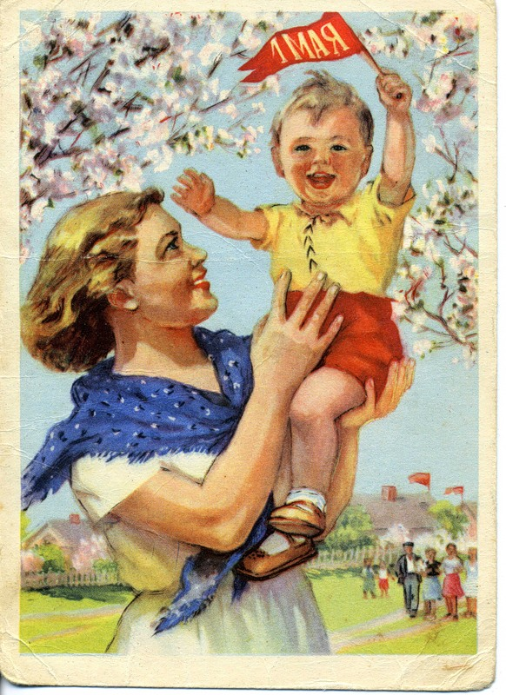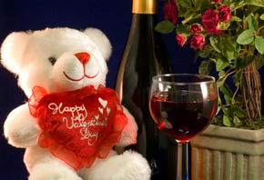
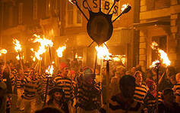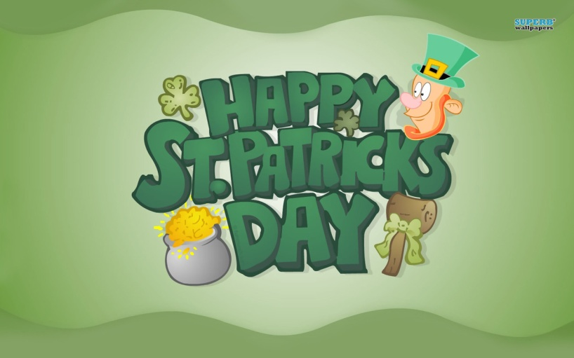
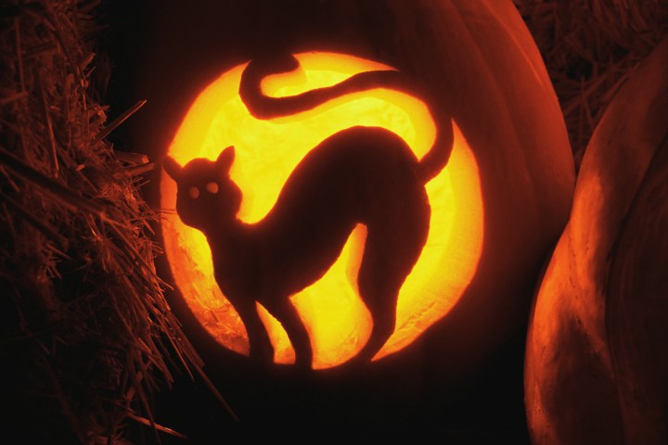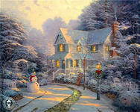

It’s celebrated on the 25th of December.
In churches people sing Christmas carols – special religious songs.
It’s celebrated on the 31st of October.
The traditional decoration is Jack-o-lantern.
It’s celebrated on the 14th of February.
Flowers and candy are favourite presents which sweethearts send to each other.
It’s celebrated on the 17th of March.
Many people wear green clothes and eat Irish food.
It’s celebrated on the 1st of May.
It’s celebrated with garlands of flowers.
It’s celebrated on the 5th of November with fireworks and bonfires.
He was put on a bonfire and burned to death.

