Приложение 1.

Team 1

Complete the sentences choosing the right variant A,B or C.

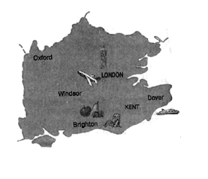
The Southeast.

1. The Southeast is ________ populated region of England.
A the least
B a highly
C a poorly

2. There is a lot of industry near the _______ .
A Thames
B Severn
C Tyne

3. When people travel to Britain by sea or air they ______arrive in the Southeast, for this is where the main passenger ports and airports are.
A never
B sometimes
C usually

4. __________ is one of the world’s busiest airports where people usually arrive when they travel to Britain.
A Heathrow Airport
B Birmingham International Airport
C Manchester Airport

5. The County of Kent is called the ______ of England.
A park
B dump
C garden

6. The Southeast is famous for its __________, for example Brighton.
A main national roads
B resorts
C passenger ports

The Southwest
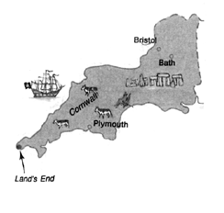
1. The Southwest is _________ region.
A an industrial
B a farming
C a cultural

2. Most of farms are small family farms where _______ _____ produced.
A bread is
B cheese is
C dairy products are

3. The main cities of the region are _____________.
A Bristol and Bath
B Stratford and York
C Bristol and Dover
4. If you want to see the famous ___________ , one of the remarkable historic places in the UK, you should also come there.
A Stonehenge
B Hadrian’s Wall
C birthplace of William Shakespeare

5. The most ______point of GB ”Land’s End” is also here.
A northerly
B easterly
C westerly

East Anglia
1. East Anglia is very flat and it is another ________ region.
A industrial
B farming
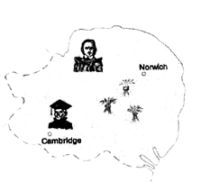
C cultural

2. The part of East Anglia called ______consists of miles of _______with almost no trees or hedges.
A the Lake District; lowlands
B the Fens; flat land
C the County of Kent; highlands

3. It is a birthplace of ___________, an English general and politician.
A Oliver Cromwell
B William Shakespeare
C the British Prime Minister

4. East Anglia is isolated from the rest of Britain because of its _________ away from the main national roads.
A meadow
B scenery
C position

Team 2

Decide if the statements are True (T) or False (T).

The Midlands
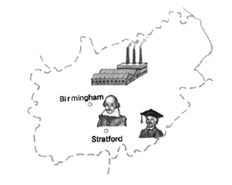
1. The Midlands is the main industrial region of the country.
2. It is the head of England.
3. Manchester, Sheffield, Liverpool aren’t the most important industrial cities.
4. Liverpool is one of Britain’s big ports.
5. There are no interesting places to visit.
6. The region is also famous for its culture and education.

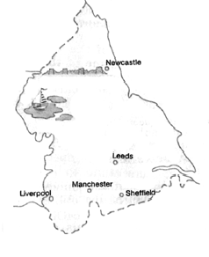

The North of England

1. The North of England is known for its very beautiful scenery.
2. There is no industry in the region because it isn’t reach in coal.
3. The territory of the region is very flat.
4. There are no interesting places to visit except the Lake District.
6. Hadrian’s Wall is a natural border with Scotland.

Key:
1. The Southeast 1.B 2.A 3.C 4.A 5.C 6.B
2. The Southwest 1.B 2.C 3.A 4.A 5.C
3. East Anglia 1.B 2.B 3.A 4. C
4. The Midlands 1.T. 2.F. 3.F. 4.T. 5.F. 6.T.
5. The North of England 1.T. 2.F. 3. F. 4.F. 6.F.

