Приложение 1 A sheet of 38 pictograms of the 2012 Summer Games in London
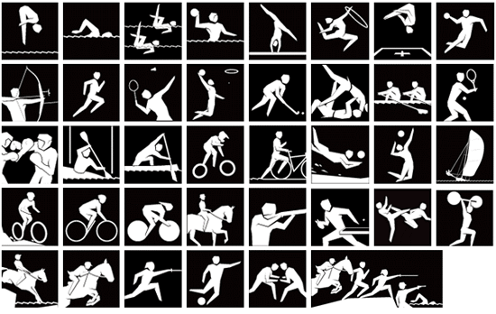

Опорная карточка для повторения/ ознакомления в течение ограниченного времени.
Wrestling | 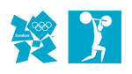  Weightlifting | Volleyball  Beach volleyball |  | 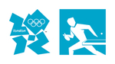  Table Tennis | 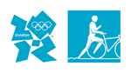  Triathlon | 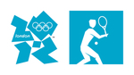  Tennis | 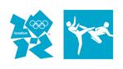  Taekwondo | 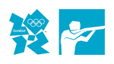  Shooting
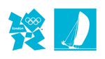  Sailing | 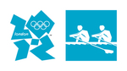  Rowing | Modern Pentathlon |  | 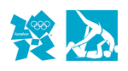  Judo | 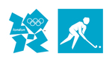  Hockey | 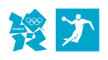  Handball | Gymnastics  Artistic Gymnastics, Rhythmic Gymnastics and Trampoline. | 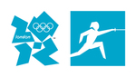  Fencing
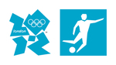  Football | Equestrian  [ɪ'kwestrɪən ],  Dressage  ['dresɑːʒ], Eventing and Jumping. |  | Cycling  Road, Track, Mountain Bike and BMX (bicycle motocross) | Canoe Sprint and Canoe Slalom. | 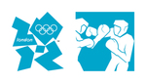  Boxing | 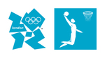  Basketball | 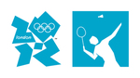  Badminton | 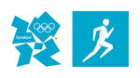  Athletics
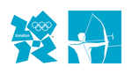  Archery | Aquatics  Diving, Swimming, Synchronised Swimming and Water Polo. |  | Интернет источник London 2012 Olympic pictograms http://mm.gettyimages.com/mm/nicePath/locog?n from London 2012 show the way with Olympic pictograms
Разрезные карточки на английском и русском языках

Прыжки в  воду | Плавание | Синхронное плавание | Водное поло | Спортивная гимнастика | Художественная гимнастика | Прыжки на батуте | Гандбол
Стрельба из лука | Лёгкая атлетика | Бадминтон | Баскетбол | Хоккей на траве | Дзюдо | Академическая гребля | Теннис
Бокс | Гребля на байдарках и каноэ | Гребной слалом | Велосипедный Мотокросс | Триатлон (плавание в открытом бассейне, велогонка, легкоатлетический кросс). | Пляжный волейбол | Волейбол | Парусный спорт
Горный велосипед | Шоссейный велоспорт | Вело  трековые гонки | Конный спорт  Выездка | Стрельба | Настольный теннис | Тхэквондо | Тяжёлая атлетика
Конное троеборье | Конный спорт  Конкур | Фехтование | Футбол | Вольная борьба Греко-римская борьба | Современное пятиборье

Aquatics  Diving, | Aquatics  Swimming, | Aquatics  Synchronised Swimming | Aquatics  Water Polo | Gymnastics  Artistic [ɑː'tɪstɪk Gymnastics | Gymnastics  Rhythmic Gymnastics | Gymnastics  Trampoline  ['træmp(ə)liːn] | Handball
Archery | Athletics | Badminton | Basketball | Field  Hockey | Judo | Rowing | Tennis
Boxing | Canoe Sprint | Canoe Slalom | Cycling  BMX | Triathlon | Beach volleyball | Volleyball | Sailing
Mountain Bike | Road Cycling | Track Cycling | Equestrian  Dressage | Shooting | Table Tennis | Taekwondo | Weightlifting
Equestrian  Eventing | Equestrian  Jumping | Fencing | Football | Wrestling | Modern Pentathlon

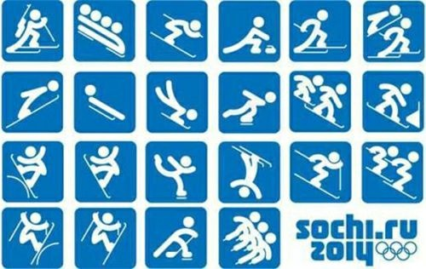

Опорная карточка для повторения/ ознакомления в течение ограниченного времени.
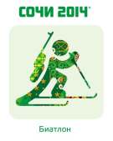  Biathlon baɪ'æθlən] | 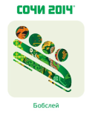  Bobsleigh['bɔbsleɪ] | 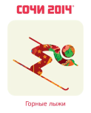  Alpine Skiing | 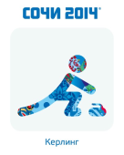  curling ['kɜːlɪŋ] | 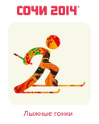  Cross-country skiing | 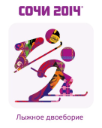  Nordic Combined in both cross-country skiing and ski jumping.
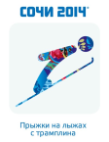  Ski Jumping | 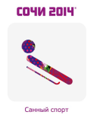  Luge[luːʤ] ; 1) одиночные сани | 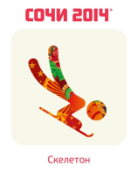  Skeleton | 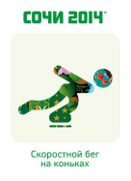  Speed Skating | 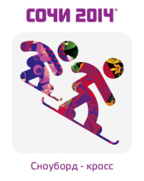  Snowboarding Cross | 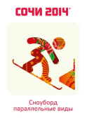  Snowboard, Parallel Events
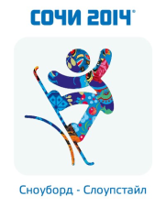  Snowboard slopestyle | 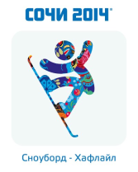  Snowboard half-pipe | 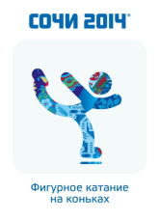  Figure Skating | 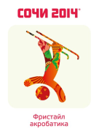  Freestyle Skiing, Aerials | 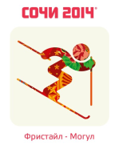  Freestyle skiing Moguls | 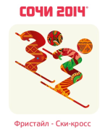  Freestyle Skiing – Ski Cross
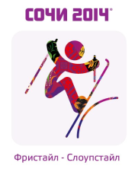  Ski slopestyle [sləup] наклон, уклон | 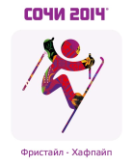  Freestyle Skiing – Halfpipe | 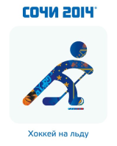  Ice Hockey | 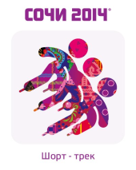  Short Track Speed Skating
The pictograms of the Olympic Games in Sochi 2014 » Design You ...http://designyoutrust.com/2012/10/the-pictograms-of-the-olympic-games-in-hi-2014/
Biathlon baɪ'æθlən] | Bobsleigh  ['bɔbsleɪ] | Alpine Skiing | Curling  ['kɜːlɪŋ] | Cross-country skiing | Nordic Combined  in both cross-country skiing and ski jumping.
Ski Jumping | Luge[luːʤ] одиночные сани | Skeleton | Speed Skating | Snowboarding | Snowboard, Parallel Events
Snowboard slopestyle | Snowboard half-pipe | Figure Skating | Freestyle Skiing, Aerials ['eərɪəlz] | Freestyle skiing Moguls (-series of bumps on a trail formed when skiers push the snow into mounds or piles). | Freestyle Skiing – Ski Cross
Ski slopestyle [sləup] | Freestyle Skiing – Halfpipe | Ice Hockey | Short Track Speed Skating

Биатлон | Бобслей | Горнолыжный спорт | Кёрлинг | Лыжные гонки | Лыжное двоеборье
Прыжки с трамплина | Санный спорт | Скелетон | Конькобежный спорт | Сноуборд | Сноуборд. Параллельные виды
Сноуборд. Слоупстайл. | Сноуборд.  Хаф-пайп | Фигурное катание | Фристайл. Акробатика. | Фристайл. Могул. | Фристайл.  Ски- кросс
Фристайл Слоупстайл. | Фристайл  Хаф-пайп | Хоккей на льду | Шорт - трек

Приложение 2
This is the credo of those who are ready to strive for setting new records It is an idea that embraces the spirit of competition.  (ОМОТТ) | This is a white silk cloth with the Olympic logo embroidered on it. The five interlocking rings represent the five continents, demonstrating the link between peoples of the world and the universality of the Olympic Games. (GAFL) | This piece of music marks raising of the Olympic flag during the Opening ceremony and during competitions (NEMAHT) | It is a special thing of the Olympic Games, which is designed to bring good luck to athletes and fans (COTSAM)
They are gold, silver, and bronze, They are awarded to three athletes, who showed the best results in competitions (SEDMAL) | It is lit in the Greek city of Olympia, at the foot of Mount Kronos, through a special parabolic mirror .( OLYMPIC MELAF) | With the help of this action the fire crosses all 5 inhabited continents of the Earth and arrives to the venue of the Games.  (TORCH LAYRE)

Приложение 3
2012 - | 2014 - | 2016 - | 2018 -
XXXth, | XXIInd, | XXXIst, | XXIIIrd
Summer Olympic Games | Winter Olympic Games | Summer Olympic Games | Winter Olympic Games
London, 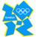United Kingdom | Sochi, Russia 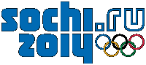 | Rio de Janeiro, Brazil | Pyeongchang, South Korea 