Протокол игры «АНГЛОМАТИКА»

задание 1, «слайды с вариантами ответов»  
1 правильный ответ – 1 балл

|  |  |  |  |  |  |
| --- | --- | --- | --- | --- | --- |
| № вопроса | Номер правильного ответа | Ответ 1 команды (апельсинка) | балл | Ответ 2 команды (капелька) | балл |
| 1 вопрос | 1 |  |  |  |  |
| 2 вопрос | 2 |  |  |  |  |
| 3 вопрос | 2 |  |  |  |  |
| 4 вопрос | 1 |  |  |  |  |
| 5 вопрос | 3 |  |  |  |  |
| 6 вопрос | 3 |  |  |  |  |
| 7вопрос | 2 |  |  |  |  |
| 8 вопрос | 3 |  |  |  |  |
|  | | ВСЕГО |  | ВСЕГО |  |

_____________________________________________

задание 2, «поставить соответствие на карточках»  
1 правильный ответ – 1 балл

You should decide are these devices input or output?  
 Put 1 for input and 2 for output.

Plotter 2

Web camera 2

Scanner 1

Printer 2

Microphone 1

Trackball 1

You should decide are these devices input or output?   
 Put 1 for input and 2 for output.

Speaker 2

Mouse 1

Monitor 1

Headset with microphone 1, 2

Keyboard 1

Graphic tablet 1

|  |  |  |
| --- | --- | --- |
| Максимум 6 баллов | Правильных ответов 1 команды (апельсинка) | Правильных ответов  2 команды (капелька) |
|  |  |
| Всего за 2 задания |  |  |

задание 3b, «видеоаудирование»  
1 правильный ответ – 1 балл

Listen to the text, as you listen it put these words or phrases or sentences into the gasps. You need write only numbers.

**1.** The RAM memory.  
**2.** DVD/CD burner power supply **3.** Hard drive  
**4.**Processor   
**5.** RAM memory  
**6**. Motherboard **7.** Video card  
**8.** Sound card

**9.** The first piece to prepare is the motherboard.

**10.** Attach the hard drive **11.** Basic Phillips head screwdriver **12**. Components **13.** Test it out   
**14.** Power supply **15.** Building a custom PC **16.** Tools  
**17**. CPU **18.** Turn your PC

Hi I'm Fred Bistec for About.com and this is an Overview of Building a PC. When 1_**15**__ yourself You will be able to create a custom machine that exactly matches your needs. It will be much easier to upgrade your machine in the future because you will understand it completely. You may be able to save some money.

### What You Need to Build a PC?

When building a PC you will need the following parts case: 2_**6**__3__**3**___4___**5**__5__**7**___

6__**4**__7__**8**__8_**2**___and a fan.

You will also need a 9_**11**____and a clean dust free environment to work at.

### Time Involved to Build a PC

Preparation is key when it comes to being as efficient as possible when building a PC. Layout all your 10__**16**____ and components beforehand. You should give yourself around 2-3 hours in complete the whole process.

### How to Start Building a PC

Begin your process by making sure you have all the correct tools and 11_**12**___ needed to build your PC. Once you have verified that you have everything you need, you will be inserting all of the these components into the case. 12_**_9**____Make sure to thoroughly inspect the motherboard for any parts that may look damaged before you install it.

The next piece to prepare and install is the 13__**14**___. Test the power supply and make sure it works before you install it. Once the power supply is safely installed and connected, you may continue to install the rest of your components into the motherboard. Start by inserting the 14___**17**__ into the motherboard. Then place 15__**1**__ into the specific slots for them. Then 16 _**10**____ to the case and connect it to the motherboard. Once you have assembled all your components together go ahead and 17 _**18**___ on and 18___**13**__. If it is working then you are good to go!

|  |  |  |
| --- | --- | --- |
| Максимум 18 баллов | Правильных ответов 1 команды (апельсинка) | Правильных ответов  2 команды (капелька) |
|  |  |

задание 3с

|  |  |  |
| --- | --- | --- |
| Максимум 5 баллов | Оценивание работы капитанов 1 команды | Оценивание работы капитанов 2 команды |
|  |  |
| Всего за 3 задания |  |  |

Задание 4а  
1 правильный ответ – 1 балл

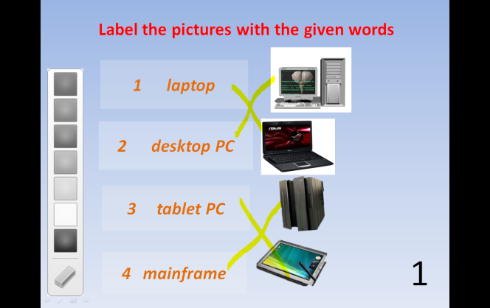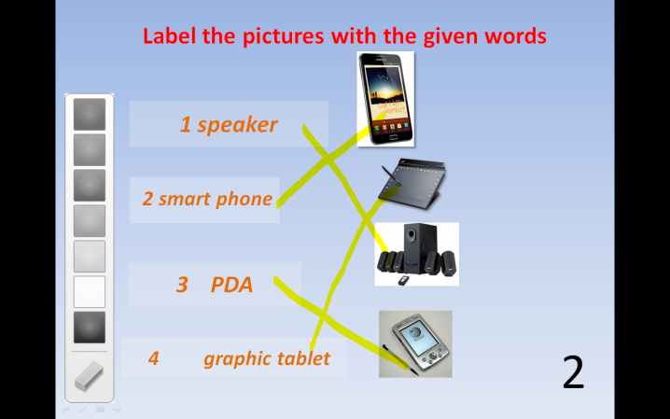

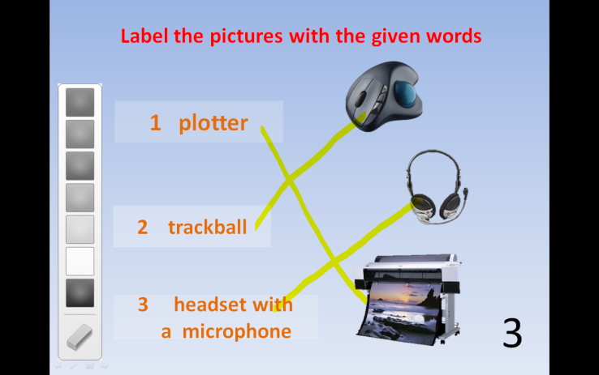

|  |  |  |
| --- | --- | --- |
| Максимум 11 баллов | Правильных ответов 1 команды (апельсинка) | Правильных ответов  2 команды (капелька) |
|  |  |

Задание 4b  
1 правильный ответ – 1 балл

|  |  |
| --- | --- |
| 1. Клавиша Esc-8 | 1. Page Down |
| 1. Клавиша Alt-5 | 1. Print Screen |
| 1. Клавиша Ctrl-6 | 1. Insert |
| 1. Клавиша Pgdn-1 | 1. Delete |
| 1. Клавиша Pgup-9 | 1. Alternate |
| 1. Клавиша Ins -6 | 1. Control |
| 1. Клавиша Del-3 | 1. Tabulation |
| 1. Клавиша Prt Scr-2 | 1. Escape |
| 1. Клавиша Tab-7 | 1. Page up |

Задание 4b (продолжение)  
1 правильный ответ – 1 балл

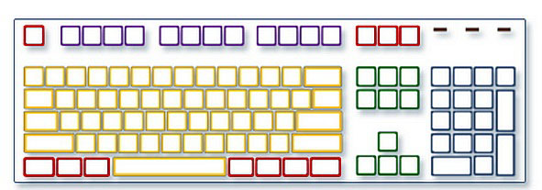

|  |  |  |
| --- | --- | --- |
| Максимум 9 баллов | Правильных ответов 1 команды (апельсинка) | Правильных ответов  2 команды (капелька) |
|  |  |
| ВСЕГО |  |  |
| ИТОГО |  |  |