Приложение 1

Space Day | The 7th of January
Victory Day | The 12th of April
Guy Fawkes Day | The 9th of May
Christmas | The end of February/the beginning of March
Maslenitsa | The 5th of November
Приложение 2 THANKSGIVING DAY
Thanksgiving Day is a public holiday, which is celebrated on the fourth Thursday in November by Americans. On this day American people honour the memory of the first settlers who came on the ship “Mayflower” to the New World in 1620. They arrived in November. Their first winter was very difficult and without fresh food, many people died.
But the Indians (the Native Americans) showed them how to grow corn, how to hunt and fish.
And next autumn of 1621 the settlers had a good harvest. They invited the Indians to dinner. It was the first Thanksgiving.
In 1951 the US Congress named the fourth Thursday of November a Thanksgiving Day.
Now it is a day for family to get together and have big dinner that includes roast turkey, cranberry souse, potatoes and pumpkin pie.
People give thanks for different things: for a healthy year, a good job and for meeting new friends.
honour – чтить, почитать
memory –память
corn -зерно
roast – жареный
cranberry souse – клюквенный соус
pumpkin –тыква

INDEPENDENCE DAY
One of the greatest and important public holidays in the USA is Independence Day. On the 4th of July Americans celebrate their whole nation birthday. On this day in 1776 the American colonies declared their independence from Britain. It was the beginning of a new life.
In the past this day was celebrated with big parades and fireworks.
Now on this day cities and towns are decorated with flags, there are parades and sports prizes in some places. People can listen to some patriotic speeches.
Many families celebrate the 4th of July by having picnics in the countryside and watching fireworks at night.
declare –объявлять

ST.PATRICK’S DAY
On the 17th of March, Americans celebrate an Irish religious holiday, St.Patrick’s Day. St.Patrick was a patron saint of Ireland.
St.Patrick became very famous in the USA, because very many people arrived from Ireland in America. This holiday was celebrated since the first days of the nation. But now St.Patrick’s Day is not celebrated only by Americans whose great-grandparents were Irish. It is a holiday for all people who want to have a fun too. On this holiday people decorate their houses, schools and streets with green shamrocks. People must wear something green. If you don’t wear green, some people may pinch you.
Famous Irish songs are played on the radio all day. And the parade is held on Fifth Avenue in New York.
shamrock – клевер
pinch - ущипнуть
The name of the holiday _____________________________________

The date of  celebration | The kind of  holiday | Beginning  of  celebration | What people  do on this  holiday | The symbols  of holiday

Приложение 3 Down:
- ………'s Day is on the 14th of February. People make or buy cards and send them to the people they love.
- ……… is on the 25th of December. Presents for children are in their stockings.
- April ………'s Day is on the 1st of April. Children play tricks on other people and have a lot of fun.
- ………'s Day is in March. It is a holiday for English women.
- ……… Year's Day is on the 31st of December. Some people in England have parties on that day.
Across:
- St. ………'s Day is a national holiday in Ireland. It is on the 17th of March.
- ……… Day is in November. People in America eat roast turkey and pumpkin pie.
- ……… Day holiday is on the first Monday in May.
- ……… is on the 31st of October. Children go from house to house and say "Trick or treat".
- ……… Day is in April or at the end of March. Children get chocolate eggs or rabbits on that day.
- ………'s day is in June. It 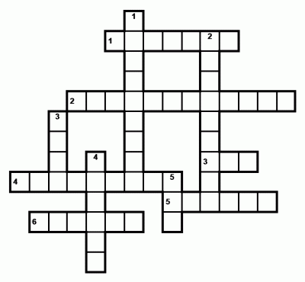is a holiday for English men.

