Name:_________________________
Task №I Make up the sentences.
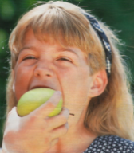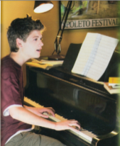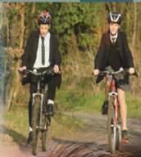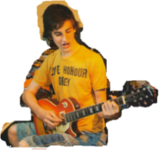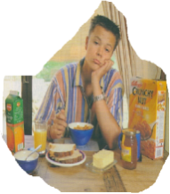
eat an apple/...a minute play the piano/...3 p.m. jump/...5 minutes ride bikes/...morning play the guitar/...5 p.m. have lunch/...30 min
1. _________________________________________ __________________
2. ________________________________________ ____________________
3. _______________ ______________________________________________
4. ______________________________________________________________
5. ________________________________________ ______________________
6. _______________________________________________________________

Task №2 Listen to the tape and circle the correct word.
- The lions have been lying there since 9 a.m./for nine hours/all day.
- He`s been swimming since 1 o`clock/for an hour/for two hours.
- We`ve been watching this film all evening/all morning/all day.
- He has been going to bed early all week/all month/all year.
- I am tired, because I have been reading/ have been working / on a new project.
- I`m wet, because it has been snowing/ has been raining/ I have been swimming.
- You look tired! What have you been doing? – I`ve been working/ I`ve been running/
I`ve been jumping.

Task №3 Read a sentence of each of the following situations using the Present Perfect Continuous Tense and necessary key words-since or for.
She started reading this book last weekend and she is still reading it.-
She has been reading this book since last weekend.
- It started raining at 3 o`clock and it is still raining.-

____________________________________________________________________
- The boy started his work at 8 o`clock and he is still working.-

____________________________________________________________________

- Helen started looking for another job two months ago and she`s still looking.-

____________________________________________________________________

- We`ve arrived here at 7 o`clock and we are still waiting.-

- The pupils started writing their compositions 20 minutes ago and they are still writing.-

______________________________________________________________

- My father started driving his car in 1998 and he is still driving.-

Grammar Test

