Министерство образования и науки Республики Казахстан
Отдел образования, физической культуры и спорта
акимата города Тараз
Гимназия №40

Разработка открытого урока по английскому языку:
«THE PRESENT PERFECT CONTINUOUS TENSE»
7-й класс
учителя английского языка
гимназии №40
Тарасовой Натальи Валерьевны

Тараз – 2011
Theme: “The Present Perfect Continuous Tense”
Objectives:
- To provide general revision of The Present Perfect Continuous Tense, to help pupils compare all present tenses.
- To improve pupils` speaking, reading and comparative skills.
- To maximize pupils` potential and to widen their world outlook.
Equipment: Microsoft Power Point Presentation, the CD, the activboard, handouts, computer tests.

Outline:
- Warm-up: I want you to look at the pictures and answer the questions:” What are they doing now?”
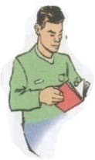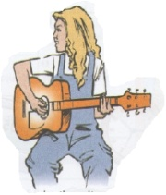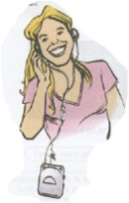
Pupils answer:
He is reading a book. She is playing the guitar. She is listening to music.
Teacher: Their actions started some time ago and they are still happening.
Now answer the question: “How long have they been doing this?”
for ten minutes since 3 o`clock all morning
Pupils answer:
He has been reading a book for ten minutes.
She has been playing the piano since 3 o`clock.
She has been listening to music all morning.
- Revision of Grammar
Teacher: The theme of our lesson today is “The Present Perfect Continuous Tense”.
What does it mean? Pupils answer: It means the actions which started in the past and they are continuing up to the present.
How is it formed? Pupils answer: It is formed with the help of auxiliary verbs-have been/has been and Ving (participle one)
have been/has been + Ving
What`s the difference between have been and has been? Pupils answer: We use have been with the pronouns I, you, we, they. We use has been with the pronouns He, she, it.
What about key words? Pupils answer: since, for, all (morning), How long...?
- Reading the text. Teacher: Now your task is to read the text and find the sentences in The Present Perfect Continuous Tense.

There is a lion lying at a small airport in South Africa. Planes can`t leave because the lion is in the way! The lion has been lying there since 9 a.m. But no one wants to move them! The passengers have been waiting for five hours! The manager of the airport thinks the lion is enjoying the sun and will move when the sun goes down. Until then, everyone must wait!

At first pupils read the text and then they find the sentences in The Present Perfect Continuous Tense:
The lion has been lying there since 9 a.m.
Teacher: Can you make a negative form?
Pupils answer: The lion hasn`t been lying there since 9 a.m.
Teacher: What about another sentence?
Pupils read out:
The passengers have been waiting for five hours.
Pupils ask a general and a special question:
Have the passengers been waiting for five hours?
How long have the passengers been waiting?

- Practice of key words . Teacher: You know that the key words –since and for have a difference. What`s the difference?
Pupils answer:
For means a period of time.
Since means when the actions started.
Teacher: Your task is to click the correct key words and then you will see a picture if you are quite right. rig
for five hours
since last month
since Friday
for twenty minutes
since 5 o`clock
since September
for ten months
since his childhood
for two years
for a long time
since Christmas
since my birthday

- Practice of key words. Teacher: Now your task is to go to the activ board and mark a correct key word-since, for, all.
- I have been working on the computer for/since/all six o`clock.
- Аlice has been reading his book for/since/all afternoon.
- Jess has been learning English for/since/all five years.
- Where is the bus? We`ve been waiting here for/since/all twenty minutes.
- The weather is awful! It`s been raining for/since/all day.
- My mother has been cooking for/since/all ten o`clock.
- The boys have been playing football for/since/all an hour.
- Making up the sentences. Teacher: You`ve got handouts on your desks. Write down your names. The task is to make up the sentences, using The Present Perfect Continuous Tense.

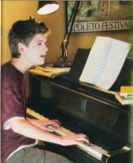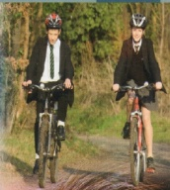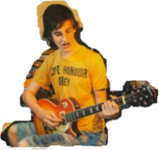
eat an apple/for a minute play the piano/since 3 p.m. jump/for 5 minutes ride bikes/all morning play the guitar/since 5 p.m. have lunch/for 30
Then pupils read out their sentences:
1. She has been eating an apple for a minute.
2. He has been playing the piano since 3 p m.
3. They have been jumping for five minutes.
4. They have been riding their bikes all morning.
5. He has been playing the guitar since 5 p.m.
6. He has been having breakfast for thirty minutes.
While reading the pupils change their handouts and check themselves.
VII. Listening. The next task is to listen to the tape and circle the correct words in their handouts.
1. The lions have been lying there since 9 a.m.
2. He`s been swimming for an hour.
3. We`ve been watching this film all morning.
4. He has been going to bed early all week.
5. I`m tired, because I have been working on a new project.
6. I`m wet, because it has been raining.
7. You look tired! What have you been doing? -I`ve been running.
Then pupils check their work using the activboard.
- Making up the sentences. Now your task is to read a sentence of each of the following situations, using the Present Perfect Continuous Tense and key words –for/since
- She started reading this book last weekend and she is still reading it.-
She has been reading this book since last weekend.
It started raining at three o`clock and it is still raining.-
____________________________________________________________________________The boy started his work at eight o`clock and he is still working.-
____________________________________________________________________________Helen started looking for another job two months ago and she`s still looking.-
____________________________________________________________________________We arrived here at seven o`clock and we`re still waiting. –
____________________________________________________________________________The pupils started writing their compositions twenty minutes ago and they are still writing.-
___________________________________________________________________________My father started driving his car in 1998 and he`s still driving.-
___________________________________________________________________________

- Reading and Speaking. Teacher: I know that there are lots of talented teenagers in the world. We shall read and speak about three of them.
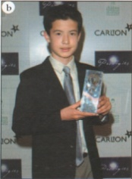 David Howell 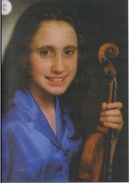 Jennifer Pike 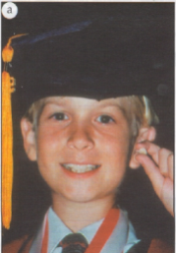 Greg Smith
At the age of 11 David Howell showed that he was one of the best chess players in the world. In 2002 he played against Russian Grand Master Kramnik. David started playing chess at the age of 5. His father explained the rules to him. An hour later David understood them and beat his father in his first game. David has been playing chess for seven years. He also likes football and playing computer games.

Jennifer Pike was twelve when she won her first prize in a competition for young musicians in Britain. She started playing the violin when she was five. She was taught by her father who worked at school for young musicians. Now Jennifer is a student at the same school. She has been playing the violin for eleven years. She loves swimming and table tennis as well, but she can`t play basketball because she might hurt her hands.

Greg Smith is probably the brightest boy in the world. He began speaking when he was three months. He was answering math problems at 14 months. His parents found a special school for him. He passed his final high school exams with top grades when he was eight. Then he went to University to study maths. He has been studying there for three years.

- Answering the questions. Teacher: Now answer the questions about these children.

When did Greg begin speaking? -He began speaking when he was three months.
At what age did he go to University? - He went to University at the age of eight.
How long has he been studying there? - He has been studying there for three years.

How long has David been playing chess?-He has been playing chess for seven years.
Who taught him? -His father taught him to play.
What else does he like doing? - He likes football and playing computer games.

What musical instrument does Jennifer play? - She plays the violin.
How long has she been playing the violin? - She has been playing the violin for eleven years.
Why can`t she play basketball? -She can`t play basketball because she might hurt her hands
- Memory game. Teacher: Look at Who-questions and give me the children`s names.
- Who likes playing table tennis? Jennifer
- Who is good at mathematics? Greg
- Who enjoys football? David
- Who could speak the earliest? Greg
- Who won a competition? Jennifer
- Who played against Russian Grand Master? David
- Who loves swimming? David
- Who went to University at the age of eight? Greg
- Who can`t play basketball? Jennifer
- Who likes playing computer games? David
- Speaking. Teacher: Now we have just read and spoken about talented teenagers in the world but I know that there are many bright and smart pupils at our school and in our class. Now your task is to ask a question beginning with How long...? and answer the questions using the pupils` names and the key words-since/for
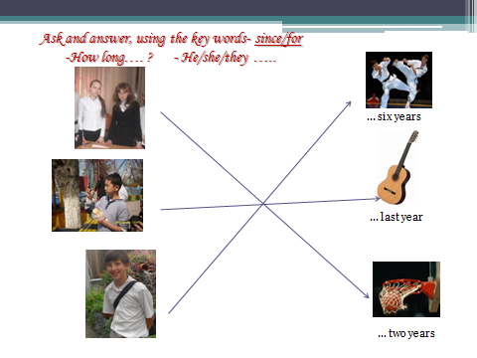
A pupil asks a question: -How long has Roma been going in for karate?
Another pupil answers:- He has been going in for karate for six years.
Repeat with other questions and answers.
- Comparison of The Present Perfect Tense and The Present Perfect Continuous Tense
Teacher asks the pupils- What`s the difference between these grammar tenses?
pupils answer what these tenses mean, how they are formed, name all key words.
- Practice of Grammar tenses
Tim ______(run) for an hour. He is training for the race.
I ______________(visit) France this summer.
We ___________(do) our homework all morning.
Ellie`s father is a driver. He _______(drive) lorries for 15 years.
Lucy is hot because she _________(sit) in the sun.
My younger brother _____just____(break) my mother`s favourite vase.
My dad`s hands are dirty because he _______(repair) his car for a long time.
Then check their answers using the activboard.

Before writing a computer test pupils should revise all present tenses
The Present Perfect Tense-completed actions-have/has+V3(ed)
The Present Perfect Continuous Tense-actions began in the past and continuing up to the present-have been/has been +Ving
The Present Simple Tense-habitual actions especially with frequency adverbs (always, sometimes, etc)-V1(s,es); do/does(-,?)
The Present Continuous Tense-actions happening at the moment of speaking-am/is/are+Ving

- Grammar Test. Today we have revised The Present Perfect Continuous Tense and other grammar tenses and now you will do a computer test with ten questions.
Pupils do the test and get their marks.
- Homework - WB p56 (to write a composition to your pen friend, using all present tenses)

