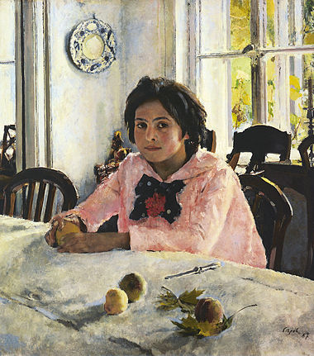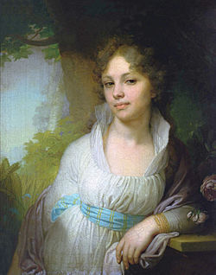

№1______________________________ №2________________________________

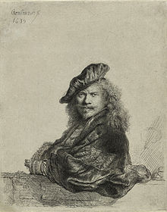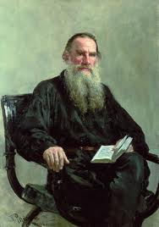

№3____________________________ №4 ______________________________

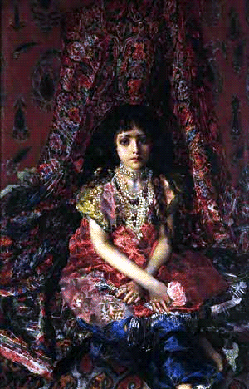

№5 __________________________