Приложение 1.

ИНТЕГРИРОВАННЫЙ УРОК АНГЛИЙСКИЙ ЯЗЫК + ГЕОГРАФИЯ
по теме: «Rossosh area: Is it interesting to visit?»
Форма занятия: Деловая игра “Пресс-конференция туристического агентства “Golden Apple”.
Оборудование:
- Мультимедийное сопровождение:
  - Презентации учащихся о достопримечательностях Россошанского района в программе Power Point на английском языке.
  - Презентация “ Ход конференции” с музыкальным сопровождением.
- Настенная карта Россошанского района с нанесёнными условными знаками туристическими маршрутами.
- Раздаточный материал:
  - Рекламные проспекты туристических маршрутов на английском языке.
  - Карточки для проведения рейтингового голосования;
  - Литература по географии и по географии Россошанского района.
- Визитные карточки участников занятия, флаги стран - участниц конференции.
- Подарки для участников
Задачи занятия:
Практические:
- совершенствовать навыки и умения монологической речи на английском языке по теме “Уникальные ландшафты Россошанского района”; уметь средствами английского языка рассказать жителям других стран о своей Родине.
- развивать навыки и умения пользования средствами ИКТ в поисках и обработке новых знаний по географии;
Развивающие:
- развивать умение выступить на публике;
- развивать речевой слух, внимание, образную память;
Воспитательные:
- воспитывать любовь к родному краю;
- воспитывать умение адекватно вести себя в ситуации “выступление на пресс-конференции”;

Общеобразовательные:
- привлечь внимание к особенностям природы Россошанского района;
- совершенствовать географическую грамотность учащихся.

ХОД КОНФЕРЕНЦИИ.

Dear Ladies and Gentlemen! We are glad to invite you to our conference. Today we get together to present the work of our travel agency “Golden apple”. The topic of our conference is Rossosh area: is it interesting to visit? We have produced some tours and we hope they’ll interest you.
(слайд с яблоками)
Песня «Вишневый край» (слайд цветущие вишни).
Russia is a very big and beautiful country and it has a plenty of exciting, wonderful places to visit. (Слайд «природа России»)
Today we’ll speak about Rossosh area as a heart of beautiful nature. And now I want our tour expert to present Rossosh area to our guests. Then the delegates of the mass media can ask him questions.
Rossosh area.
Welcome to Rossosh area. It is an area of apples, cherries and blooming gardens. Rossosh is situated in the south part of Voronezh region. It is on the trunk railway Moscow – Rostov.
Rossosh area is one of the most successful areas and today its agrarian sector occupies the leading position in our region.
The histjry of Rossosh area is rich and various; its present day is interesting and remarkable mostly by the kind actions of our citizens.
The name of our town according to the opinion of our students of local lore is connected with its position in a flood stage of two rivers. They are Rossosh and Chernaya Kalitva. Since 1923 Rossosh has been a centre of a district. And in 1923 Rossosh got a status of a town. Since that time every September our town has its birthday.
Rossosh is one of the industrial, educational and cultural areas in Voronezh region. Today our town is built and developed very actively.
Rossosh area is the biggest area in Voronezh region. Our town is the most industrial area. The main plant here is “Minudobrenia” corporation. The goods that are produced in our town and area occupy the highest positions in Voronezh region. On the territory of Rossosh there are 23 big industrial corporations. Today Rossosh grows, studies and works…
Thanks for your attention.
(вопросы СМИ)
Now, please your questions.

The magazine “World News”.
1) You said that the town is situated near the chemical plant; will you say if it might be dangerous for the inhabitants and tourist? Thank you.
Answer: It is not very dangerous, because our chemical plant is situated on the east of the town, but the main direction of the wind in our area is western.
2) The travel agency “Valencia”.
How do you value the tourist voltage of Rossosh area? What other places can we visit here? Thank you.
Answer: On the territory of our area there are a plenty of interesting nature objects. They are:
- Melovoy Bor near the village Karabut.
- A beautiful prairie near the village Stitsenkovo.
- The park in the Elenovka village. In the middle of the park there is Chertkov’s house, which was visited by Tolstoy and others.
It was the description of our area. And now our travel agents will present you some tours around the town.
The first tour is “The road to the temple”.
We’d like to suggest you one of our tours. This tour we named as “the road to the temple”. In Rossosh area there are 3 famous churches.
I’d like to start with the church that is situated in Zhilino village. This church is the monument of the history of culture. It was taken under the state protection of monuments and culture in Voronezh region.
The refectory and the bell tower of the church were built in 1801, but the patronal part of the church was built only in 1882.
The interior of the temple has an original composition of the 3 average windows of the refectory, which was divided with the help of pillars.
After the difendence of the village Zhilino in 1943 from Germen invaders the church was rehabilitated and opened for everybody.
In 1964 it was closed and then it was used as a pantry.
From of old in Rossosh there was Krestovozdvizhenskaya church. According to the legend the first church in Rossosh in honor of exaltation of the Holy and Vivifying Cross was built when Peter the Great was on the throne.
The real Krestovozdvizhenskaya church was built and hallowed in 1834, but finally the temple was decorated in 1843.
The real bell tower of Krestovozdvizhenskaya church, which was held away from the church on 65 steps, had 4 floors; its height is 82 arshins.
And finally we’ll visit St. Elius temple. Its birthday is on the 1st of August in 2006. This temple was built under “In memory of the past but with the belief in the future”.
The temple is a road to something light and clean. We can’t we can’t show it, it is in the soul of every person and it is appeared through our prayers. Olshanskiy as a president of the board of guardians helped to build this temple. St. Elius temple has its own Sunday school, where 80 pupils can study.
Thank you for your attention.
(вопросы СМИ)
Now, please your questions.
- The TV channel “Explorer”.
You have described the churches of your area. How do you think what role will they play in lives of inhabitants? Thank you.
Answer: I think they will contribute to the mental and moral education of young citizens. They’ll help to join people of all ages to Orthodox faith and culture.
- The travel agency “Valencia”.
Can you say were there any other churches on the territory of the area? Thank you.
Answer: Yes, there was St. Elius temple. It was situated near the communal grave number 277. But it was destroyed in the 30-s of the 20th century.
The next tour is “Altar places”.
I invite you to visit some altar places of our town.
Firstly we’ll visit the central communal grave number 277. It is buried here 3516 men, but we know only 595. In 1950 a high stone obelisk was constructed. By the 9th of May in 1993 the communal grave was reconstructed.
And now we are travelling to school number 25, where the communal grave number 278 is situated. It is buried here 623 men, but unfortunately we know only 16. After the Great Patriotic War teachers and those who worked and studied at school at that time established the bosoms of teachers and pupils who worked and studied at school during the war. There were the bosoms of heroes of the Soviet Union. They were Pismenniy and Ryabtsev and some others.
On the territory of our town there are some memorable symbols.
The first memorable symbol was devoted to the Острогожско- Россошанская operation during the Great Patriotic War. It was opened in 2003.
And now we’d like to show you the memorable bosom of Alekseev. One of the streets of our town got his name. He was given the rank of the hero of the Soviet Union. He was in the command of the operation to free our town from German invaders.
One more symbol. It is the symbol for those citizens, who died in the peacetime. The opening of the monument was in 1999.
The next memorable symbol is a tank. This symbol was set in honor of the tankmen, who had defended Rossosh during the Great Patriotic War.
(And we have one more symbol, which we’d like to show you. This symbol was set in honor of the railway workers, who were the participants of the Great Patriotic War. This monument is set on the territory of the engine-house. The memorable tablet has the inscription “And the rescued world remembers…”)
(вопросы СМИ)
Now, please your questions.
- The TV channel “Explorer”.
Is there something interesting that is connected with the Great Patriotic War? Thank you.
Answer: In our local museum we have an exposition that is devoted to the Great Patriotic War. It was made by our student of local lore Morozov. School number 25 has a museum of the Great Patriotic War.
- The TV channel “Travel”.
What other monuments of the Great Patriotic War are there in your area? Thank you.
Answer: In the village Novaya Kalitva there is a monument for the Italians, who died during the Great Patriotic War. It is Mironova Mountain. The memorial in Podgornoe village and some communal graves practically in every village.
And the last tour. We named it “Fruit world”.
We’d like to suggest you the most interesting and exciting tour. We named it “Fruit World”. And now we invite you to Rossosh zonal practiced station of gardening. It is a centre of scientific gardening in our region. Rossosh practiced station is famous in Russia with its wonderful sorts of fruit plantings were selected by Ul’yanischev. He was a doctor of agricultural science. Progenies and students continued his work. They selected a lot of different plantings by themselves. One of the streets of Podgornoe village got his name. Every year zonal practiced station produced about 300 tons of stone-fruit. They are cherries, peaches, plums and others; about 2000 tons of apples and pears, and about 500 tons of sprigs of fruit, berry-like and flowered decorative plantings.
(Вопросы СМИ)
Please, your questions.
- The magazine “National Geographic”.
Do you know what new projects are there in Rossosh zonal practiced station now? Thank you.
Answer: At present the worker of the zonal station execute the laying of new gardens of fruit trees. More than that, they continued the experience work on the nurture of new sorts.
Thanks our agents for the tour presentations.
Now I want you to vote for the tour you like most of all. On your tables you have sheets of paper with questions. It’s a questionnaire. (раздаются вопросники).
And now I’ll name the tour which is the best. It’s _________
Our congratulations to our travel agent ___________, who has presented this tour.
I want our director to say some words and give presents to our participants.
Well, our conference goes to its end. I want to thank all our participants and guests of the conference. Thank you for your great attention.(аплодисменты, звучит песня все расходятся.)

Приложение 2.

НАЦИОНАЛЬНАЯ ОБРАЗОВАТЕЛЬНАЯ ПРОГРАММА «ИНТЕЛЛЕКТУАЛЬНО-ТВОРЧЕСКИЙ ПОТЕНЦИАЛ РОССИИ»
НАЧАЛЬНАЯ ШКОЛА (ПРОЕКТ «ПОЗНАНИЕ И ТВОРЧЕСТВО»)
РОССИЙСКИЕ ОТКРЫТЫЕ ЗАОЧНЫЕ КОНКУРСЫ-ОЛИМПИАДЫ
2011/2012 УЧЕБНЫЙ ГОД ■ ЗАДАНИЯ ОСЕННЕГО ТУРА
НОМИНАЦИЯ «Эрудит» ▪ ДЛЯ УЧАЩИХСЯ 3 - 4 КЛАССОВ

Наш маленький Эрудит, при выполнении заданий не забывай пользоваться словариком английского языка.
Удачи!
Task 1. Read the text and answer the questions (8 points).
Reginald is a funny fluffy rabbit. He lives in the forest, in his cosy hole. He has a big family. He has a mother, a father and four brothers: Jim, George, Harry and Ron. However, they do not live with him because Reginald is grown-up. He is four years old and he likes to live alone.
Like any rabbit, Reginald eats a lot of cabbage and carrots. But he is really crazy about carrots. He eats one carrot every Sunday. On Mondays he eats three carrots, on Tuesday five carrots and so on.
1. On which day of the week does Reginald eat nine carrots?
2. How many carrots does he eat on Saturdays?
3. How many carrots does he eat every week?
4. Reginald and his brothers can eat five carrots in three minutes. How much time will his eighteen relatives need to eat 18 carrots?
to be grown-up – быть взрослым;
so on – и так далее;
How much time will … need … - сколько времени понадобится.
Task 2. The English words for ten animals are in the grid – broken into parts. Find the correct parts and assemble them. Десять названий животных разбиты по частям. Соберите правильно все части (10 points).
TOR CA ROT AL RAB
ON LI CHA ON DER
MEL GA TOISE LE RA
COB ME GA TOR PAR
SPI KAN LI BIT ROO
Task 3. Can you read and translate these two famous English proverbs (4 points)?
1. Afri endin needis afri endin deed.
2. .tsebsi emohts ew rot saE
Task 4. Какое слово нужно исключить из каждой группы?
Explain your choice (short, in Russian, 5 points).
1. Trumpet, flute, violin, harmonica, tuba.
2. Dog, goose, cat, sheep, cow.
3. Pliers, hammer, screwdriver, fork, drill.
4. Toaster, hair dryer, scissors, iron, mixer.
5. Tomato, strawberry, radish, cucumber, cherry.
Task 5. В каждой группе из семи слов подчеркни слово, которое является обобщающим для всех в группе и вычеркни лишнее слово, которое не подходит к ней (10 points).
Example: ant, fly, insect, butterfly, beetle, bee, snail
1) alligator, reptile, snake, frog, tortoise, lizard, crocodile;
2) chestnut, log, oak, plane, tree, pine, fir;
3) plum, melon, tomato, seed, grape, fruit, peach;
4) china, saucer, vase, napkin, jug, dish, teapot;
5) trout, whale, salmon, cod, tuna, fish.
Task 6. В названиях 12 песен некоторые слова были заменены на символы. Эти слова: HOW, WHAT, WHERE, WHO, WHY, AM, IS и ARE. Определите, какой символ соответствует каждому пропущенному слову, и напишите правильные названия песен (12 points).
1. ►○ LOVE?
2. ▲CAN'T WE LIVE TOGETHER?
3. ▼WEARS THESE SHOES?
4. □ DO YOUR HEART GO?
5. ► CAN I SAY?
6. ■ CAN I BE SURE?
7. ▼◄ I?
8. ▲ DON'T THEY UNDERSTAND?
9. ►○ A MAN?
10. □ DO WE GO FROM HERE?
11. ▼○ IT?
12. □ ● YOU NOW?
a. ■ = ….. e. ▼ = …..
b. □ = ….. f. ◄ = …..
c. ▲ = ….. g. ○ = …..
d. ► = ….. h. ● = …..
Task 7. Перед вами список из 12 выдуманных профессий. Соедините правильно первую и вторую части и запишите настоящие профессии (12 points).
For example:
“window operator” and “telephone cleaner” →
“window cleaner” and “telephone operator”.
1. computer dancer
2. hotel photographer
3. driving manager
4. newspaper singer
5. opera programmer
6. rock worker
7. film driver
8. aircraft director
9. ballet editor
10. construction instructor
11. lorry musician
12. wedding technician
Task 8. Замените род подчеркнутых слов на противоположный (10 points).
F.e.: “What time is it?” she asks.
“What time is it?” he asks.
1. She is a cute girl.
2. “What a nice princess she is!” he thinks.
3. “My mother is a perfect wife.” Jack said.
4. Her sister comes today.
5. Lions live in a pride.
6. My uncle is a waiter.
Task 9. Пройдет еще немного времени, и космические путешествия станут обыденным делом. Каждый человек сможет добираться до самых отдаленных планет нашей Галактики за считанные часы. Будут ходить космические автобусы, такси. И, вполне вероятно, будет день, когда мы столкнемся с инопланетными цивилизациями. Представьте, что вы капитан космического корабля, который был первым, кто встретил инопланетянина. В мире вы становитесь сенсацией! Огромное количество журналистов стремятся взять у вас интервью. И у каждого вопрос: как выглядит инопланетная форма жизни? Вам надо подробно описать ее, начиная с формы тела, и заканчивая цветом глаз. Целая планета ждет ваш рассказ! (30 points, рисунки приветствуются).
Уважаемые участники! Проанализируйте итоги своей работы. Что далось легко, что понравилось, а где пришлось подумать и поработать? Что для вас было нового, а какой материал вам удалось повторить? Ждем ваши отзывы и предложения по нашему конкурсу. Оргкомитет

Приложение 3.

Эссе на тему «Как я вижу своё будущее?» выполнила Казначеева Анастасия 10 класс.
“HOW DO I SEE MY FUTURE?”
Many people believe that in the nearest future they’ll live better. Dreaming about the future is normally for a child and for an adult. Everybody has plans for the future; everybody dreams of having a life one or few steps ahead of how they live in the present.
To begin with, I would focus on my plans for the future. I’m a student of the 10th form. And my childhood will last only two years, and then I’ll start an adult life. Next year it will be my last year at school. First and foremost I should make a decision what to do by the end of the last year at school. There are many alternatives – either to continue my education at a high school or to go to a college, or probably start working. I think I would choose to go on with the education and would go to high school later on.
Besides, I, as an average living person, am dreaming of putting myself on a higher level when I grow older. We live in a world in which fame and money are on the first place. So, all of us wish to have a better future and a big hope that our dreams will be coming true. But that depends on how we lead our life through.
For me, I want to be a successful designer, following my aunt’s steps. She tries for everything in life by herself. I like to decorate and furnish everything beautifully at home. I would like to visit fashionable cities in the world: Paris or Milan, for example. There are a lot of beautiful places and museums there. But it is quiet easy to dream, isn’t it? And how can I obtain those is totally the question. I could answer my own question by saying that I’ll work hard to obtain my plans for the future. I know I’ll study in Voronezh. Doubtless after graduating from the university I’d like to have a family, a two-storied house. But firstly I want to get a well-paid job or to have my own business, (I’d like to have my own café or a hotel), in order to have financial independence. And then it’ll be the time to have a family: a loving husband and children three boys and a girl.
To sum everything up I can never tell if I can execute those plans that I have. It does not depend on me only, but there are lots of factors that surely will affect my plans. Nobody can tell the future, no matter how I work hard today. I can’t even say if my dreaming for the future still be alive tomorrow or the day after tomorrow. But I like my life and I believe I can realize all my plans!

Приложение 4.
Фотогалерея
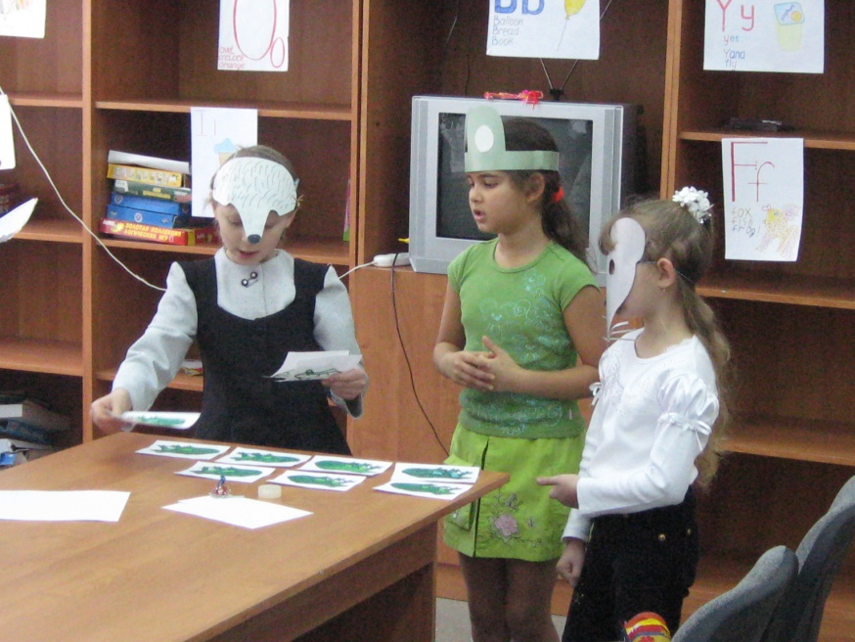
Сказка «The house in the wood»
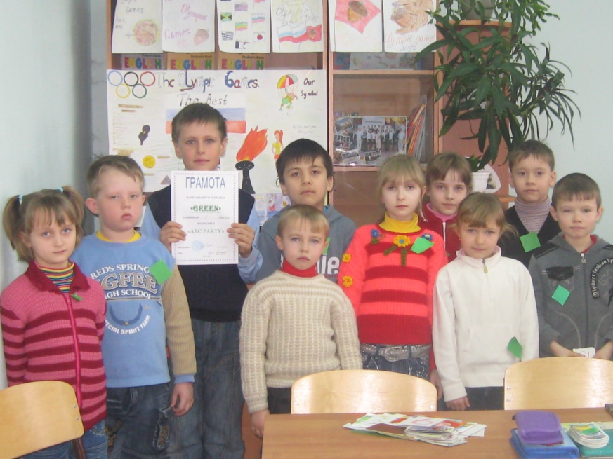
Викторина «Do you know English well?»
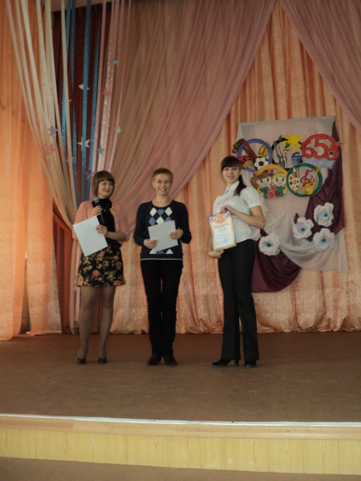
«Одаренные дети» Клуб лингвистов – Хохлачева Виктория – 1 место

