Приложение 2.

Задание для группы 1.

Read the dictionary entry and match the definitions 1 – 6 with their Russian equivalents
a – f below:

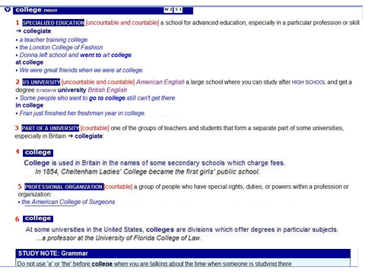

a) факультет
b) училище, техникум
c) коллегия
d) университет
e) профильный университет
f) название частной школы, лицея, гимназии

Задание для группы 2.

Read the text and complete the column about the USA. Then add information about Russia.
In the United States, the approach varies from state to state. Most of the vocational courses are offered by community colleges. Historically, high schools have offered some vocational courses, such as home economics, typing, and auto repair, though schools have put more emphasis on academic subjects for all students because of educational reform standards.
Most colleges operate under a policy of “open admission”. This means that anyone with a high school diploma may attend, regardless of prior academic status or college entrance exam scores.
The “open admission” policy results in a wide range of students attending college classes. Students range in age from teenagers to working adults who are taking night classes to complete a degree or gain additional skills in their field. There are also students with graduate degrees who enrol to become more employable or to pursue lifelong interests.
The first type of study is to get an associate’s degree, in which a student earns the qualification after a two-year course. This degree coincides with jobs that require some level of college education but not a full four-year degree. The associate’s degree programme is also for students who are planning to obtain a bachelor’s degree at a four-year college. It allows them to complete the necessary “core” requirements before they enter the four-year college.
The second type of study provides certification in an area of training to become, for example, a computer repairperson, a medical technician, or a translator. Such certification allows for better job opportunities in many areas, as well as hiring preference or higher salary status when entering the workplace.
The largest and the most unified system of vocational education was created in Russia in the second half of the 20th century with the so-called Professional’notehnicheskoye uchilische and Tehnikum.
Vocational education is still an important part of the education system in Russia. A vocational qualification from Russia is generally recognized in the other states in Eastern Europe . . .

 | The USA | Russia
1. Where can you get a vocational education?

2. Are there any entrance exams?

3. What are the minimum entrance requirements?

4. Who studies there?

5. How long is the course?

6. What qualifications (degrees) are given at the end of the course?

Задание для группы 3.

Write down the advantages of studying at a vocational college or university.
University | Vocational college
- gives more prestigious qualification | - is easier to enter

