FAMOUS PEOPLE
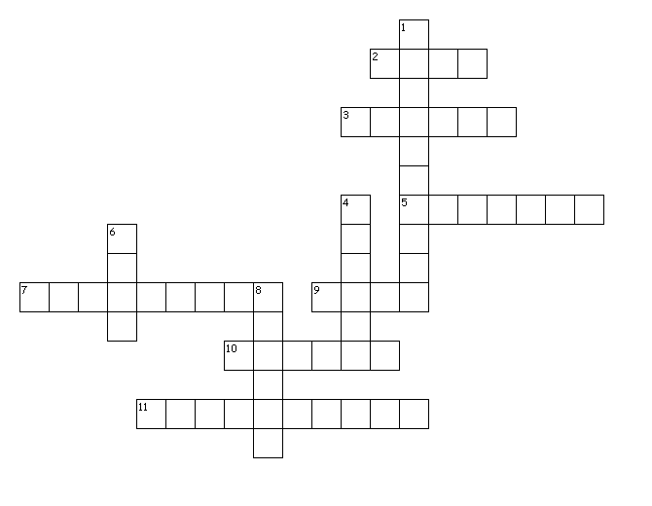
Across

2. In this museum the history and magic of cinema and TV is explained. The visitors can select a film to watch, or even draw their own cartoon film.
3. Mark Twain, the famous American ......, was well-known as a lecturer.
5. The writer was born in the 19th ….
7. Charles Darwin was famous for his theory of evolution and he is an outstanding.... .
9. This writer was ..... in 1892.
10. The pictures of this ........ are very popular.
11. An English poet and playwright. He is often called England's national poet and the "Bard of Avon" .One of his famous plays is "Romeo and Juliet"

Down
1. Sir Winston Churchill was a famous ….... .
4. John R.R. Tolkien is ...... for his books.
6. A.S.Pushkin is a favourite ...... of many people around the world.
8. A master of water-colours.
Created by Puzzlemaker at DiscoveryEducation.com

FAMOUS PEOPLE

Across

2. In this museum the history and magic of cinema and TV is explained. The visitors can select a film to watch, or even draw their own cartoon film.
3. Mark Twain, the famous American ......, was well-known as a lecturer.
5. The writer was born in the 19th ….
7. Charles Darwin was famous for his theory of evolution and he is an outstanding.... .
9. This writer was ..... in 1892.
10. The pictures of this ........ are very popular.
11. An English poet and playwright. He is often called England's national poet and the "Bard of Avon" .One of his famous plays is "Romeo and Juliet"

Down
1. Sir Winston Churchill was a famous ….... .
4. John R.R. Tolkien is ...... for his books.
6. A.S.Pushkin is a favourite ...... of many people around the world.
8. A master of water-colours.

Created by Puzzlemaker at DiscoveryEducation.com
