№1 Ingredients
3 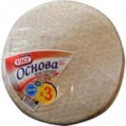 three bases
200gr. two hundred grams of sausage
1 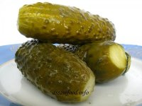 one salted cucumber
200gr. 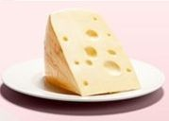 ________________________________
2 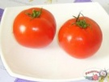 ________________________________
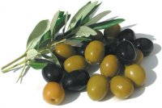 olives
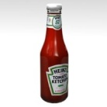 mayonnaise and ketchup
__________________________________________________________
- Take _________ and put some ________________________________ on it.
- ___________ some _________.
- 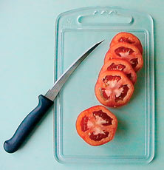 __________ ____________, _________, _________ and __________.
- Put everything on the ___________.
- 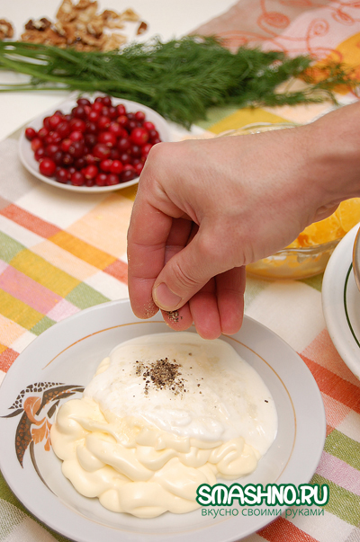 ___________ the _________ over it.
- 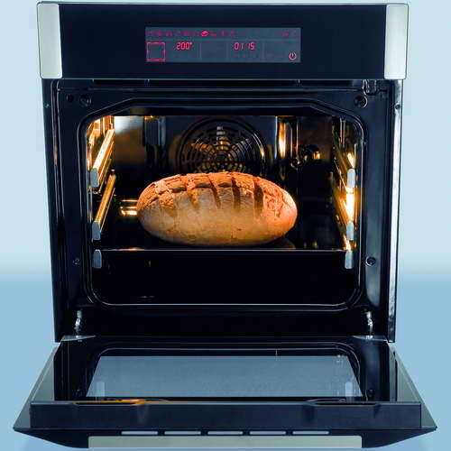 ___________ it for 15 min.
№2 Ingredients
500 gr. 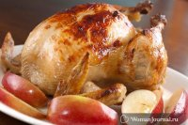 five hundred grams of ____________
2 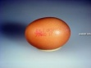 ______________________________
150 gr. ______________________________
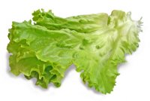 ______________________________
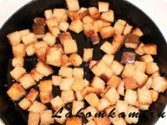 dried crust
mayonnaise
__________________________________________________________
- 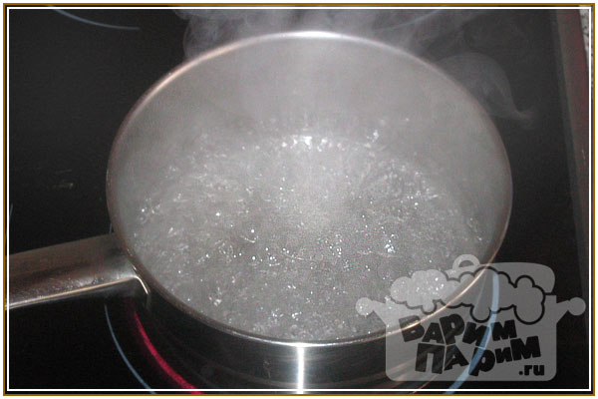 ______ the ________ and 2 _______
- _______ them.
- ___________ some _________.
- _______ the __________.
- 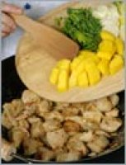 _______ ____________ .
- _______ _______________.
- 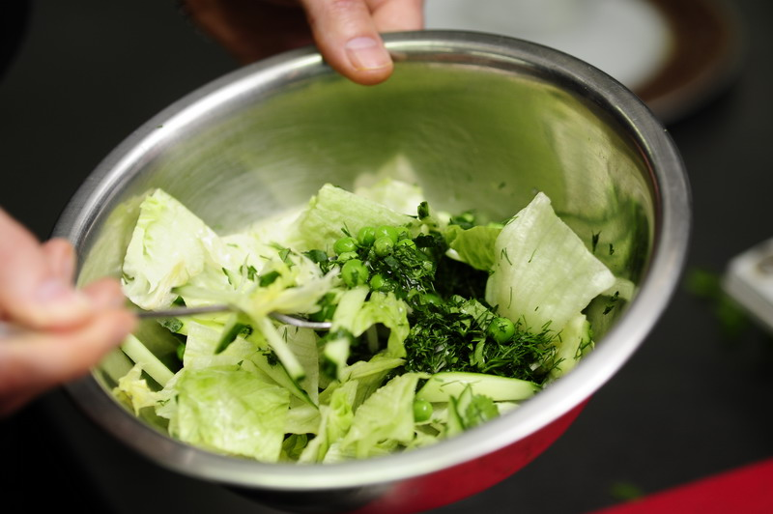 _________ everything.
№3 Ingredients
3 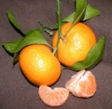 three mandarins
2 ______________________________
2 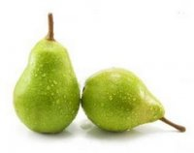 two pears
200 gr. 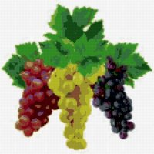 two hundred grams of ___________
2 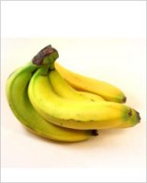 ______________________________
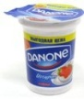 ______________________________

__________________________________________________________
- 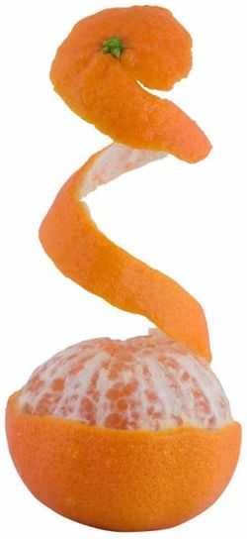______ ______, ____ and ______.
- _______ them.
- _______ __________ and ________.
- _______ some ____________ .
- _________ everything.

