Приложение 2

Группа 1. Освещениесобытияпорадио

RADIO
We continue our broadcasting and now some news about accidents on the roads in our town.
There was an accident on the road not far from a country pub. A car with 3 people inside crashed and burst into flames. Liz Pursey with her friend Neil helped people to get out. The police presented them with certificates for bravery.
So be careful while travelling on the roads.
And now the weather forecast for today…

Группа 2. Освещениесобытиявгазете

Picture Story from Place of Accident
Рисунок2.A 32-year-old Neil Blacky was a witness of an accident on the road. Together with his friend Liz Pursey he rescued 3 people from a burning car. He kindly agreed to give us the photos which he had made at the moment of an accident.
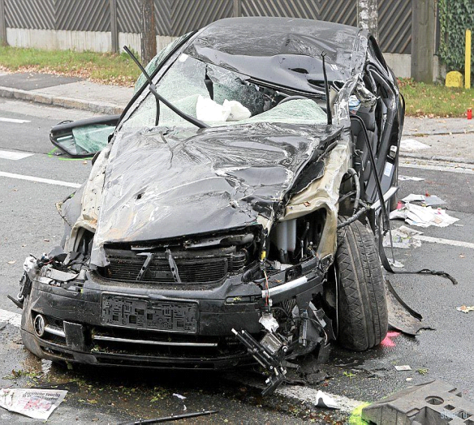
Рисунок 3.A car with 3 people inside crashed and burst into flames
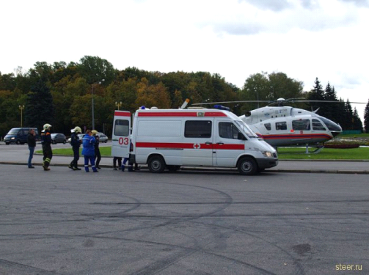
Рисунок 4.People from a nearby campsite call the emergency services.
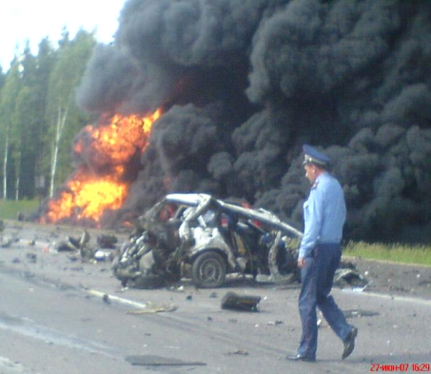
Рисунок 5.The police examine the witnesses.
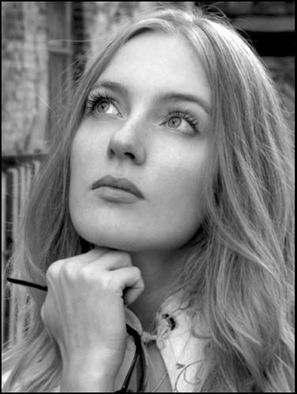
Рисунок 6.Liz Pursey in a state of shock.

Группа 3. Освещение события по телевидению.

Передача “Пусть говорят”

LetThemTalk
Presenter:Hello! Today in our weekly programme "Let them talk" we are discussing true life stories, and our guest is LisPursey. Welcome Liz!
Liz: Hello!
Presenter:Liz is an English woman from London. She rescued 3 people from a burning car! How did it happen, Liz?
Liz: Well, last Sunday I went home with my friend Neil. It was evening. Suddenly, a car drove past us out of control. It crashed and burst into flames. There were 3 people inside. We got them out.
Presenter: Wow! But you were not alone, aren't you? You were with your friend Neil. He must act first, he is a man. Was he frightened?
Liz: I think, nobody knows how he or she will behave in any situation. Maybe he was in a shock.
Presenter:OK, we invited Neil to our studio!
Neil: I'm very surprised listening to your story, Liz. We did everything together. Just imagine, how could a woman get 3 people out of a burning car alone? As for me, I don't think I did anything extraordinary. It was just really unexpected for me to see your photo in a magazine.
Presenter:To explain the situation we invited the editor of the magazine!
Editor: Hello. I'm an editor of a so-called women's magazine. It's a sensationalist story very typical of such publications. Readers of these magazines are encouraged to send in their own experiences and they get a prize if they are published.
Presenter:WOOHOO it’s so hot here! Now we are interrupting for some advertisement, and after it 3 saved people will appear in our studio. Don’tturnoverourchannel!

Группа 4. Освещение события через Интернет.

Презентация 3
Слайд 1.In the Internet we can find not only the event we are interested in but a lot of additional information, for example gossips about private life of the characters. The Internet could interpret this event in the following way.
Cлайд 2.You see 3 topics in local news:
-Local heroes;
-Accidents on the roads;
-True life drama.

Слайд 3. Let’s click “Local heroes”. You see an interview with Liz Pursey’s student who speaks about her traits of character.

Слайд 4. Click “Accidents on the roads”. You will learn facts and details of this accident.

Слайд 5.Click “True life drama” and you will find information about the relations between Liz and Neil after the accident.
After reading these articles you will know not only facts but the opinions of different people, a lot of rubbish and gossips. Be careful!

