Приложение 1 раздаточный материал для учащихся
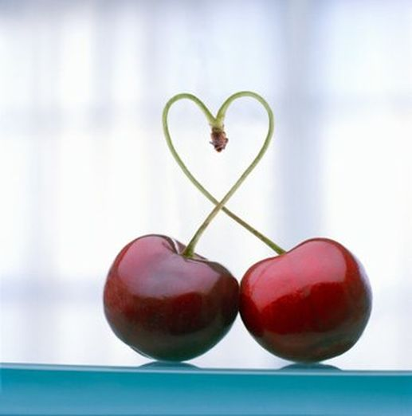

Part I: Say a fact about you:
Ex: Hi! I’m Nika. I am kind and clever. What about you?

Class survey: Make a question and ask everybody in your class. Write down answers.
Ex: Hello. What’s your favourite food?- My favourite food is chicken
My question: _____________________________________________________________________________________?

Name | Answer

Now say about your classmates
Ex. His\her favourite animal is a dog

Part II: Vocabulary and grammar
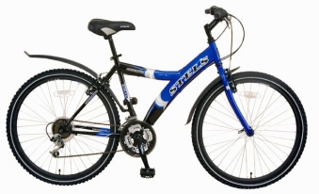
Remember!
I like riding my bike
We love singing songs
I hate eating bananas

Things to do
listening to music | going to the theatre
riding a bike | taking pictures
watching films | cooking
playing the piano | sitting in the Internet
playing computer games | going for a walk
dancing | getting up at 7 o’clock
going shopping | speaking on the phone
studying | eating sushi

Write down 3 things that you like and hate
I love __________________________  I like ___________________________  I like ___________________________ | I hate ______________________________  I hate ______________________________  I hate ______________________________

Now ask your partner and write 3 things that you like in common
Ex. Do you like singing? – Yes, I do. \No, I don’t
- _____________________________________
- _____________________________________
- _____________________________________

Part III. Listening
Listen and match the famous people and the things that they love or hate
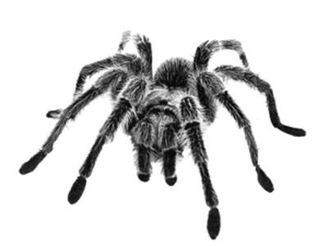
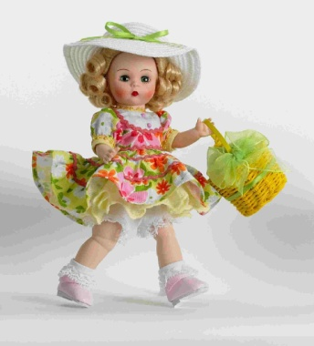
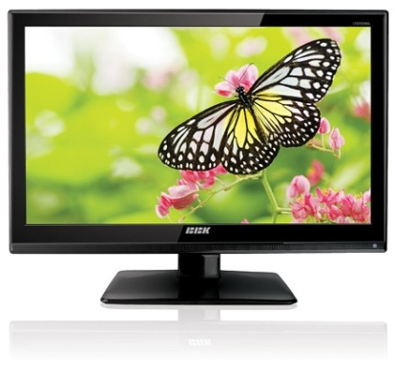

Part IV: Creating and speaking
Now draw a funny man and describe it

His name is _________________. He is ___________________.
His favourite ___________ is ______________.
He likes ______________ and ___________________.
He loves ________________!
He hates ________________.

