Memory game.
Look at the picture of a living room for two minutes. Then close the picture and write what there is in the picture.

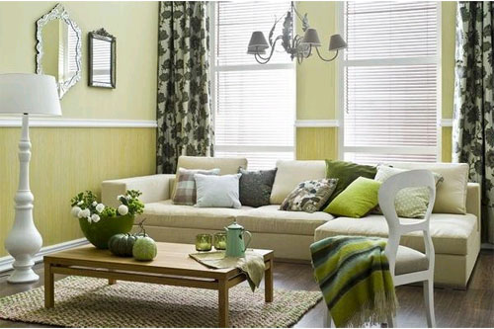

Возможные ответы:
- Two mirrors
- Two lamps
- A carpet
- A table
- A vase
- Flowers
- Two pumpkins
- A coffee pot
- Two glasses
- A table mat
- A chair
- A scarf
- A sofa
- Pillows
- Two windows
16.curtains

