And now we will put our smiles to that place in our poster which shows the future of two our languages.
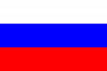  Russian without English | English instead of Russian | 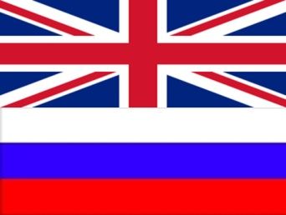  Russian and English together

