Приложение 1

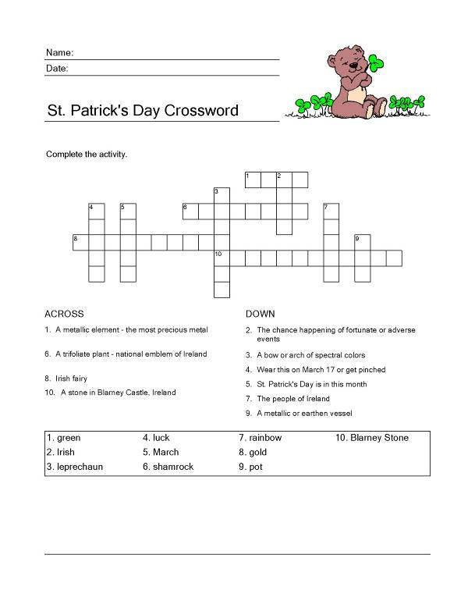
Приложение 2

St. Patrick's Day
St. Patrick's Day is here, you see.
We'll pick some shamrocks, one, two, three.
We'll count the leaves and look them over,
And maybe find a four-leafed clover.
I'll sew green buttons on my vest,
Green for St. Patrick is the best.
I'll wear a green hat, very high,
And dance a jig--at least I'll try!

I'll Wear a Shamrock
St. Patrick's Day is with us,
The day when all that's seen
To right and left and everywhere
Is green, green, green!
And Irish tunes they whistle
And Irish songs they sing,
To-day each Irish lad walks out
As proud as any king.
I'll wear a four-leaf shamrock
In my coat, the glad day through,
For my father and mother are Irish
And I am Irish too!

The Wearin' O' the Green
Today is the day fer the wearin' o' the green.
Today is the day when the little people are seen.
Today is St. Patrick's Day, so if ye'r Irish me lad,
Join the celebratin' fer the grandest time ta' be had.
Ya' put yer hand up in the air, the other hand on your hip.
Ya' tap yer toe, ya' tap yer heel, ya' bounce yer knee a wee bit.
Ya' prance 'n dance around the room, n' circle one two three.
The saints be praised, I must admit, ya' all look Irish ta' me.

