Appendix 1.
Vocabulary

Types of schools & school life

1. Match the types of schools (1-6) to the descriptions (A-F). Which are the most common/uncommon in your country? What type of school do you go to?

1 boarding school | 4 state school
2 single-sex school | 5 private school
3 co-educational school | 6 specialist school

A A school for boys and girls.
B A school you usually have to pay to go to.
C A school students go to for a particular reason (e.g. to become actors).
D A school for only boys or only girls.
E A school owned by the government.
F A school which students live in during school term.

2. Read the following statements. Which ones are true for your school?
- Students wear a school uniform.
- There are lots of rules.
- Facilities and equipment are good (e.g. libraries, science labs, sports equipment).
- The teachers are strict.
- Students are motivated.
- There is a selection of unusual subjects to choose from.
- Students sit a lot of exams.
- Most students take part in extra-curricular activities (e.g. drama, sports).
- Students get a lot of homework.
- Most students live nearby.

Appendix 2.

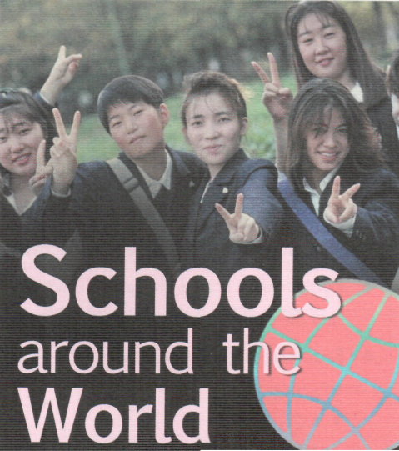 | Do you look forward 1) … going to  school or do you absolutely dread it? Or,  perhaps you'd prefer to go to school  somewhere else! This week, Go\  magazine takes a look at how schools are  different 2) … the world.
There are many types of schools in the world. Some are expensive, private boarding schools, like Rugby School in England where the game of rugb A'as invented! There are also some specialist schools, like drama schools, dance schools or the 40 acrobatic schools in Wuqiao, China. It might sound like fun, but, as 13-year-old Zhang Li explains, "Our training starts at 5:30 am. It's very hard, but these skills will help me 3) … a living when I leave." There are also a wide range of school subjects at different schools. At Holden High School in the USA, subjects include comic book art, photography, song writing and yoga.

At a school in the Annapurna mountains in Nepal, classes don't start until 10 am because a lot of students have to walk for about an hour to get there. In Japan, it isn't unusual for students to 4) … two hours or more getting to school on public transport. "It's not so bad," says 15-year-old Keiko from Tokyo. "I sometimes sleep or study on the train, and it's a great way to catch 5) … with my friends."
The average school day in the UK and the US is 6.5 hours for high school students. Students in Korea and Greece, 6) … are not so lucky! After school they attend extra classes in private schools. "On a typical day," says Jie Kim from Seoul, South Korea, "I don't get home until midnight, but if I don't study hard, I won't 7)… into a good university."

All schools have rules, but sometimes they are really strict At Eton College, a very famous boys' boarding school in England, the students have a smart but very old-fashioned uniform with a long jacket, trousers and shirt. In Japan, everyone has to participate in 'o soji', or the cleaning of the school, before they go home, whereas at Summerhill School in England, it's the students who 8) … the rules!
So, is your school better or worse than schools in other parts of the world? No matter what your answer is, we shouldn't forget that 30C million children in the world don't have any schools to go to. So even if you'd like to change some things about your school, you really are one of the lucky ones!
Choose the best word (A, B, C or D) for each gap (1-8).
- A in B from C at D to
- A over B around C from D across
- A win B get C take D earn
- A pass B take C spend D be
- A up B on C from D together
- A therefore B however C moreover D thus
- A get B be C go D apply
- A put B say C make D give
Listen and check.

Appendix 3.

Listening

t|} Two people are talking about the schools they went to - a traditional British public school* and an alternative school in the USA. Read the Strategies and prepare three questions.
* In Britain, a public school is, in fact, a private independent school.
Listen again and complete the table.
 | UK Boarding School | US Alternative School
Location and size | dty, 700 students | forett, 60 students
Facilities
Learning
After-school activities
Discipline

Tapescript

Man: Well, I went to a traditional British public school. I left four years ago. The school is in the city. It has about 700 students, and it's mostly a boarding school. There are lots of facilities for sport -tennis courts, swimming pool, that sort of thing. There are also good science laboratories and lots of computers. The classes are small, so if you fall behind with your work the teacher will go over it with you. It may have changed now, but we did a lot of subjects and we even had lessons on Saturday mornings! We had some free afternoons when we could get together. They gave us lots of homework and we had tests all the time. I remember that after-school clubs were quite popular. I was in a drama club - we once put on a performance of Hamlet - and I also set up a school radio station! There were lots of rules and discipline was strict. We could only go out of the school at certain times, and we had to wear a uniform. I didn't get into trouble very often, but one of my friends did. He got lots of punishments - he wasn't allowed to go out at the weekend, and once he was sent home for three weeks.
Woman: My school was very different from most schools. It was in a lovely old house in a forest. There were only sixty pupils. There weren't many facilities, but there was a good library if you wanted to look up information or catch up with your work. You won't believe this, but we didn't have to go to lessons! And there was no homework or tests, or anything like that. We could do what we wanted - if we felt like it, we could play all day. If we wanted to study, we just went to the teachers and asked them to help us. At first, I did nothing, I put off studying for weeks! Then I got interested in science and computers, and I studied science with a teacher who I got on with. I liked it so much that now I'm studying engineering at university and I want to go on to do further research. There were lots of other activities at school you could take up if you wanted - sport, painting and acting. I guess the best thing was that we were free, and the school was democratic. Everything was decided at school meetings, and everyone could vote - each student had the same vote as the teachers. We decided all kinds of things - we even selected the teachers! And discipline, well, we all decided on rules and punishments when one of us did something wrong. A lot of people don't believe me, but it worked really well.

