Приложение 1

Рис 1

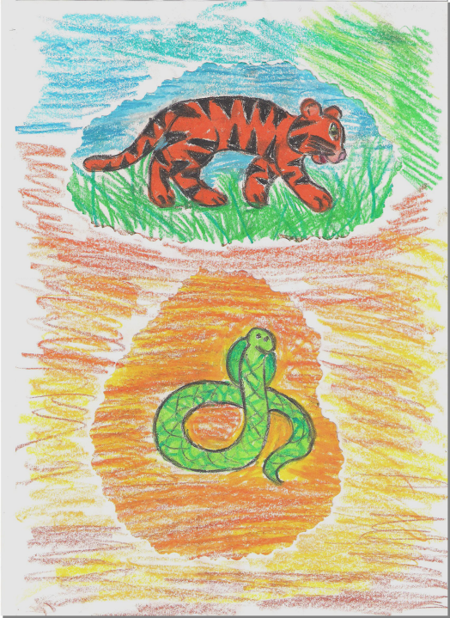

Who is big?

Tell me, please,
Who is big?
Who is long?
Who is strong?

The tiger is big.
The cobra is long.
They both are strong.
Am I wrong?

Рис 2
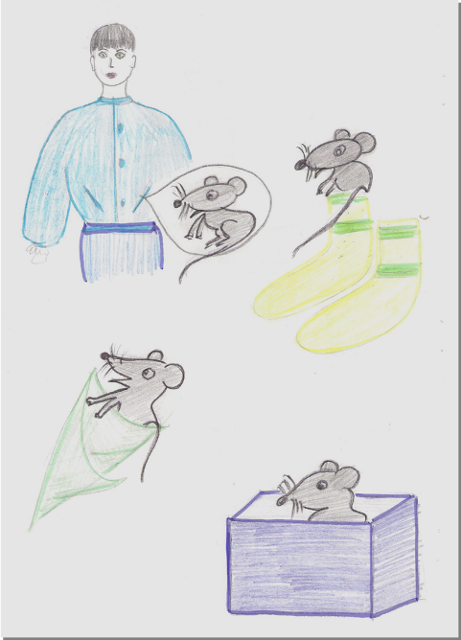

To Australia with a pet

Tell me, please,
How will you get
To Australia
With a pet?

Will you take it in your pocket?
Will you take it in your socks?
Will you take it in a parcel?
Will you put it in your box?

Рис 3
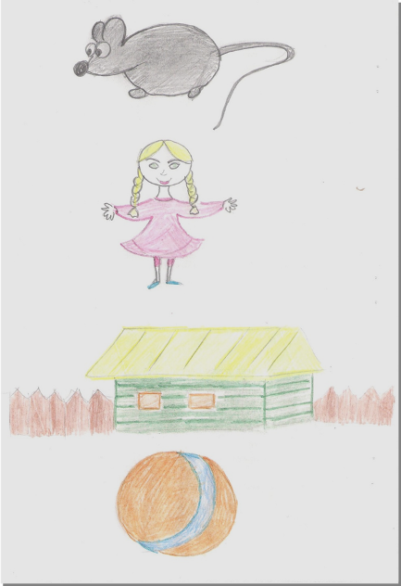

Is it a mouse?

Is it a mouse?
Is it a doll?
Is it a house?
Is it a ball?

Рис 4
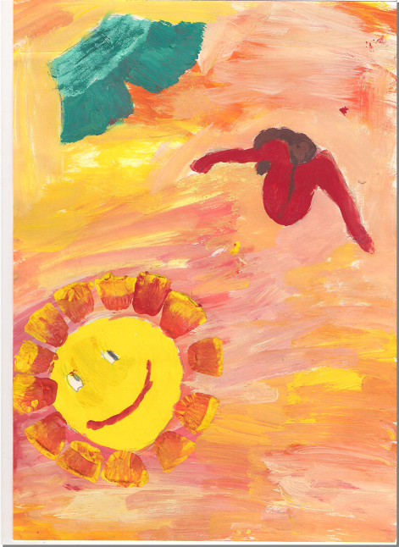

What must be short?

What must be short?
Your shorts must be short!
What must be warm?
Your jumper must be warm!
What must be bright?
Your smile must be bright!
What must be good?
Your mood must be good!

Рис 5
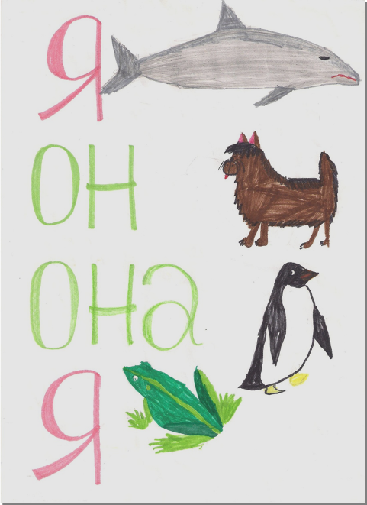

Have I got a dolphin?

Have I got a dolphin?
Has he got a dog?
Has she got a penguin?
Have I got a frog?

Рис 6
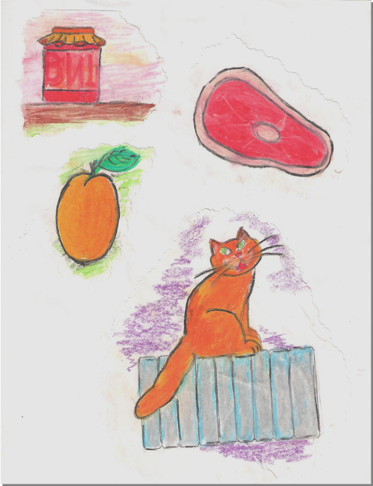

Can you eat your jam with bacon?

Can you eat your jam with bacon?
Can you play with an apricot?
Can you sleep on a radiator?
My cat can, but I cannot!

Рис 7
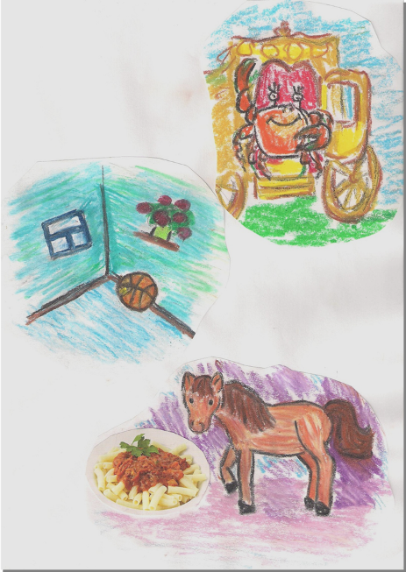

Who is riding in the cab?

Who is riding in the cab?
A crab.
Who is jumping in the hall?
A ball.
Who isn’t eating macaroni?
A pony.

Рис 8
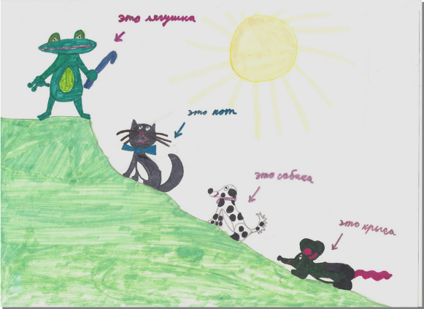

Is it a frog?

Is it a frog?
Is it a cat?
Is it a dog?
Is it a rat?

Рис 9
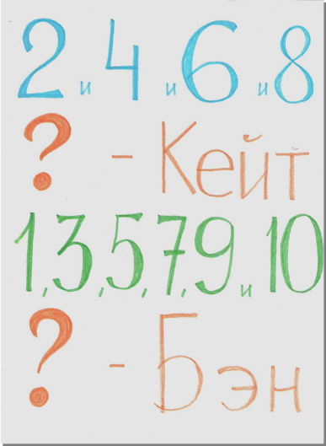

What’s your name?

2 and 4 and 6 and 8.
What’s your name?
My name is Kate.

1, 3, 5, 7, 9 and 10.
What’s your name?
My name is Ben.

Рис 10
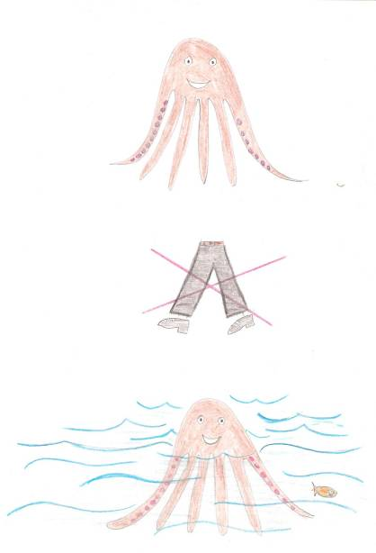

Why do you swim?

– Octopus, Octopus,
Why do you swim?
– I have legs, but cannot walk,
That’s why I swim.

