Pupil’s work sheet.
Name_____________________________________________________________
Surname___________________________________________________________
Form______________________________________________________________
1. Find some of London sights in the table. Add necessary word.

R | W | A | O | H | E | M | Q | E | N
S | E | P | L | O | Y | E | E | V | B
T | S | B | I | G | B | E | N | O | M
V | T | U | S | S | A | U | D | S | L
K | M | C | K | Y | T | K | G | R | O
L | I | K | N | M | E | K | M | O | T
O | N | I | M | H | D | X | C | T | G
T | S | N | W | I | N | D | S | O | R
R | T | G | R | E | N | P | A | W | H
D | E | H | W | A | H | Y | D | E | O
T | R | A | F | A | L | G | A | R | T
Z | E | M | N | Y | O | K | N | K | Y
________________________________________________________________________________________________________________________________________________________________________________________________________________________________________________________________________
2. Вы услышите 5 описаний достопримечательностей Лондона. Установите соответствие между описаниями 1 – 5 и картинками, данными в списке A – F. Используйте каждую картинку, обозначенную буквой, только один раз. В задании есть одна лишняя картинка. Вы услышите описания дважды. Занесите свои ответы в таблицу.
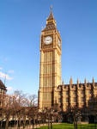
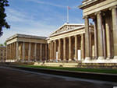
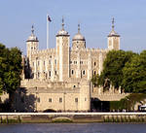
A B C

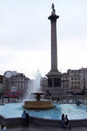
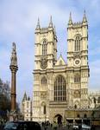
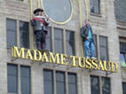
D E F

1. | 2. | 3. | 4. | 5.
3. Read the text “St. Paul’ Cathedral”. Try to predict what kind of information you will get.
Tick your predictions.
- the geographical position of St. Paul’s Cathedral
- the architect of the cathedral
- when the cathedral was built
- what tourists can see inside the cathedral
- how long and high the cathedral is
St. Paul’s Cathedral is one of the symbols of London. A great English architect Sir Christopher Wren built it. He designed many churches across England but St. Paul’s Cathedral is his masterpiece. It took Christopher Wren 35 years to build it. The work was completed in 1710. The cathedral is 175 m long and 111 m high. The interior of the cathedral is beautiful. There are a lot of mosaic decorations. St. Paul’s Cathedral is famous for the Whispering Gallery. It has unique acoustic. If you whisper anything on one side of the gallery, your words will be heard very clearly on the other side. To get to the gallery we will have to climb 263 steps. If you are not tired and ready to climb another 118 steps, you will be able to stand outside the Dome and enjoy a fantastic view over London.
St. Paul’s Cathedral is a place for many state ceremonies. Every year a special service is held on the occasion of the Monarch’s birthday.
masterpiece - шедевр
Whispering Gallery- Галерея шепота
аcoustiс - акустика
Dome - купол
service – служба

1) Answer the questions.

- Who built St. Paul’s Cathedral?___________________________________
- Christopher Wren was a famous architect, wasn’t he?__________________
- How long and high is the cathedral?________________________________
- What can tourists see inside the cathedral?___________________________
- Why is it worth climbing to the Dome?______________________________
- What is the Whispering Gallery famous for?_______________________________________________________________________________________________________________________

2) Complete the sentences.

- After looking around the cathedral you can climb … and … the Whispering Gallery.
- In 1710 the Cathedral was …
- You can see a lot of beautiful … inside the cathedral.
- St. Paul’s Cathedral is one of the …
- Every year a special service is held …

