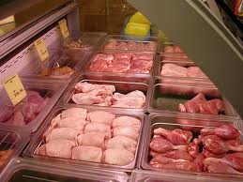 butcher’s
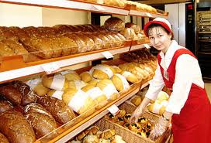 baker’s
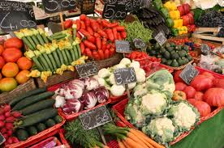 greengrocer’s
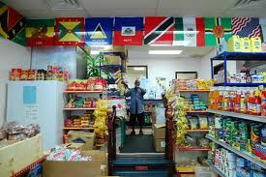 grocer’s
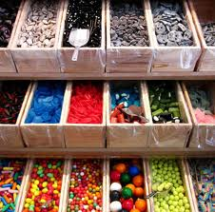 sweet shop
Fruit and vegetables

Cakes and biscuits

Sweets

Lemonade, juice, crisps
Meat, sausages

It would be good to take…
It‘s nice if we take…
It would be fantastic if we take…

If you want to look smart, you should wear…
You will look wonderful if you put on…
You will look pretty in….

A dress trainers
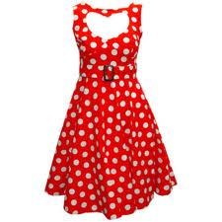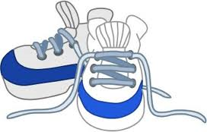

Shorts a T-shirt
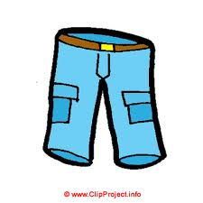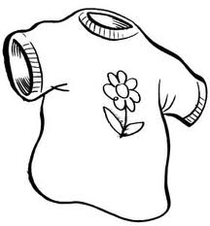
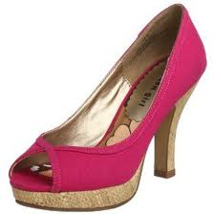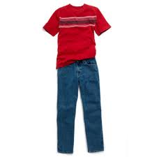
High-heeled shoes jeans

A shirt flip-flops
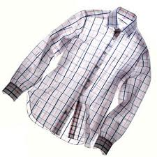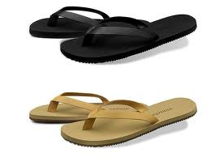
A coat a sombrero
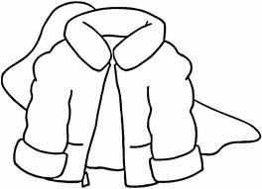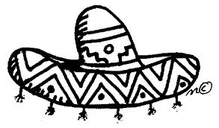
A skirt a tracksuit
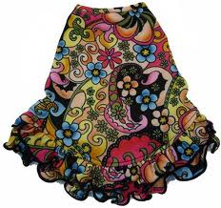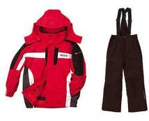

Costumes for a fancy-dress party
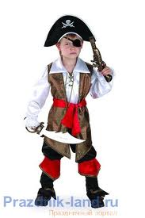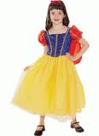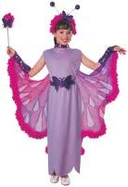
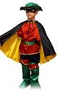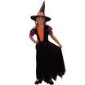
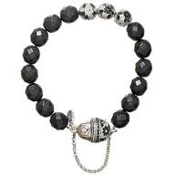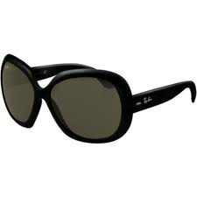
A necklace sunglasses

A bow-tie a tie
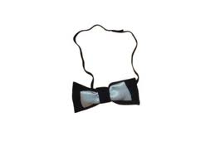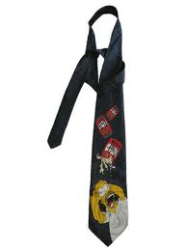
A suit

balloons
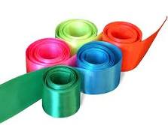ribbons
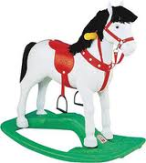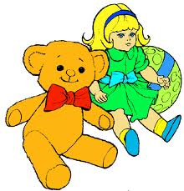toys
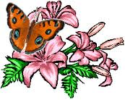flowers

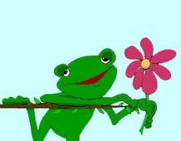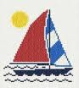pictures

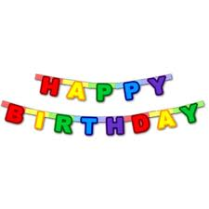banners

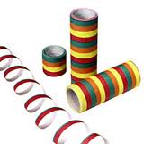streamers

Listen to The Shopping Song and fill in the gaps:-

Take a look all around.
Here are some shops that I found.
There are different shops in every 1. ___________ ,
And you can buy everything there.

There are little shops
And 2. __________ shops
And 3. ______________
Selling all you need;

Food to eat and clothes to 4._______
Or books and papers,
5. _____________ to read.

Say what you need to buy.
It may be on a 6.__________ up high.
Grown-ups meet and 7.__________ and babies cry,
And you can buy everything there.

There’s a 8. ___________ shop with bread and cakes;
A 9.________ shop with some fashion for your feet.
The shop with all the games and toys,
And next door there’s a shop that’s full of 10._________.

Take a look all around.
Here are some shops that I found.
There are different shops in every town,
And you can buy everything there.

Invitations
Dear Lena,
You are invited to my birthday party
On Fri 22 Oct at 17:00
My address is 44, Mitinskaya Str., Flat 55
Hope to see you there!
Victoria

A party is brewing
And you’re invited!
I’ll be happy to see you at my
Birthday party
At “Capri” café
On Fri 22 Oct at 5 o’clock
At 34, Baryshiha Str.
Victoria

Shopping
1.You should buy ………………………………..
at the butcher’s.
2.You should buy…………………………………
at the baker’s.
3.You should buy………………………………….
at the grocer’s.
4.You should buy………………………………….
at the greengrocer’s.
5.You should buy………………………………….
at the sweet shop.

Clothes.

If you want to look smart, you should wear……………………………………………………..
You will look wonderful if you put on…
……………………………………………………..
You will look pretty in…………………………..
………………………………………………………………..
For a fancy- dress party you can wear…………………………………………………………

Decorations.
For decorations it would be good to take…………………………………………………………
…………………………………………………………………..
It’s nice if we take……………………………….
……………………………………………………………………
It would be fantastic if we take……………….
………………………………………………………………………….

banners- плакаты
balloons-шары
pictures- картинки
streamers- серпантин
ribbons- ленты
flowers-цветы
Invitations.
Dear friend,

You are invited to my birthday party

On Friday 22 October at 17:00

My address is

44, Mitinskaya Street, Flat 55

Hope to see you there!

Mary
Listening
Listen and match the people to the birthday presents they have got:
1.Tony A gloves
2.Sue B guitar
3.Lyn C scarf
4.Peter D watch
5.Mary E basketball
F skateboard
G bicycle
H cap
Dialogue:
- What would you like to have as a present?
- I want a…………. because I like………. And you?
- I want …………………because……
shumeiko1944@mail.ru
Monster Shopping Trip
Tick the presents the monsters bought for Hairy Henry:

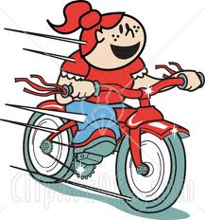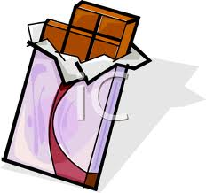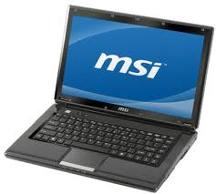

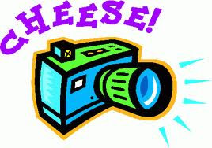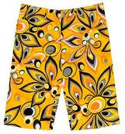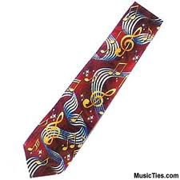

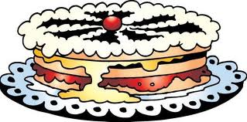

Homework:
- Write a list of things you advise to do for my birthday,
- Decide which present you will buy for me.
- Send all this information on my e-mail: shumeiko1944@mail.ru
Thank you!

Homework:
- Write a list of things you advise to do for my birthday,
- Decide which present you will buy for me.
- Send all this information on my e-mail: shumeiko1944@mail.ru
Thank you!

Homework:
- Write a list of things you advise to do for my birthday,
- Decide which present you will buy for me.
- Send all this information on my e-mail: shumeiko1944@mail.ru
Thank you!

