Приложение 2

Listen to the weather forecast and choose the right picture.
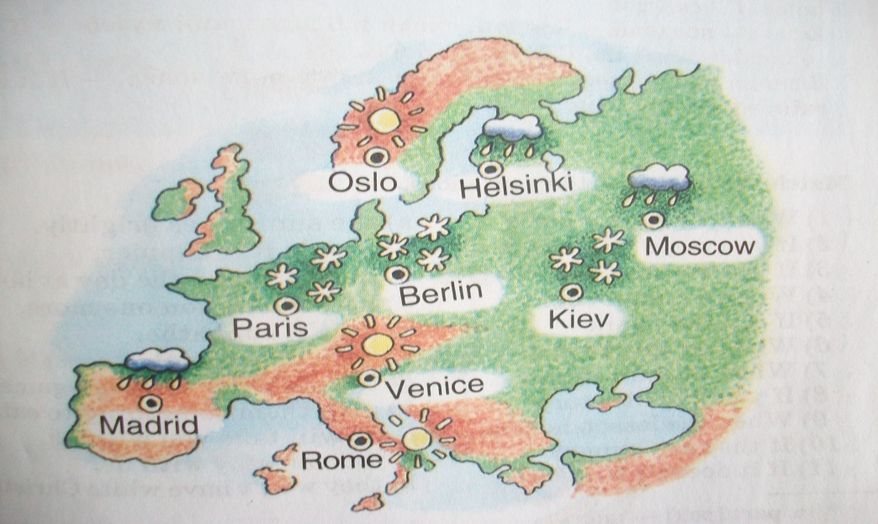
Picture 1

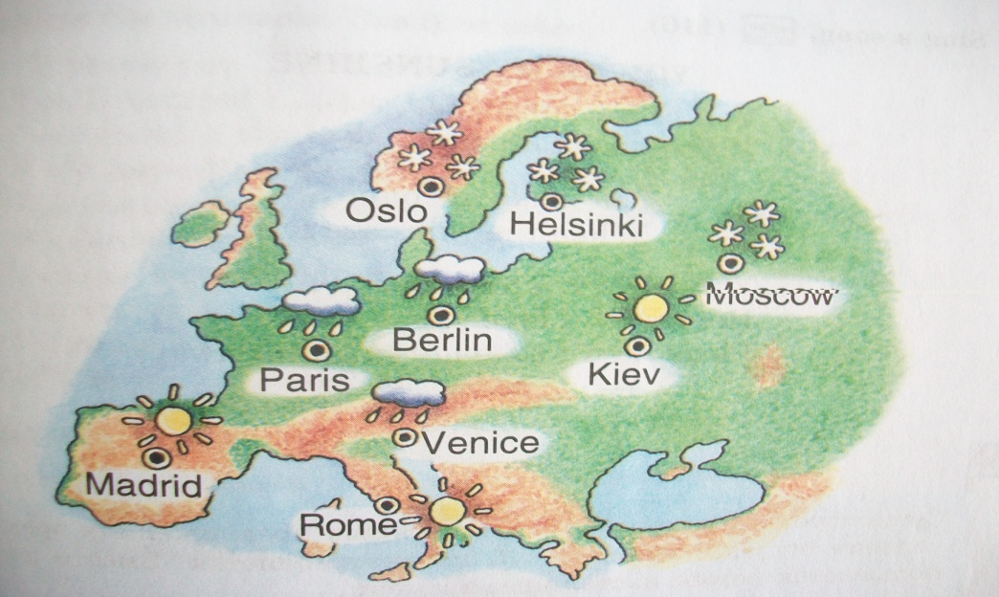
Picture 2

Текст для аудирования:
Italy: Sunny all day with wind and temperatures 10-12 above zero.
France, Germany: Rainy with temperatures 8-10 above zero.
Spain: Cloudy with winds, sunny periods with temperatures only 10 above zero.
Scandinavia: Frosty and snowy with temperatures 5-7 below zero.
Austria: Cloudy with rainy periods. The temperature is only 8 above zero.

