РОССИЙСКАЯ ФЕДЕРАЦИЯ

ЯМАЛО-НЕНЕЦКИЙ АВТОНОМНЫЙ ОКРУГ

ДЕПАРТАМЕНТ ОБРАЗОВАНИЯ АДМИНИСТРАЦИИ ПУРОВСКОГО РАЙОНА

МУНИЦИПАЛЬНОЕ БЮДЖЕТНОЕ ОБЩЕОБРАЗОВАТЕЛЬНОЕ УЧРЕЖДЕНИЕ
«СРЕДНЯЯ ОБЩЕОБРАЗОВАТЕЛЬНАЯ ШКОЛА №1» п.г.т.УРЕНГОЙ ПУРОВСКОГО РАЙОНА
629860, Ямало-Ненецкий автономный округ, Пуровский район, п.Уренгой,
4 мкр., дом 39А тел(факс)34934 9-31-77 Urengoi_1@ mail.ru

SCHOOL OF REAL DREAM
Школа реальной мечты

Автор:
Доброхотова Анастасия Владимировна
муниципальное бюджетное общеобразовательное учреждение
«Средняя общеобразовательная школа №1» п.г.т.Уренгой Пуровского района»
10 класс
Научный руководитель:
Хащивская Галина Денисовна
учитель английского языка
высшая категория
муниципальное бюджетное общеобразовательное учреждение
«Уренгойская средняя общеобразовательная школа №1» п.г.т.Уренгой Пуровского района»

Уренгой
2012
АННОТАЦИЯ

ЦЕЛЬ РАБОТЫ : Совершенствование существующей модели школы.
АКТУАЛЬНОСТЬ: Проектная работа содержит конкретные замечания и предложения по обновлению модели существующей школы, согласно мнениям и желаниям учеников, учителей.
НОВИЗНА: Представлены идеи снижения тревожности и релаксации во время перемен, изменения модели учебного дня с целью улучшения качества подготовки к занятиям, сохранения здоровья школьника за счет реорганизации учебного процесса и высвобождения свободного времени на отдых и занятия по интересам. Внесены идеи совершенствования питания в школьной столовой, организации досуга в стенах школы, введения школьной формы.
НАУЧНОСТЬ: Работа выполнена в форме поисково- исследовательского проекта, в основу которого заложена технология критического мышления, использован проблемный, поисковый, исследовательский методы. Проведены и обработаны исследования по выдвинутым замечаниям и предложениям в виде анкетирования, составлены таблицы, информация отслежена в количественном и процентном отношении. Изучен и проанализирован материал на английском и русском языках из сети Интернет. Сделан самостоятельный перевод. Составлен глоссарий незнакомой лексики.
ПРАКТИЧЕСКАЯ НАПРВЛЕННОСТЬ: Большинство предложений выполнимы в условиях данной школы, могут способствовать ее обновлению, иметь положительный результат. Работа может быть использована при прохождении темы «Школа», «Школа моей мечты» (9 класс) для проведения дебатов, уроков-диспутов на английском языке.
Способы достижения цели: Выступить с результатами исследований и предложениями на школьной научно-практическоой конференции. Предложить принять участие в обсуждении проекта все заинтересованные стороны: ученическое самоуправление, администрацию школы, родителей, педагогов, районный Департамент образования. Выступить на страницах проекта «Портфолио» для привлечения более широкого круга читателей с целью модернизации школы. Достижение целей проекта возможно при совместном обсуждении результатов исследований и предложений.

ANNOTATION
GOAL: Perfection of a present day school model.
ACTUALITY: A project contains concrete remarks and proposals on updating an existing school model, according to pupils` and teachers` opinions and desires.
NOVELTY: I proposed the ways of decreasing a feeling of anxiety and uneasiness during the school breaks promoting a feeling of relaxation, gave ideas about a new model of a school day with the aim of better preparation for lessons, preservation of health due to reorganization of an educational process, and, as a result, having more free time for rest and hobbies. I tried to give some ideas as to canteen feeding perfection, spending leisure time inside the school, school uniform inculcation at school.
SCIENTIFIC APPROACH: A research project is based on the technology of critical thinking. The problem, searching and investigating methods are used. I interviewed students and teachers, the results of surveys are put in the tables. The information is counted in quantitative and percentage ratio. The Internet material in English and Russian is studied and analyzed. The translation is made on my own. The glossary of unfamiliar words is applied.
PRACTICAL ORIENTATION: Most proposals are possible to be fulfilled at school. Innovation could have positive results. A project can be used while studying the topic "School", «School of my dream» (Form 9) to run debates, discussions in English.
GOAL ACHIEVEMENT: To achieve the goals, it is necessary to organize a joint discussion of three groups( teachers, parents, pupils), to discuss all proposals at the teachers` stuff meeting, parents` meetings, Parents` and Teachers` School Council, Student`s School Council, District Educational Department.

КРАТКАЯ АННОТАЦИЯ
Цель работы – совершенствование существующей модели школы. Проведены исследования в форме анкетирования 25 учеников и 25 учителей. Результаты показали, что большинство опрошенных поддерживают предложения автора работы. Реализация некоторых аспектов проекта возможна после согласия администрации школы, педколлектива, Совета школы, ученического самоуправления школы, районного Департамента образования.

SHORT ANNOTATION.
The aim of the project is perfection of a present day school model. Interviews of 25 students and 25 teachers were investigated. According to the results, most of the interviewees supported the author`s proposals. Realization of some aspects of the project are possible after the common consent of School Administration, teachers, Parents` and Teachers` School Council, Students` Self-Governing Council, District Educational Department.

CONTENTS
INTRODUCTION.
MAIN BODY:
- Some tips to a new school model
- A school day according to a new school model
- A school canteen reconstruction
- Self-preparation
- PT lessons
- A five-day week
- Free school attending
- Distance teaching
- Evaluation
- Computer testing, computers in all classrooms
- Free Internet access at school
- A language laboratory
- A library
- School Democracy
- Breaks and «bells»
- A cinema Hall
- A school uniform
CONCLUSION
GLOSSARY.

INTRODUCTION
School shouldn’t only prepare us for life, it should be life itself because it lasts for a long period of time, 11 years.
Recently I read some statistics and it shocked me: only 10% of students are healthy, and 90% of students have different problems and deviations in physical and psychological development, also connected with nervous system, e.t.c.
Why does it happen? I have looked at my schoolmates` life from the side of an observer and tried to find out the reasons of our school-life discomfort and the ways out.
To be convinced, that I am not the only one who wants to have real changes in our school life (that may influence both health and studying), I have made some investigation concerning school discomfort in a form of a survey for 25 students and 25 teachers (Appendix I).
My suppositions were coincided with my schoolmates` and teachers`. The aspects I`d like to modernize were: not perfect present day model of a school day, PT lessons in a school-day schedule, a school canteen, democracy at school: election of a student self-governing (once a year), teachers, a school administration, a school Director ( once in 3 years), reconstruction of a school canteen, implementation of a 5-day week, free-school attending, a school uniform, organization of distance teaching, credit and 100-score evaluation (instead of «5»scores), introduction of some ways of relaxation at school.
The results of the survey were submitted in tables in quantitative and percentage ratio (Appendix II, Ш).
SOME TIPS TO Our School Model presuppose to change an ordinary school day: it will last for 4 hours. Then we`ll have our break for lunch (12.30-13.30). Some pupils may have lunch at home, others may have it at school canteen . Lunch time- is a long break, it is our free time.
The breaks between the lessons shouldn`t be as long as they are now, because we will have a chance to have a substantial lunch in the middle of the day.
During the short 10 minutes breaks we may go to the canteen and have some snacks from automatic machines.
An ordinary school day will look like that:
- Start of school-8.30 a.m.
- 1st lesson-8.30-9.10 a.m.
1st Break-9.10-9.20 a.m.
- 2nd lesson-9.20-10.00 a.m.
2nd Break-10.00-10.10 a.m.
- 3rd Lesson-10.10-10.50 a.m.
3rd Break-10.50-11.00 a.m.
- 4th Lesson-11.00-11.40 a.m.
4th Break-11.40-11.50 a.m.
- 5th Lesson-11.50-12.30 p.m.
- Dinner, free time-12.30-14.00 p.m.
- Self preparation-14.00-16.00
16.15 -17.45 p.m. –PT lessons (sections)
SCHOOL CANTEEN. The results of our survey showed that our students would like to have some changes in the process of feeding and nutrition.

A school canteen is not only a place where we can eat our meals, it`s a place to rest after our brains ` hard work at the lessons. And we want our dining-room and lunch time to be conformed to the requirements as follow:
- To have more time to eat substantial meals (to have a long break for lunch 12.30-13.30)
- To give a great choice of dessert (fruits, cakes, ice-cream, different sweets, juice)
- Hot tasty meals, a great choice of drinks from automatic machines at any break we like.
At the canteen students will be able to choose what they want according to their tastes. Also they will be able to take away food, if they like, when they are pressed in time and need to be in a hurry.
It is necessary to put automatic machines with cold meals, snacks and drinks (yoghurts, different salads, sandwiches, cakes, juice, fizzy drinks, chocolate, sweets), hot meals and hot drinks (potatoes, rice, buckwheat, pasta, chicken, fish, beef, tea, coffee, cocoa e.t.c.)
We`d like to adorn our canteen with different pictures and rules of etiquette.
Also we would like to give the opportunity (both for students and teachers) to have a “Swedish table” in the canteen ( once a week).
Grown -ups should remember that all of us are different and have different tastes!
Since 2 p.m. to 4 p.m. we WIll have our self-preparation at school with teachers on duty on some subjects: Mathematics, Russian, English, History, Geography, Physics, Chemistry, Biology as consultants ( according to our next day schedule). It does not t mean that the teachers who teach you should be your consultants- any teachers of the same subject may help you to cope with your home-tasks for the next day. The question is: is it necessary to attend such lessons of self preparation? I think: yes, because it will organize you to do your lessons more quickly and to get more free time for your physical and mental development.
After our self-preparation (14.00-16.00) we suppose to have lessons of PT in different sections since 16.15.to 17. 45., not less than 3-4 times a week for 90 minutes. We will not have our lessons of PT in the first part of the day. Most students agree that it is very inconvenient and they suffer great discomfort when they need to attend lessons of Maths or Russian, English or other lessons when they are physically exhausted and sweaty, damp with perspiration, with not fresh smell. No shower and no time for shower proves the fact that PT lessons should not be in the schedule between other lessons if they are really in the interests of children.
Instead of PT lessons at school, we would like to go in for sport sections of different kinds of sport. It will be possible for everyone to choose that kind of sport which students like most of all and, therefore, they will be able to improve their health according to their choice and physical abilities, get much more profit for health and pleasure than during nowadays PT lessons.
17.45 WE ARE FREE TO DO WHAT WE LIKE.
A FIVE-DAY WEEK- is not a luxury, it is the necessity! We will spend much more time with parents, friends, go in for hobbies, develop our creativity, read, play and just relax enough to feel healthy. Sunday, the only day in a week, is not enough to restore our forces lost during the week.
FREE SCHOOL ATTENDING.
Every student should have the right for free school attending. It means that every student has the right to study at home and not to go to school every early morning. But a student should do his class work and homework on his or her own. Parents should sign an agreement that they allow their children not to attend school for a certain period of time (a week or two, no more), but they should pass the credit after that and report about the work at home on their own.
DISTANCE TEACHING is a way to help students not only in extending their outlook and enriching their knowledge, but acquiring skills in self - dependent work. Project work, credit evaluation should be more effective and less stressful than every day evaluation at school.
EVALUATION. We suppose, that a «5» scores mark shouldn`t exist any more as it does not depict the real picture of evaluation. More than that, it does not exist any more at most profile colleges and institutes, universities and Academies. So, it would be better to run a 100 scores system, as it is used in our State Exams, high education institutions.
COMPUTER TESTING, Computers in every classroom for every student.
The scientists are quite right saying that it is impossible to imagine the 21st century without computers .The computers will check up the students knowledge in all subjects. Why?
On the one hand, it is convenient for teachers because pupils can not cheat when doing tests on computers. On the other hand, it is good for students because they will get real, fair marks (it happens sometimes that some teachers raise too high their evaluation, the others underestimate students knowledge and there is too much misunderstanding and offense, even conflicts).
So, I offer computer testing. Nobody will blame the machine and feel offended because of his or her final results. Computers must be set up in every classroom, for every student.

Free Internet access.
To have good knowledge – it is not enough to get information from textbooks, there should be free Internet access from any computer at school, at any classroom, laboratory, library, work-shop.

A language laboratory. It would be of great importance to have a language laboratory with a good methodological base, film collection for lessons and the school Cinema Hall, equipment and literature for making projects and preparing for exams, tests, Olympiads .

A LIBRARY.
A special place for acquiring knowledge is a library. It should be equipped with a number of computers, not one only for the librarian , as we have now. There should always be textbooks in the library to take for the lesson if it happens that you have forgotten them at home. But the ideal variant is to have textbooks in the classrooms, at least one for the table, not to carry heavy bags.

SCHOOL DEMOCRACY.
Every 4 years we elect our President, Duma. It helps to innovate our life. Students should have the right to choose teachers, a School Director, a School Administration, a student self –governing, as well.
The Day of Elections will be a holiday for both students and teachers – October1, for example. Teachers, a School Director, a School Administration should be elected every 3 years. But a student always has and will have the right to change a teacher or a school if he feels some discomfort.

Breaks and bells
The sound of the bell at the end and at the beginning of the lesson should not be so harsh and cause a feeling of alarm. Therefore: 1) most students and teachers would like to listen to the birds` singing, splash of sea-waves or tunes of quiet music 2) no bright lights in the corridors and classrooms during the breaks 3) our favourite music should be played during the whole break long. The students of upper forms should be responsible for it.

Cinema hall
It would be great to have a cinema hall at our school. Why not to use our school assembly hall for watching new films in English, German, French, Russian in our free time? Some students of High School may be responsible for it. Pop-corn and sweet bars, juice could be proposed at low price there. It is much better than hanging out in the streets, smoking and drinking alcohol, listening to stories about young drug and Internet -addicts and what not.

SCHOOL uniform
Every child wants to look as an individual bright person. Sometimes, when we are in bad mood, «bright students» raise our mood. We are happy to see them! Many students vote for a free dress-code.
STUDENTS` AND THEIR PARENTS` OPINIONS

FOR | AGAINST
A uniform allows everybody to prepare for a good future  (Most jobs require you to wear a uniform) you might want to research high paying jobs that require uniforms. | A uniform takes pressure of deciding what you have to wear
You don't have to worry about what to wear the next day. When you have a uniform you already know what you will be wearing the following day and so. | You can`t show up. You should be as all the rest. And I want to look differently.
If there was a uniform we wouldn't have to worry what you are allowed to wear or not.
It`s good that I know exactly what I am wearing the next day.
Only students of a respectable school, can be proud to wear it`s school dress-code, badges.

A sense of unity appears between pupils.

When on public transport etc, even if a kid is in a lower year, you can recognize the uniform. It helps you to connect with people and become closer.

What do the professionals say?
- As psychologists say, a child in a school uniform is more likely to take school seriously. Putting on the school uniform signals he or she is going to school just like dad dresses up
to go to work. Schools report that when students dress in "work clothes" rather than "play clothes" they take a more serious approach to their studies.
- Promotes Good Discipline:
Many think that school uniforms help to maintain school discipline, decreasing the amount of discipline problems. The argument is that children today are lacking in self-discipline because parents refuse to discipline them. This makes it more difficult on the teacher who has to deal with classes of 25-30 students at a time.
- Reduces Fighting and Violence:
Schools report that school uniforms decrease fighting and violence that arise out of arguments over fashionable clothes. Children invariably tease those who do not have trendy clothes. Those who can't afford name brand clothes are often sensitive about their clothing. Schools struggling with gang problems report that school uniforms help ease tensions.
- Distractions:
Many parents believe that students wearing school uniforms look nicer and that a school uniform policy ensures that children will come to school in appropriate clothing, avoiding distractions such as fads considered to be outlandish or overly revealing. Some students have turned school into an unending fashion show. This distracts from learning, as some kids spend more time focused on their clothes than on homework.
- Values:
School uniforms stress that individuality and self-expression are not determined by designer clothing or the latest fashion fad.
- Low Cost:
They are becoming far less expensive than many other clothes. School uniforms are economical, especially compared to designer clothing, and parents agree that school uniform has good durability. They say school uniforms last longer because they are made for repeated wash and wear. Many schools abroad capitalize on this by starting used school uniform stores or swap meets. Parents can get used school uniforms at discount prices, or just use them as hand-me-downs between siblings.
- School Spirit:
Some believe that wearing a school uniform helps to build school spirit. It instills a feeling of belonging. As the Beach Boys said, "Be true to your school." A school`s report - an increase in school pride.

CONCLUSSION. To sum up, I must say that my proposals and dreams may come true only under the support of School Administration and teachers, parents, students. All proposals should be discussed on these levels, pedagogical staff meeting, parents` meeting, School Parents` and Teachers` Council, Regional Department of Education, students` self-governing meeting.
The results of my investigation showed that most of the interviewees were not indifferent to my proposals. It was rather interesting to discover that the same percentage (56%) of students and (56%) of teachers are for free school attending, 84% of teachers and 100% of students are for canteen reconstruction and changing the process of feeding. Both students (80%) and teachers (76%) would like to change the school breaks, to change a sharp sound of the «bell» at the end and at the beginning of the lessons. They would be happy to feel relaxed from birds` singing , splash of water or some pieces of music instead of nowadays sounds of the «bell». All students and teachers want to look smart. There is a good reason for further discussion. 32 % of students and 68% per cent of teachers would really like to see our students hot and stylish in a new kind of school uniform . 20% of students are not against it, but it depends, what kind of uniform they will be proposed. I have drawn pictures of a traditional uniform which is loved by girls for many years. It is like a symbol of Russian schools. And not bad at all. 80% of students and 80 % of teachers are «FOR» a new model of a school day and PT lessons after school, 48 % of students and 80% of teachers are «FOR» Computer testing. Cinema Hall at school is of great interest for teachers (84%) and for students (60%.)

I have asked only 50 people, and more than a half of them proved, that we really need some changes in our school life. In my project I tried to explain what do I want to change and why, gave tips how to change our school life for better.
I`d like to continue my project. There is one more important thing I have to research: the inner spirit of school. What does it depend on and what can we do to make it more comfortable both for students and teachers? I want to investigate why all levels of some contests and Olympiads by correspondence (even International) are in hands of some responsible teachers at school. As a result, some students are aware of tasks, the others –don`t. It`s unfair. I think, all contests and Olympiads by correspondence («The British Bulldog», «URFO», etc.) should always be on line for all volunteers. It greatly influences the school spirit. Especially it`s important for motivated students. I have one year to continue and finish my project and, perhaps, the school life for those who follows us will be more attractive and comfortable.

LITERATURE
- I.R. Galperin, New English-Russian Dictionary.-М. Рус. яз.,1979.
- E.V.Gvozdikova, Up-to-date Topics for Discussion: Let Me Say.- М.: Rolf, 2001.
- Е.I. Kisunko, Е.S. Muzlanova, Topics, dialogues, exercises in English M.: ACT: Vladimir,2010.
- A.I. Smirnitsky, Russian-English Dictionary.-M.: Pyc.яз.,1990.
- The Internet RESAURCES:
  - SchoolUniformsDebateMessageHustoStud
  - http://www.expressiya.ru/catalog/catalog_01.aspx
6.3 www.photosight.ru
6.4 www.privet.ru
6.5 www.liveInternet.ru
6.6. www.bodybuilt.ru
6.7. www.newsprom
6.8. www.optom.ru
6.9. www.EngoyYourCooking.ru
6.10.www.kostum4you.ru

Glossary
Access – доступ
Acquiring – приобретение
Addict – зависимость, наркоман
Alarm – тревожность
Amount – количество
Approach – подход к чему – либо
Belonging – преданность
Beyond any doubt – вне сомнения
Bluster gun - отпугивающее оружие
Bright – яркий
Cheat – обманывать
Convenient – удобный
Cope – справляться
Credit evolution – система оценивания
Cruelty – жестокость
Damp – влажный
Decrease – уменьшение
Discount – сниженная (цена)
Distraction – отвлечение
During – в течении
Easy tension – снизить напряжение
Enrich – обогатить
Equipment – оборудование
Exhaustible – истощимый
Extending – расширение
Fad - причуда
Fair – честный, справедливый
Fighting – борьба
Governing – управление
Grown –up – взрослый
Hurry – торопливость
Increase – увеличение
Importance – важность
Instead – вместо
Instill – внедрять, воспитать
Invariably tease – дразнят, не разбираясь
Knowledge – знания
Leisure – свободный
Looser – неудачник
Maintain – поддерживать
Mental – умственный
Misunderstanding – непонимание
Nutrition – качество питания
Offence – обида
Offer- предлагать
Ordinary – обычный
Outlook –мировоззрение
Pleasant – приятный
Presuppose – предполагать
Pride – гордость
Prosperous – состоятельный, процветающий
Refuse – отказывать
Report – сообщить
Requirement – требование
Respectable –порядочный, почтенный, приличный
Responsible – ответственный
Schedule – расписание
«5» score marks – пятибалльная система оценивания
Self-dependent – самостоятельный
Self-dependent - самостоятельный
Sensitive – чувствовать
Shower – душ
Simultaneously – одновременно
Snack – перекуска
Smell - запах
Solve – решать (проблему)
Spirit – дух
Substantial – основательный
Suffer – испытывать
Swap – менять, обменивать
Sweaty – потный
Textbook – учебник
Tip – подсказка
Unending – бесконечный
Value – оценка
Violence – насилие
Vote – голосовать
Work-shop – мастерская
Whole – весь, сполна

APPENDIX

- Questionnaire №1
- Results of the questionnaire №1
- Questionnaire №2
- Results of the questionnaire №2
- Some tips to a new school model
- School day
- Canteen reconstruction
- Language laboratory
- School democracy
- School uniform

qUESTIONNAIRE №1 Вопросы для анкетирования №1
1.Комфортно ли тебе в школе? А) да В) не очень С) нет
1. Do you feel comfortable at school?
2. Ты не выполняешь домашнее задание потому, что А) лень В) трудно С) выполнял бы, если бы была помощь
2. You do not do your homework because A) you are lazy B) it is difficult for you to cope with it C) you would do it if somebody helps you
3. Отношение к питанию в нашей школьной столовой: А)нравится в) редко нравится С) не нравится
3. Your attitude towards meals in our school canteen: A) I like B) I rarely like C) I dislike
4.Сколько учеников вашего класса регулярно питается в школьной столовой?
4. How many students from your class have regular meals in school canteen?

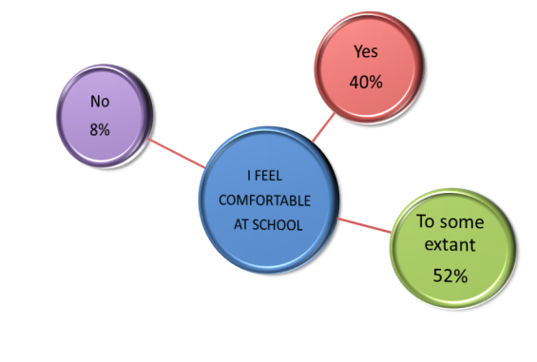

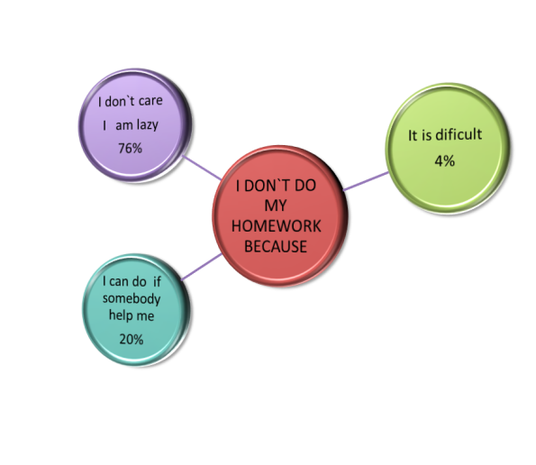

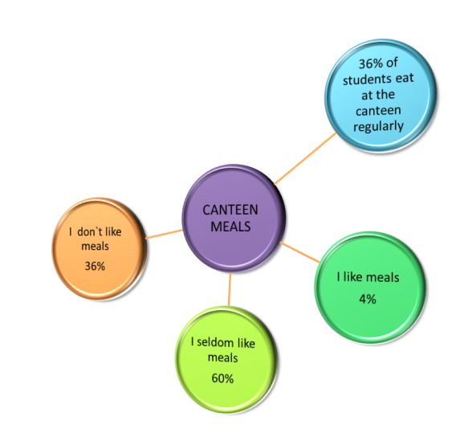

Вопросы для анкетирования

1) Хотелось бы вам, чтобы наши ученики имели право свободно посещать школу, не более 2 недель (согласно письменному соглашению родителей), при этом выполнять классную и домашнюю работу в домашних условиях, в конце - сдавать зачет или проект?
1. Would you like the students to have the right for free school attending, not more than for 2 weeks (according to their parents` agreement ) doing their class-work and homework at home, passing a credit or presenting a project at the end of their staying at home?
2) Хотелось бы вам, чтобы наши ученики имели право выбирать ученическое самоуправление , учителей, администрацию и директора школы?
Would you like our students to have the right to choose a students` self-governing (every year), the teachers, a school administration, a school director (each 3 years)?
3) Хотелось бы вам, чтобы в столовой появилось такое оборудование, как автоматы с едой и напитками? Хотели бы вы один раз в неделю питаться разнообразной едой («Шведский стол»)?
3. Would you like to have automats with meals and drinks in your school canteen? Would you like to have a «Swedish table» once a week?
4) Хотели бы вы слушать спокойную или любимую музыку на переменах?
4. Would you like to listen to quiet or your favorite music during the school breaks?
5) Хотелось бы вам слышать звонок с урока или на урок с нестандартным звучанием (пение птиц, шум морской волны, мелодию спокойной музыки)?
5. Would you like to hear not standard «bell» from or for the lesson (birds` singing, splash of sea-wave, quiet music)?
6) Каково ваше отношение к школьной форме?
6. What do you think about a school uniform?
7) Хотелось бы вам, чтобы в школе был кинозал (в актовом зале), была возможность смотреть фильмы на английском, немецком, французском и родном языках?
7. Would you like to have a Cinema Hall (in our Assembly Hall) to watch films in English, German, French and Russian?
8) Хотелось бы вам, чтобы тесты и контрольные работы учеников проверял не учитель, а компьютер?
8. Would you like the students` tests to be checked by computers, not teachers?
9) Хотелось бы вам, чтобы уроки физической культуры были вынесены во вторую половину дня в форме секционных занятий 3-4 раза в неделю?
9. Would you like to have sport sections 3-4 times a week in the afternoon, instead of PT lessons in a school-day schedule?

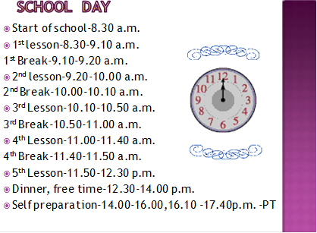

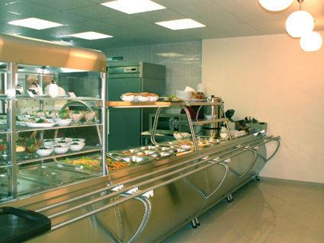
CANTEEN RECONSTRUCTOIN

Kinds of automats
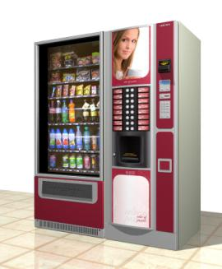
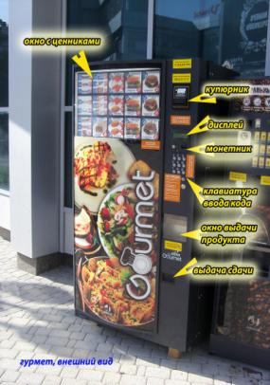

LANGUAGE LABORATORY

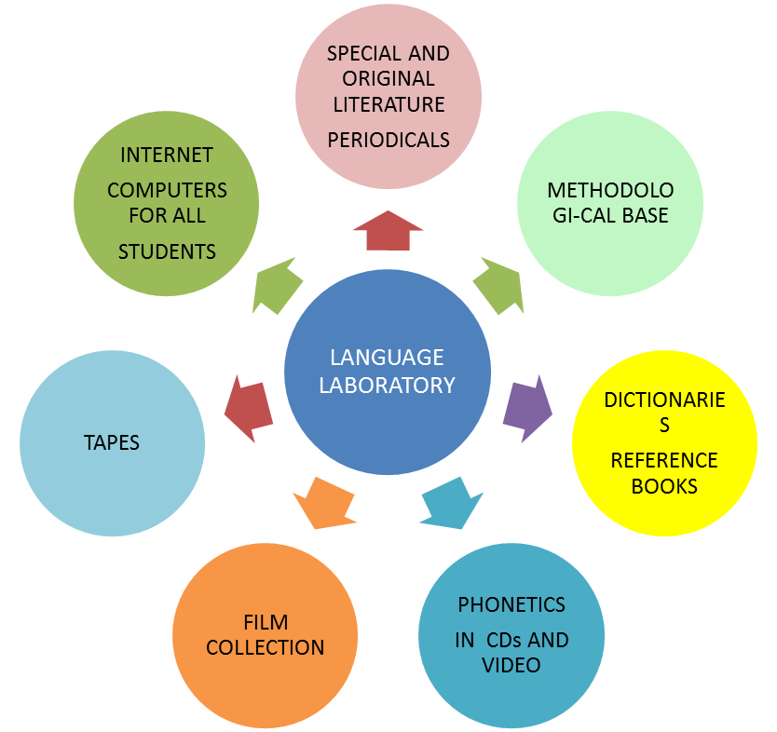

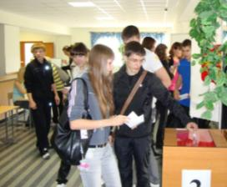
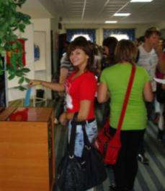
SCHOOL DEMOCRACY
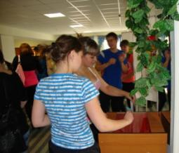

Election of Students‘ Self-Governing | Election of teachers, School Director, School Administration
Every year | every 3 year

