Приложения
r | a | b
b | i | t

black
red
white
green
yellow
blue
grey
pink
brown
orange
c _ t
c _ n

d _ g
fr _g
f _ x
b _ g
p _ g
p _ nk
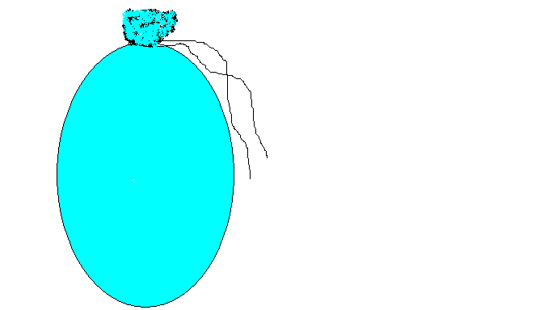
It is _________________.
(green, brown)
It is _________________.
(big, small)
It can ________________________.
(run, jump, swim, fly)
It can’t _______________________.
(run, jump, swim, fly)
What is it? It is a ____________________.
It is _________________.
(green, brown)
It is _________________.
(big, small)
It can ________________________.
(run, jump, swim, fly)
It can’t _______________________.
(run, jump, swim, fly)
What is it? It is a ____________________.
It is _________________.
(green, brown)
It is _________________.
(big, small)
It can ________________________.
(run, jump, swim, fly)
It can’t _______________________.
(run, jump, swim, fly)
What is it? It is a ____________________.

cat
dog
fox
hen
pig
fish
frog
rabbit
monkey
elephant
crocodile

