*Приложение 2*

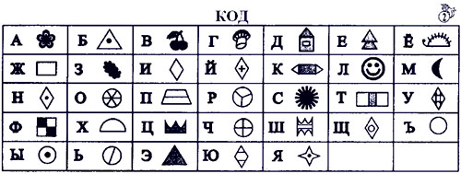

*****

Добро пожаловать в Цветочный город



|  |  |  |  |  |
| --- | --- | --- | --- | --- |
|  |  |  |  |  |



|  |  |  |  |  |  |  |  |  |  |
| --- | --- | --- | --- | --- | --- | --- | --- | --- | --- |
|  |  |  |  |  |  |  |  |  |  |



|  |  |  |  |  |  |  |  |  |  |  |
| --- | --- | --- | --- | --- | --- | --- | --- | --- | --- | --- |
|  |  |  |  |  |  |  |  |  |  |  |



|  |  |  |  |  |
| --- | --- | --- | --- | --- |
|  |  |  |  |  |

*****

Приветствуем вас в Цветочном городе



|  |  |  |  |  |  |  |  |  |  |  |  |
| --- | --- | --- | --- | --- | --- | --- | --- | --- | --- | --- | --- |
|  |  |  |  |  |  |  |  |  |  |  |  |



|  |  |  |
| --- | --- | --- |
|  |  |  |



|  |  |  |  |  |  |  |  |  |  |  |
| --- | --- | --- | --- | --- | --- | --- | --- | --- | --- | --- |
|  |  |  |  |  |  |  |  |  |  |  |



|  |  |  |  |  |  |
| --- | --- | --- | --- | --- | --- |
|  |  |  |  |  |  |

*****

Приглашаем вас в Цветочный городок



|  |  |  |  |  |  |  |  |  |  |
| --- | --- | --- | --- | --- | --- | --- | --- | --- | --- |
|  |  |  |  |  |  |  |  |  |  |



|  |  |  |
| --- | --- | --- |
|  |  |  |



|  |  |  |  |  |  |  |  |  |  |  |
| --- | --- | --- | --- | --- | --- | --- | --- | --- | --- | --- |
|  |  |  |  |  |  |  |  |  |  |  |



|  |  |  |  |  |  |  |
| --- | --- | --- | --- | --- | --- | --- |
|  |  |  |  |  |  |  |