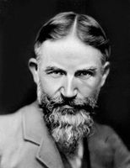
- G.B. Shaw was born in Dublin, Ireland, on the 26th of July 1856. His family was very poor. Shaw even had to leave school at the age of fifteen. He became a cashier in a Dublin land agency. After he had worked for five years he gave it up and left for London.
- Shaw tried to make a living by writing. He wrote four novels, but they were not successful.
- In the nineties Shaw began to write for the theatre. He was the creator of modern satire. Shaw wrote over twenty plays.
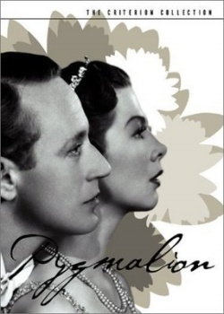
- In 1931 he toured India, China, Africa, America and Russia. In 1925 he was awarded the Nobel Prize for Literature and in 1934 the medal of the Irish Academy of letters.

- Pygmalion is one of Shaw's most popular and successful plays. It is an amusing and profound comedy. Like any of Shaw's plays, Pygmalion is full of criticism of contemporary life. It is against social barriers and distinctions.

- The idea of the play.
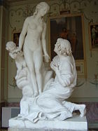
The idea of the play, expressed in the title, originates from an ancient myth. Pygmalion, an ancient sculptor, while creating a statue of a beautiful girl, Galatea by name, fell in love with his creation. His love was so great that he began to pray to Aphrodite, the goddess of love, to breathe life into the statue.
- The goddess made the statue live, and Pygmalion married Galatea.

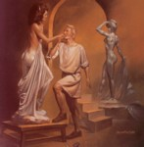

Pygmalion in Shaw's play is Mr. Higgins, a professor of Phonetics. Galatea is Eliza Doolittle, a street flower girl, and the play itself is the story of Mr. Higgin`s attempt to make a duchess out of the flower - girl. (And now watch the play)
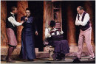
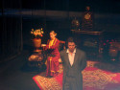

Characters:
The Narrator,
The flower girl,
Mr. Higgins,
Colonel Pickering,
Theatregoers.
The sound of rain and thunder. The narrator appears, holding an umbrella.

Act One.
Narrator [under the umbrella]: It is evening. It is raining cats and dogs. The theatergoers are waiting for the cabs to take them home. A young but very dirty flower-girl offers flowers to an elderly
gentleman. The second man writes her words down and repeats them. The girl begins to cry because she is afraid that the second man is a policeman.
The flower-girl: Ah-ah-ow-ow-ow-o! I have done nothing wrong. I never spoke to him except to ask him to buy a flower off me.
The second man [to an elderly one]: You see, this girl will be in the gutter to the end of her days because of her awful pronunciation. Well, sir, in three months I could pass her off as a duchess at an Ambassador’s garden party. I could even get her a place as a lady’s maid or shop-assistant, which requires better English. I’m a professor of phonetics. My name is Higgins.
The elderly gentleman: Professor Higgins? Oh, I’ve come from India to make your acquaintance. I’m Colonel Pickering.
Higgins: Pleased to meet you. Come and see me tomorrow. My address is 27 A Wimpole Street.
Pickering: With pleasure.
They shake hands and go away. The flower-girl is looking in the direction of Mr. Higgins.

Act Two.
Characters:
The Narrator
Mr. Higgins
Colonel Pickering
Mrs. Pearce
The flower-girl [Liza]
Narrator: Mr. Higgins and Colonel Pickering are playing chess when Mrs. Pearce enters the room.
Mrs. Pearce [to Mr. Higgins]: A young woman wants to see you, sir.
Higgins: Show her in, Mrs. Pearce.
The flower-girl enters the room. She is wearing a hat of three ostrich feathers, orange, sky-blue and red. She has a nearly clean apron on and her coat has been brushed off a little.
Higgins [recognizing her]: Why, this is the girl whose words I jotted down last night. She is of no use: I’ve got all the notes I need of the Lisson Grove accent. Be off with you.
The flower-girl: Don’t be so rude. I haven’t come here to ask for any compliment; and if my money isn’t good enough I can go elsewhere.
Higgins: Good enough for what?
The flower-girl: Good enough for you. I’ve come to have lessons, and to pay for them too: make no mistake.
Higgins: Well!!![Recovering his breath with a gasp] What do you expect me to say to you?
The flower-girl: Well, if you were a gentleman, you might ask me to sit down, I think.
Pickering: Sit down, please. What is your name? What is it you want my girl?
The flower-girl [sitting down]: My name is Liza, Eliza Doolittle. I want to be a lady in a flower shop. But they won’t take me in unless I can talk more genteel.[Pointing to Higgins] He said he could teach me. And I am ready to pay him-not asking any favour-and he treats me as if I were dirt.
Mrs. Pearce: How can you be such a foolish girl asto think you could afford to pay Mr. Higgins?
Liza: Why shouldn’t I? I know what lessons cost as well as you do, and I’m ready to pay you a shilling. Take it or leave it.
Higgins [walking up and down the room]: You know, Pickering, if you consider a shilling not as a simple shilling, but as a percentage of this girl’s income, it works out fully equivalent to sixty pounds from a millionaire.
Liza [rises]: Sixty pounds. What are you talking about? [She begins to cry]
Higgins: Sit down. Here’s a handkerchief for you.
Liza: What’s this for?
Higgins: To wipe your eyes. To wipe any part of your face that feels moist. Remember: that’s your handkerchief and that’s your sleeve. Don’t mistake the one from the other if you wish to become a lady in a shop.
Pickering: Higgins, I’m interested. What about the ambassador’s garden party? I’ll say you are the greatest teacher alive if you make good on that.
Higgins [tempted, looking at her]: It’s almost irresistible. She is so horribly dirty.
Liza: Ah-aah-ow-ow-oo! I’m not dirty, I washed my face and hands before I came, I did.
Pickering: Will you help us Mrs. Pearce?
Mrs. Pearce: Certainly. Come with me Liza.
And now, friends, you will be given a test in which you are to decide whether statements1-10 are true or false. Write T or F beside every statement.

Then on the screen we’ll show you the key to check your answers.

- Pygmalion was an ancient sculptor.
- He fell in love with Galitea, a statue of a beautiful girl.
- Mr. Higgins has come from India, he’s a colonel.
- Mr. Higgins is a professor of phonetics.
- Eliza Doolitle was a shop assistant.
- Mr. Higgins wanted to pass her off as a duchess in three months.
- B. Shaw’s play was called “Pygmalion”.
- His play was called “My Fair Lady”
- The idea of the play originated from an ancient myth.
- Mr. Higgins has managed to make a duchess out of the flower-girl.

