Ход урока
Содержание | Деятельность | Экран | Хрономет-раж
I. Организационный блок. Речевая зарядка.  Вступительная беседа учителя  – Hello, boys and girls! How are you? Suppose you are fine. Look at the pictures. What are the people in the pictures doing?  – Have you ever helped your neighbourhood?  -Have you ever helped people in need?  -Have you ever taken care of homeless children?  – What kind of activity is it?  – How do we call the people who are always ready to help without payment?  -Yes, you are right. They are called volunteers. And the activity is called voluntary work or voluntarism.  You know Sochi will host 2014 Winter Olympics which will not be able to exist without the time, energy, dedication and commitment of its Special Olympics volunteers. So, we need a program to train “the most dedicated and wonderful Games volunteers ever seen at any Olympic Games”. That’s why I suggest you to make a virtual volunteer tour around English-speaking countries hosted the Olympics and I hope that our friends will introduce their countries and thanks to their information we will learn more about geography, history, traditions, sights, policy, volunteer movement and get a lot of efficient tips how to organize the work of Olympic volunteers in Sochi. | T----P  T----Ps | 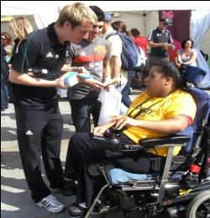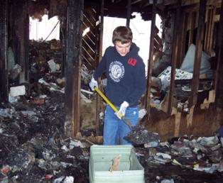  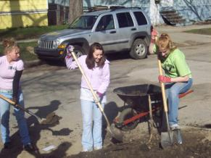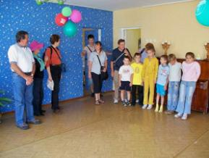 | На усмотрение преподавателя

II. Информационный блок. (Активизация навыков говорения и аудирования)  P1: Voluntary movement appeared in late 20s of the former century after the I World War. Young people from France and Germany met together and decided to work in a team to reconstruct their countries after the war and help the world peace. This idea spread all over the world. And 85 countries have been involved into this activity.  P2: A volunteer is someone who does work without being paid for it and who offers to do a particular task without being forced to do it. People of different ages and occupations join voluntarism.  T: Have you got any questions to our newsmakers?  Suggested questions:  1. What do the volunteers usually do?  2. Are there any voluntary organizations in English speaking countries and in Russia?  3 What does it mean to be an Olympic volunteer?  Suggested answers:  1. They help their countries in different projects:  ecological, social and economic and in such areas as medicine, education and emergency rescue.  2. There are a lot of voluntary organizations in the USA, Canada, the UK, Australia and in Russia. | P---Ps  Ps---Ps | 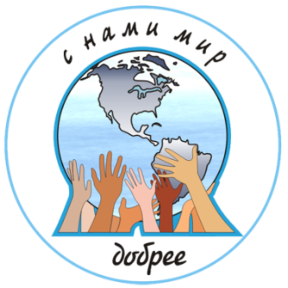
III. Основной блок. Ролевая игра “Satellite Link”.  T: Thanks a lot for your interesting information. You know that our country has joined voluntary movement recently I suggest you to take part in Satellite Link and learn more about it from our friends living in different countries. The aim of our meeting is to exchange views about Olympic voluntary movement because Sochi will host Winter Olympic and Paralympics Games in 2014.  (Класс делится на 5 групп. Каждая группа представляет волонтеров из англоговорящих стран принимавших Олимпийские игры.)  T: So, let’s start our work. |  | 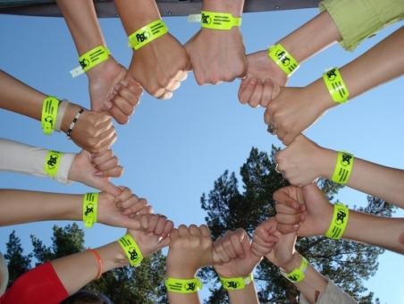
British group: Hello, Sochi. The group of volunteers from the UK is happy to greet you here in London. You can call us Games Makers and we are ready to answer all your questions about London 2012 Olympic Games. But before that we are going to present you our country.  Приложение 1  Suggested questions and answers:  1. How many volunteers are needed?  – London 2012 Olympic Games are looking for 70,000 volunteers.  2. What criteria do volunteers need to satisfy?  – Volunteers should provide unique, friendly, personalized and high– standard volunteer services.  3. What can volunteers expect to do?  – General volunteers should drive, distribute uniform, check tickets, greet people at airports, and distribute results sheets.  4. How old do volunteers need to be?  – They should be aged 18 or over at 1st January 2012 and 1500 junior volunteers will take part in this project.  5. When was the program launched?  – It was launched on September 2010.  P2: Thank you London. We have got very useful information and are going to use it in 2014.Good luck!  P3: Our next guests are from the up-side-down country – Australia. Australia hosted the Summer Olympics in 2000 and gained a great experience in volunteering. I think they have a lot to share about.  Australian group: Hi, Sochi! Volunteers from Sydney are happy to see you and share our ideas of hosting the Olympics. And now we are happy to give you some more information about our country. Приложение 2  Suggested questions and answers:  1. How many volunteers took part in the Sydney Games?  – We are proud to admit that the Sydney Games saw the largest gathering of volunteers at one time, in one place: 62,000 gave their time, skills, enthusiasm, warmth, and never forgetting passion, to make the games the great success.  2. What did you get from the Games?  – We were honoured with a parade like the athletes. Mr. Samaranch, the head of the IOC awarded us “the most dedicated and wonderful Games volunteers  ever”.  3. What is the best thing about volunteering at Sydney 2000?  – We have learned a lot about the games that we didn’t know before. Besides we have met a lot of interesting people that I just would not have met had I not volunteered there.  P4: A lot of thanks, Sydney. Your information is really important, it will be helpful for us. Hope to hear from you soon. | p--ps | 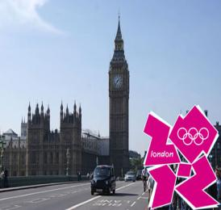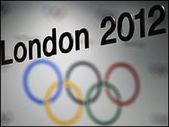  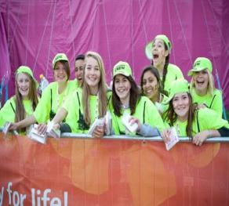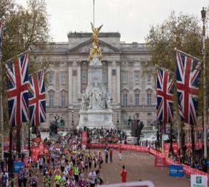  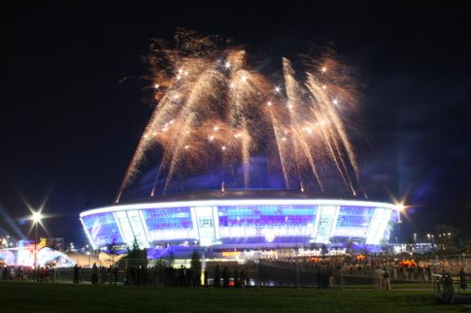  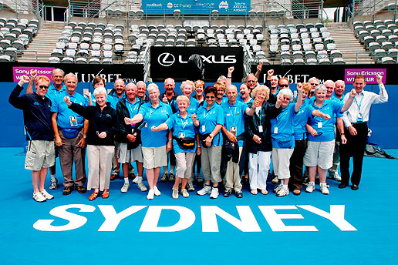
P4: And now we are going to the USA, the country with a very long history of voluntarism. T: I want you to listen to the American group and at the end of their speech be ready to do the task.  Развитие навыков аудирования c извлечением необходимой информации. Приложение 3  Учащиеся слушают текст и выбирают правильный ответ из трёх предложенных вариантов. 1– T(True), 2– F(False), 3– NS(Not stated)  American group: Pleased to see you Sochi. Welcome to Salt Lake City, the host city of 2002 Winter Olympics. We are glad to tell you about voluntary movement in our country.  Volunteers are an integral part of the Olympics. They are the face of the city to the world. In Salt Lake City, Utah, residents who wanted to become volunteers at the 2002 Winter Games in February had to conquer many obstacles to earn a spot on the volunteer team.  It was not easy to become a volunteer at the 2002 Games. Nearly 70,000 people applied for about 23,000 available positions. The selection process was tough and intense. The candidates had to go through interviews, background checks conducted by state agencies, and complete several training sessions before being chosen as a volunteer. We needed volunteers that could find ways to diffuse frustration and anger and find ways to make people happy for even being there.  Making Olympic guests happy was a major theme at the meetings. The volunteers were called "Team 2002 in training." At the training sessions they were instructed on how to behave during the Games.  Salt Lake Organizing Committee expected every team member to be committed, helpful, adaptable, respectful, gracious, enjoy.  Spirit and good manners are what SLOC hopes to instill in the volunteers. SLOC wants the hospitality of the Utah volunteers to surpass the hospitality of the Sydney Summer Olympic volunteers. To help, SLOC provides tips on how to act and deal with visitors from other countries, tips like how to smile and topics of conversation to avoid.  A smile works great with everyone, maybe not with too many teeth, that's kind of scary for some people. We are going to refer to our guests as international visitors, not foreigners. Avoid discussing politics and religion. We really wanted our "Team 2002" to be the best group of volunteers ever seen at any Olympic Games.  1. Volunteers are an integral part of the Olympics.  1) True 2) False 3) Not stated  2. It was easy to become a volunteer at the 2002 Winter Games.  1) True 2) False 3) Not stated  3. Making Olympic guests happy was a major theme at the meetings.  1) True 2) False 3) Not stated  4. Volunteers took part the Opening Ceremony of the 2002 Winter Olympics  1) True 2) False 3) Not stated  5. Volunteers were to discuss politics and religion with their guests.  1) True 2) False 3) Not state  T: And now we are going to Vancouver, Canada, where the last Winter Olympics took place. Vancouver, we are listening to you…  Unfortunately, there is a problem with connection. We can see our Canadian friends, but we cannot hear them. That is why they have sent us a text message about volunteering for Vancouver’s 2010 Olympics share our opinions. Приложение 4  Let us read it and then match the texts to the headings  1. Olympic Dream or Reality  2. The Official VANOC Volunteer  3.The Olympic Committee Calls For Volunteers  4.At the training Session  Volunteering For Vancouver's 2010 Olympics  The 75000 selected volunteers at the 21st Winter Olympics had to face hurdles to reach their goal. Their journey to become Olympian assistants was like a three-stage rocket.  Stage One –  At that time, applicants had to fill out a five-page online form which required some computer VCs. This was the first stage of the rocket, so to speak.  The organizers were very clear about expectations. If one felt that they could rise to the challenge then they sent in the application. That first thrust was jettisoned and applicants waited for…  Stage Two-  Several months later, if the applicant received a phone call from VANOC, there was the invitation to begin the Olympic journey, although it was made clear that it was not a guarantee of a position.  Stage Three-  For every three applicants, two would fall like that second stage. In the summer and autumn of 2009, VANOC began offering specific positions to the lucky ones who would make up the special 25,000. The possibilities were legion – from drivers, to village hosts and sport-site specific teams, and even direction-givers perched on lifesavers stands for events. For instance there are 1,200 volunteers at Whistler to maintain the down-hill courses.  Receiving the uniforms was like being dubbed, “Rise Sir Knight”, an official badge of honour to worn proudly. Valued at $800, each official volunteer received a sky-blue jacket and vest, two long-sleeved T-shirts, black wind breaker pants, and a toque. The red mittens were not part of the kit however.  Задание. Установите соответствие между заголовками 1-4 и текстами A– C. Используйте каждую цифру только один раз. В задании один заголовок лишний.  Занесите ответы в таблицу.  A  B  C  3  1  2  T: So, it’s high time to finish our tour. I hope that our tour was educational, instructive and useful. Well, we’ve got a lot of information about English-speaking countries hosted the Olympics and about the Olympic voluntary movement in these countries.  You all know that Sochi was honoured to be the capital city of XXII Winter Olympic and Paralympic Games in 2014. After that great event Olympic voluntary movement started in Sochi. The Russian Olympic Committee announced that 25,000 volunteers are needed.  That’s why, Olympic voluntary movement appeared in Sochi and all over the country. The voluntary centre was founded in Sochi.  T: And now let’s accumulate all the tips given to us by our foreign friends. What are they?  Suggested answers:  - Provide unique, high– standard volunteer services;  - Be people-oriented;  - Encourage mass participation;  - Abide the Olympic rules;  - Be professional and efficient;  - Emphasize Russian characteristics  - Promote mass participation;  - Promote the development of the voluntary service;  - Promote the all-round development of volunteers;  - Promote cultural exchanges between Russia and foreign countries;  T: Thank you for your tips. I am sure they will be very useful for our volunteers. And can you list preferred volunteer behaviours?  Suggested answers:  - Hard Worker  - Positive Attitude/ Enthusiasm/Warmth  - Reliable/Punctual/team Player  - Poised Under Pressure  - Solves Problems/Makes Decisions  - Honesty/Integrity  T: So, if volunteering appeals to you and you want to get involved before 2014, there are some amazing projects going on in your local area today!  THANK YOU FOR YOUR WORK!!!  BE INVOLVED! |  | 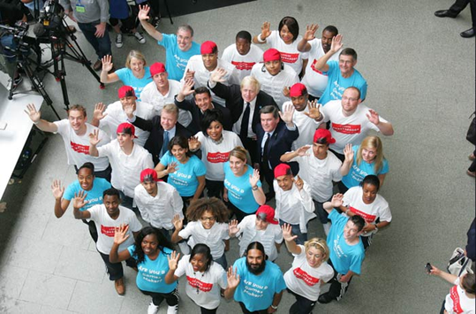  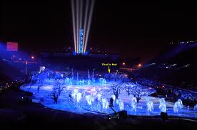  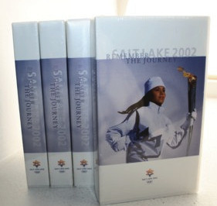  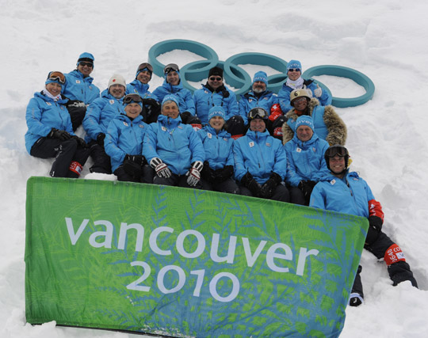  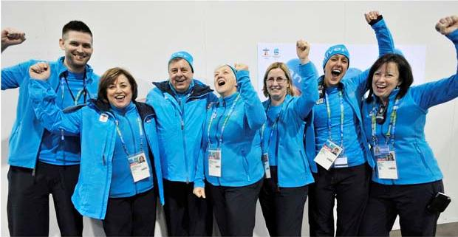  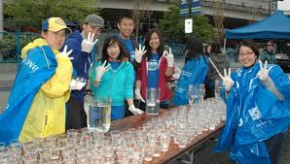  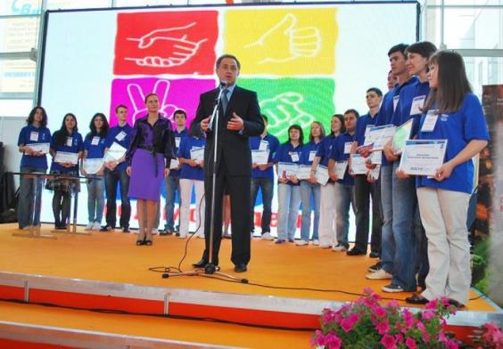  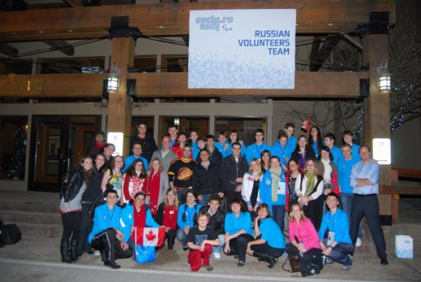  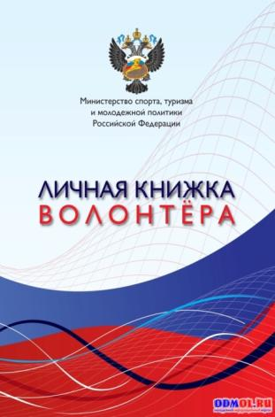

Используемая литература, адреса в Интернете:
1. www.volonter59.ru.
2. http://www.vancouver2010.com
3. http://olympicstudies.uab.as
4. http://www.centr-perspectiva.ru
5. http://volonter.info
6. Урок иностранного языка. Е.И. Пасссов. Н.Е. Кузовлева. “Глосса-Пресс”, Москва, “Феникс”, Ростов-на-Дону, 2010.

