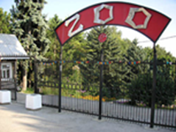
Welcome to our ZOO

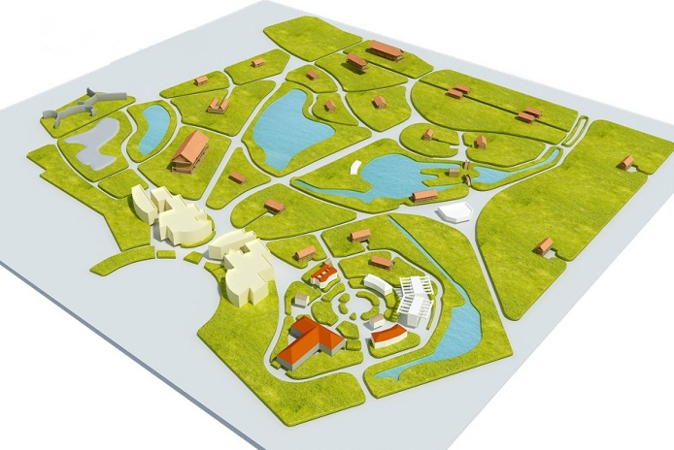
The map
Animals | Number | They are from… | They are | They like eating

