ПРИЛОЖЕНИЯ
ПРИЛОЖЕНИЕ 1
Tongue twisters are sentences that are difficult to say. They are good pronunciation practice. Listen, and then try saying these quickly.
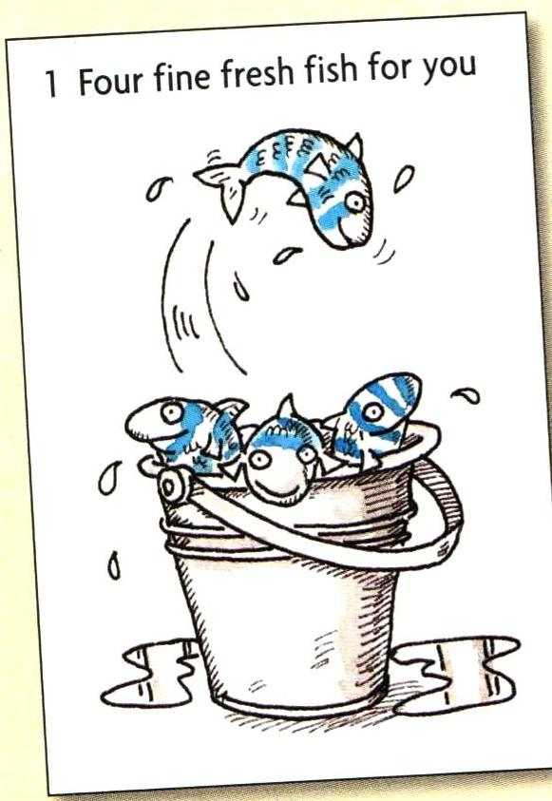

ПРИЛОЖЕНИЕ 2

Write the words in the correct column.

an armchair, a fridge, a television, a coffee table, a shelf, a plant, a stereo, a lamp, a cooker, a washing machine, a telephone, a cupboard, a cup, a sofa.

The living room | The kitchen | Both

ПРИЛОЖЕНИЕ 3

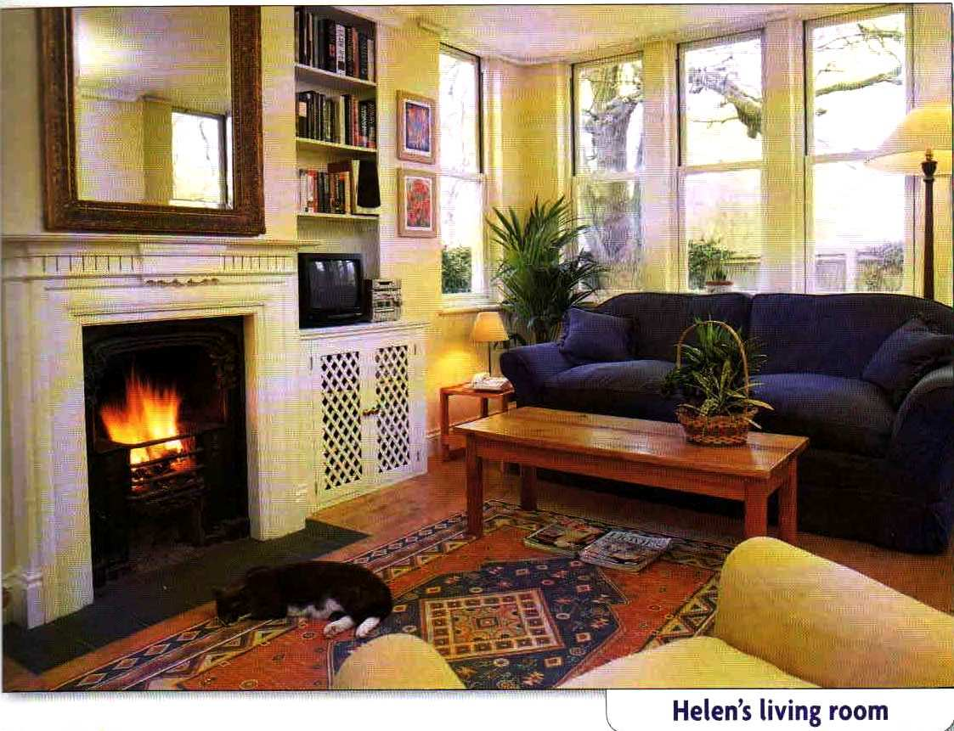
ПРИЛОЖЕНИЕ 4

There is \ There are …

Positive

There | is | a sofa.
 | are | two books.
(singular)
(plural)
Negative

There | isn’t | an armchair.
 | aren’t | any flowers.
(singular)
(plural)

Yes \ No questions Short answers

Is | there | a table?
Are |  | any photos?
Yes, there is. \ No, there isn’t
Yes, there are. \ No, there aren’t
ПРИЛОЖЕНИЕ 5

Ask and answer questions about these things.

a dog a cat a computer
a fire a mirror a clock
a rug
plants pictures bookshelves
lamps newspapers photos
flowers

ПРИЛОЖЕНИЕ 6

Look at the picture of Helen’s living room. Complete the sentences with prepositions.

on under next to in front of

- The television is ______ the cupboard.
- The coffee table is _____ the sofa.
- There are some magazines _____ the table.
- The television is _____ the stereo.
- There are two pictures _______ the walls.
- The cat is ____ the rug ____ the fire.

ПРИЛОЖЕНИЕ 7
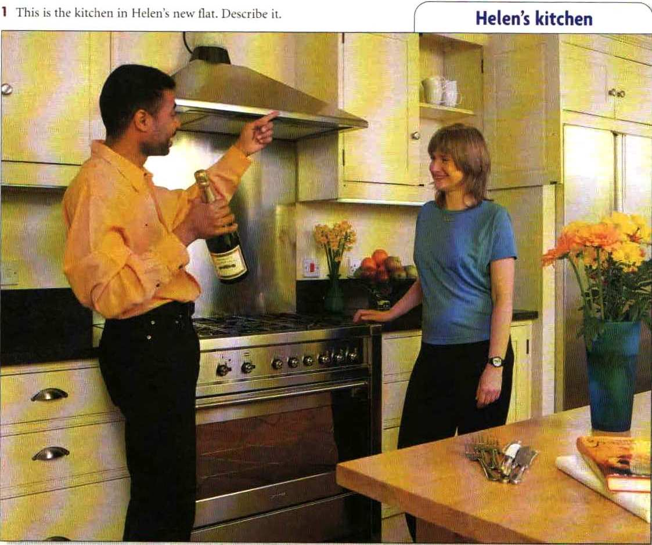

ПРИЛОЖЕНИЕ 8

Listen and complete the conversation between Helen and her friend, Bob.

Helen: And this is the kitchen.
Bob: Mmm, it’s very nice.
Helen: Well, it’s not very big, but there _____ a _____ of cup boards. And _____’s a new fridge, and a cooker. That’s new, too.
Bob: But what’s in all these cupboards?
Helen: Well, not a lot. There are some cups, but there aren’t any plates. And I have _____ knives and forks, but I don’t have _____ spoons!
Bob: Do you have _____ glasses?
Helen: No, Sorry.
Bob: Never mind. We can drink this champagne from those cups! Cheers!

ПРИЛОЖЕНИЕ 9
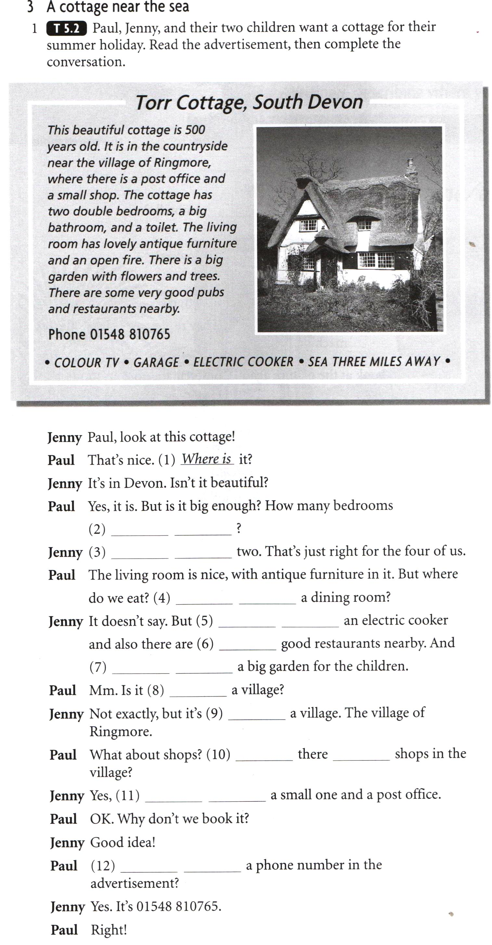

ПРИЛОЖЕНИЕ 10, 11
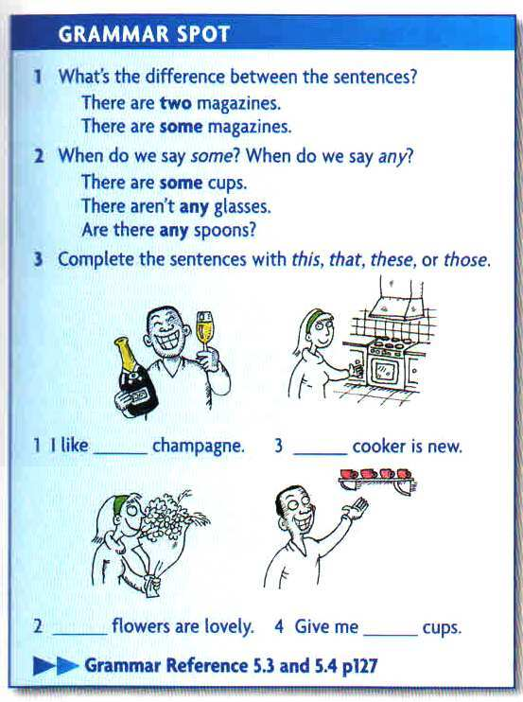

ПРИЛОЖЕНИЕ 12
Complete the sentences with some or any.
- In our classroom there are _______ books on the floor.
- There aren’t _____ plants.
- Are there _____ Spanish students in your class?
- There aren’t _____ Chinese students.
- We have _____ dictionaries in the cupboard.
- There aren’t _____ pens in my bag.

ПРИЛОЖЕНИЕ 13
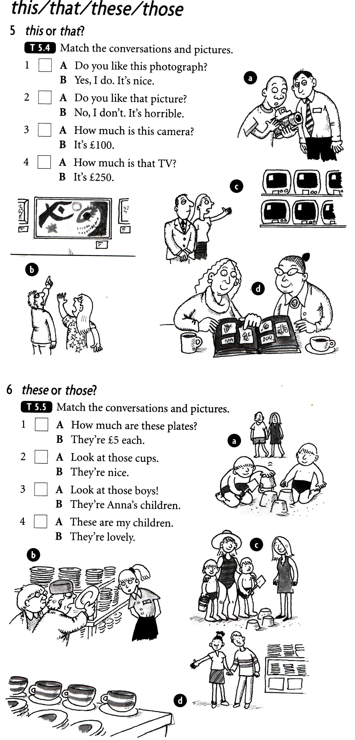
ПРИЛОЖЕНИЕ 14
Complete the sentences with this, these, that, those, it, they.
1. A: Bob, this is my mother.
B: Hello, Mrs. Smith.
2. Take _____ bags into the kilchen.
3. I don’t like _____ music.
4. A: Is _____ book John’s?
B: Yes, _____ is.
5. A: Are _____ book Mary’s?
B: Yes, _____ are.
6. A: How much are _____ glasses?
B: They’re very cheap.
7. A: _____ exercise is very easy.
B: No, _____ isn’t. _____ ‘s difficult!
8. Is _____ your brother over there?
9. Look at _____ beautiful flowers!
10. What’s _____ in your bag?
11. A: Is _____ house Ann’s?
B: Yes, _____ is.
12. A: Are _____ boys your brothers?
B: Yes, _____ are.
13. A: How much is _____?
B: _____’s £ 350.
14. A: Do you like ______ shoes?
B: No, I don’t. _____’re horrible.

ПРИЛОЖЕНИЕ 15

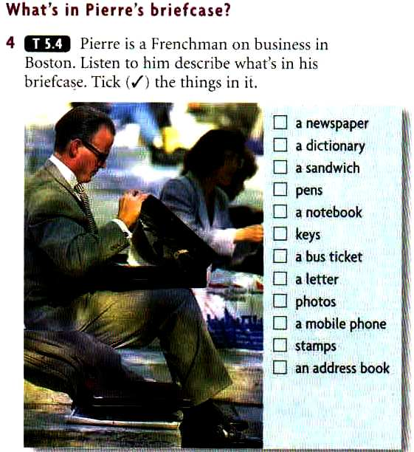

ПРИЛОЖЕНИЕ 16
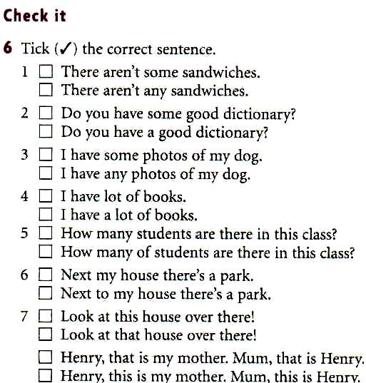

ПРИЛОЖЕНИЕ 17
Tongue twisters are sentences that are difficult to say. They are good pronunciation practice. Listen, and then try saying these quickly.
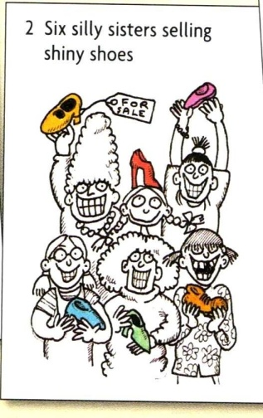

ПРИЛОЖЕНИЕ 18
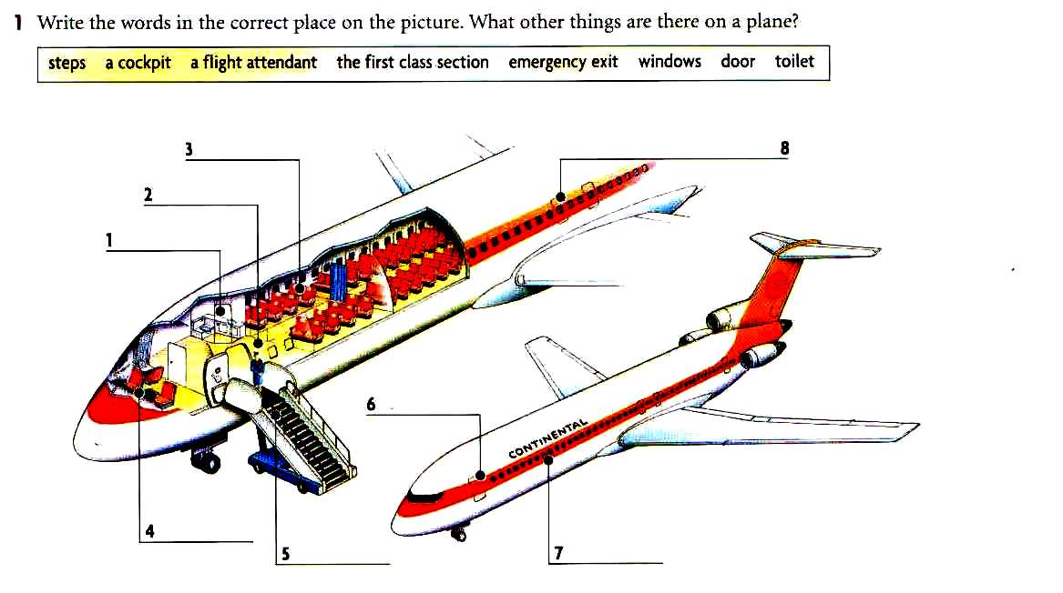
ПРИЛОЖЕНИЕ 19
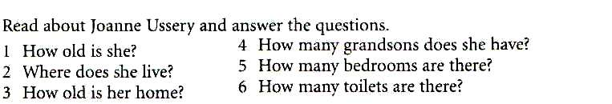
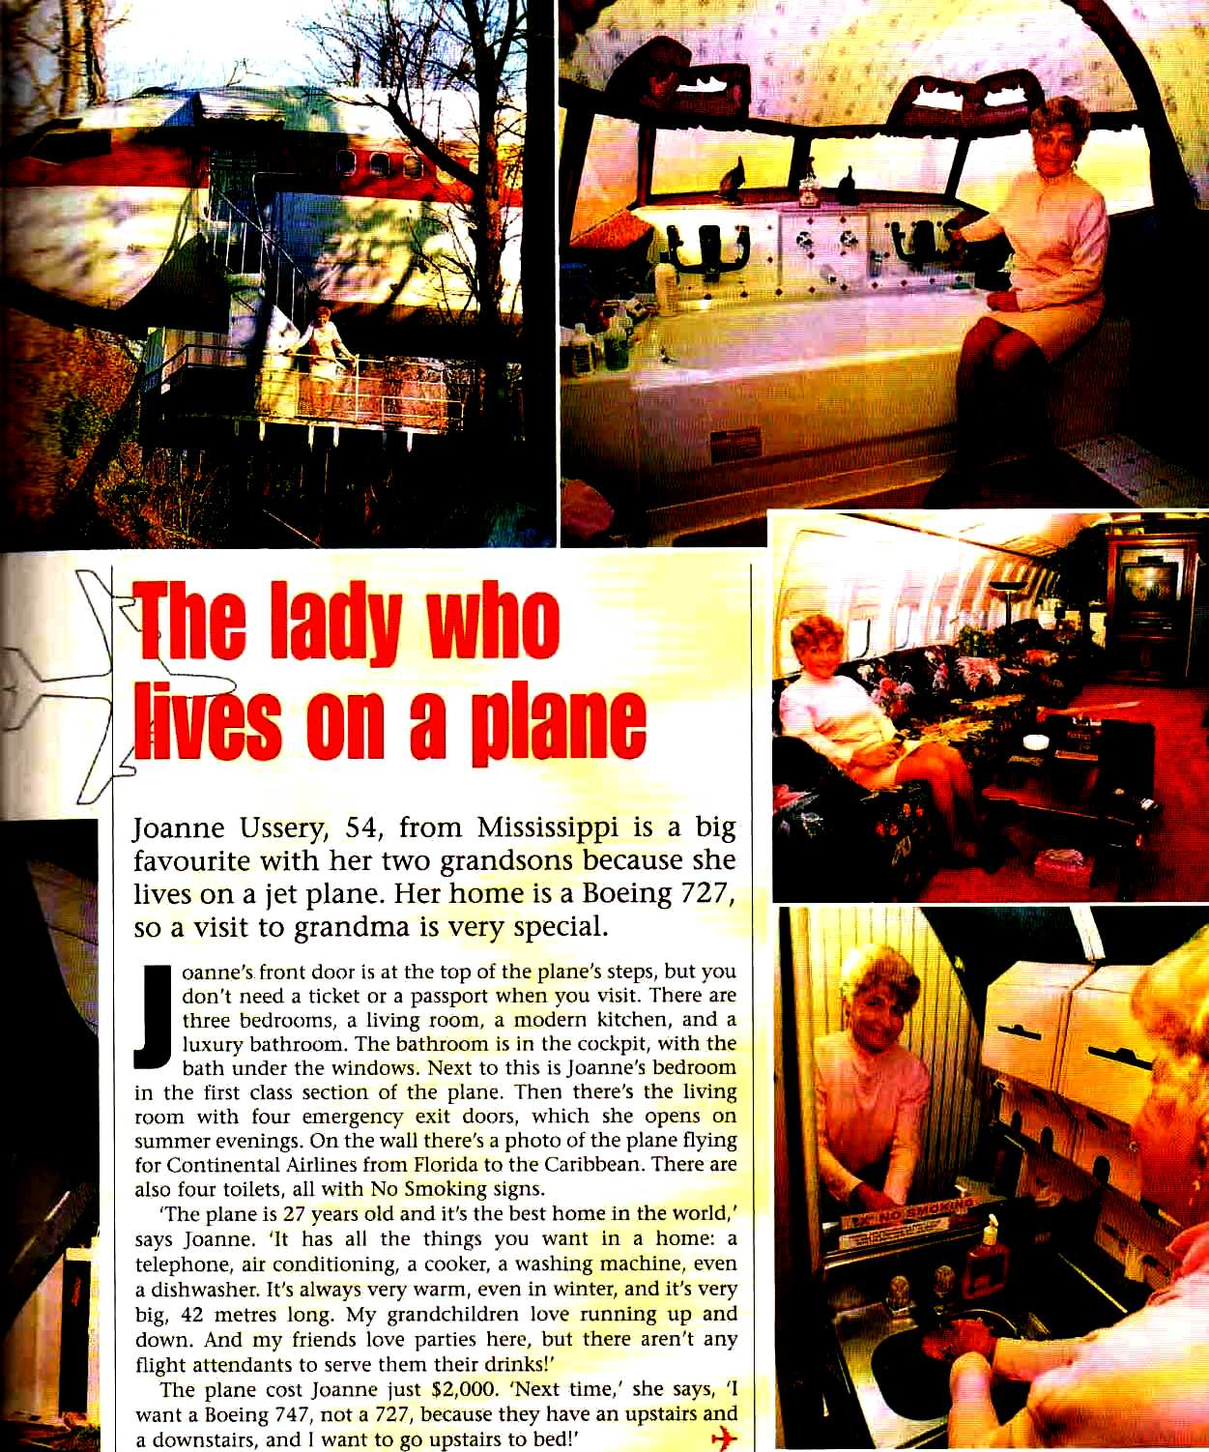

ПРИЛОЖЕНИЕ 20
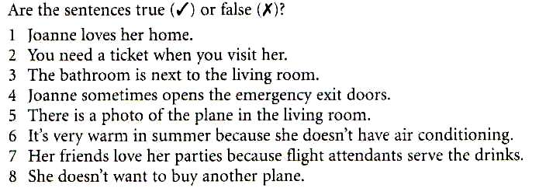

ПРИЛОЖЕНИЕ 21
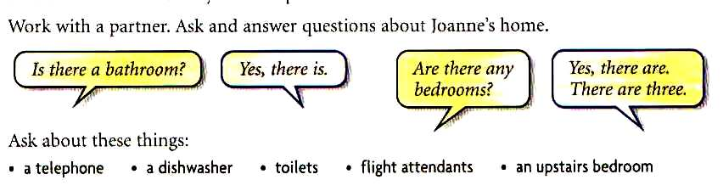

ПРИЛОЖЕНИЕ 22
Tongue twisters are sentences that are difficult to say. They are good pronunciation practice. Listen, and then try saying these quickly.
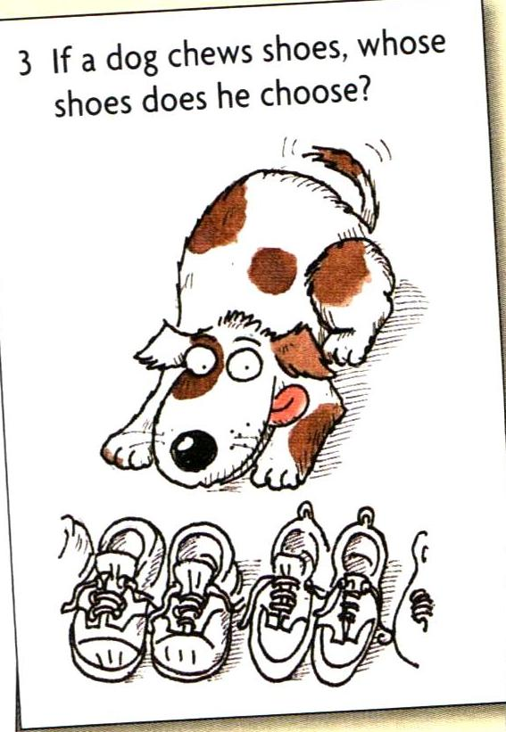

ПРИЛОЖЕНИЕ 23, 24, 25
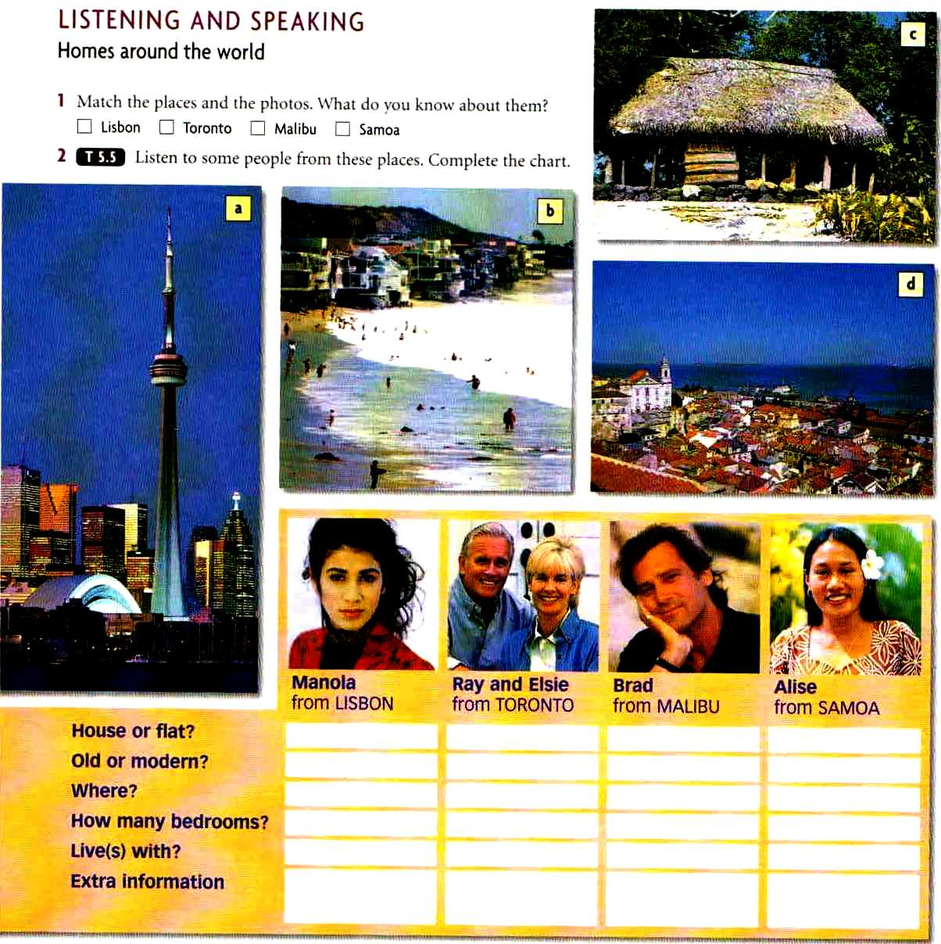

ПРИЛОЖЕНИЕ 26
Tongue twisters are sentences that are difficult to say. They are good pronunciation practice. Listen, and then try saying these quickly.
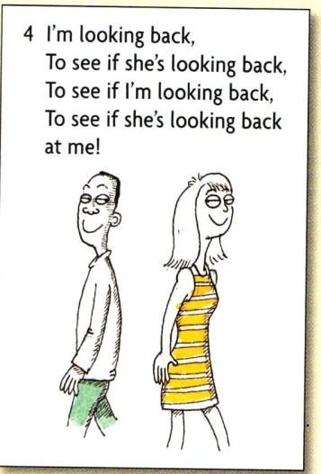

ПРИЛОЖЕНИЕ 27
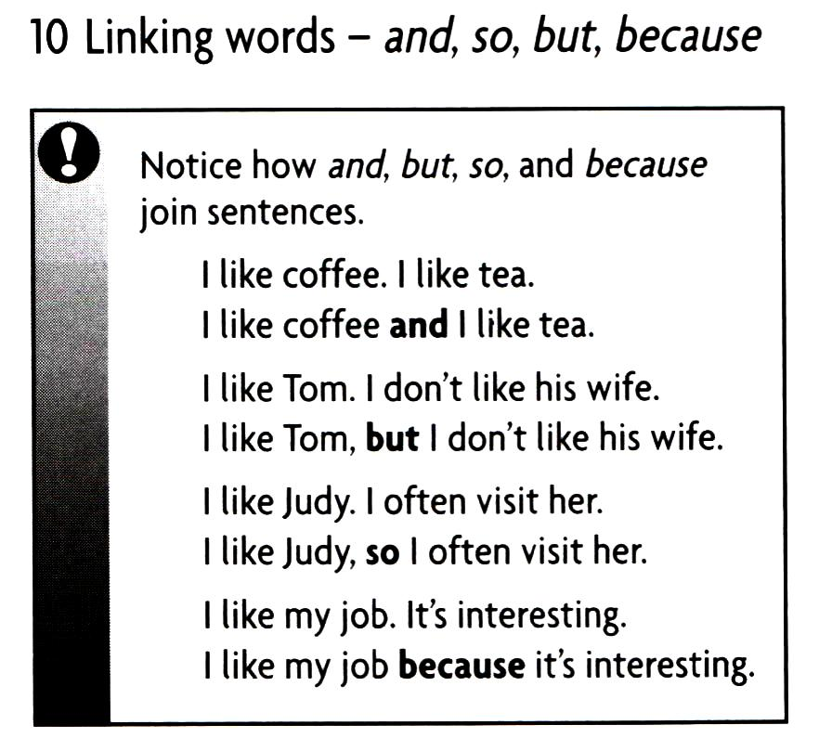

ПРИЛОЖЕНИЕ 28
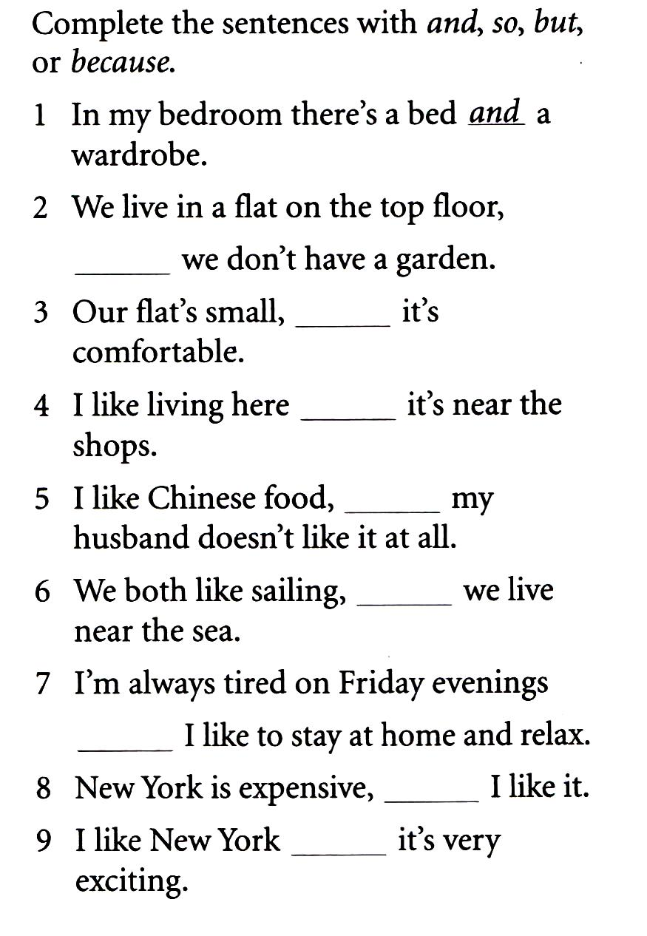

ПРИЛОЖЕНИЕ 29
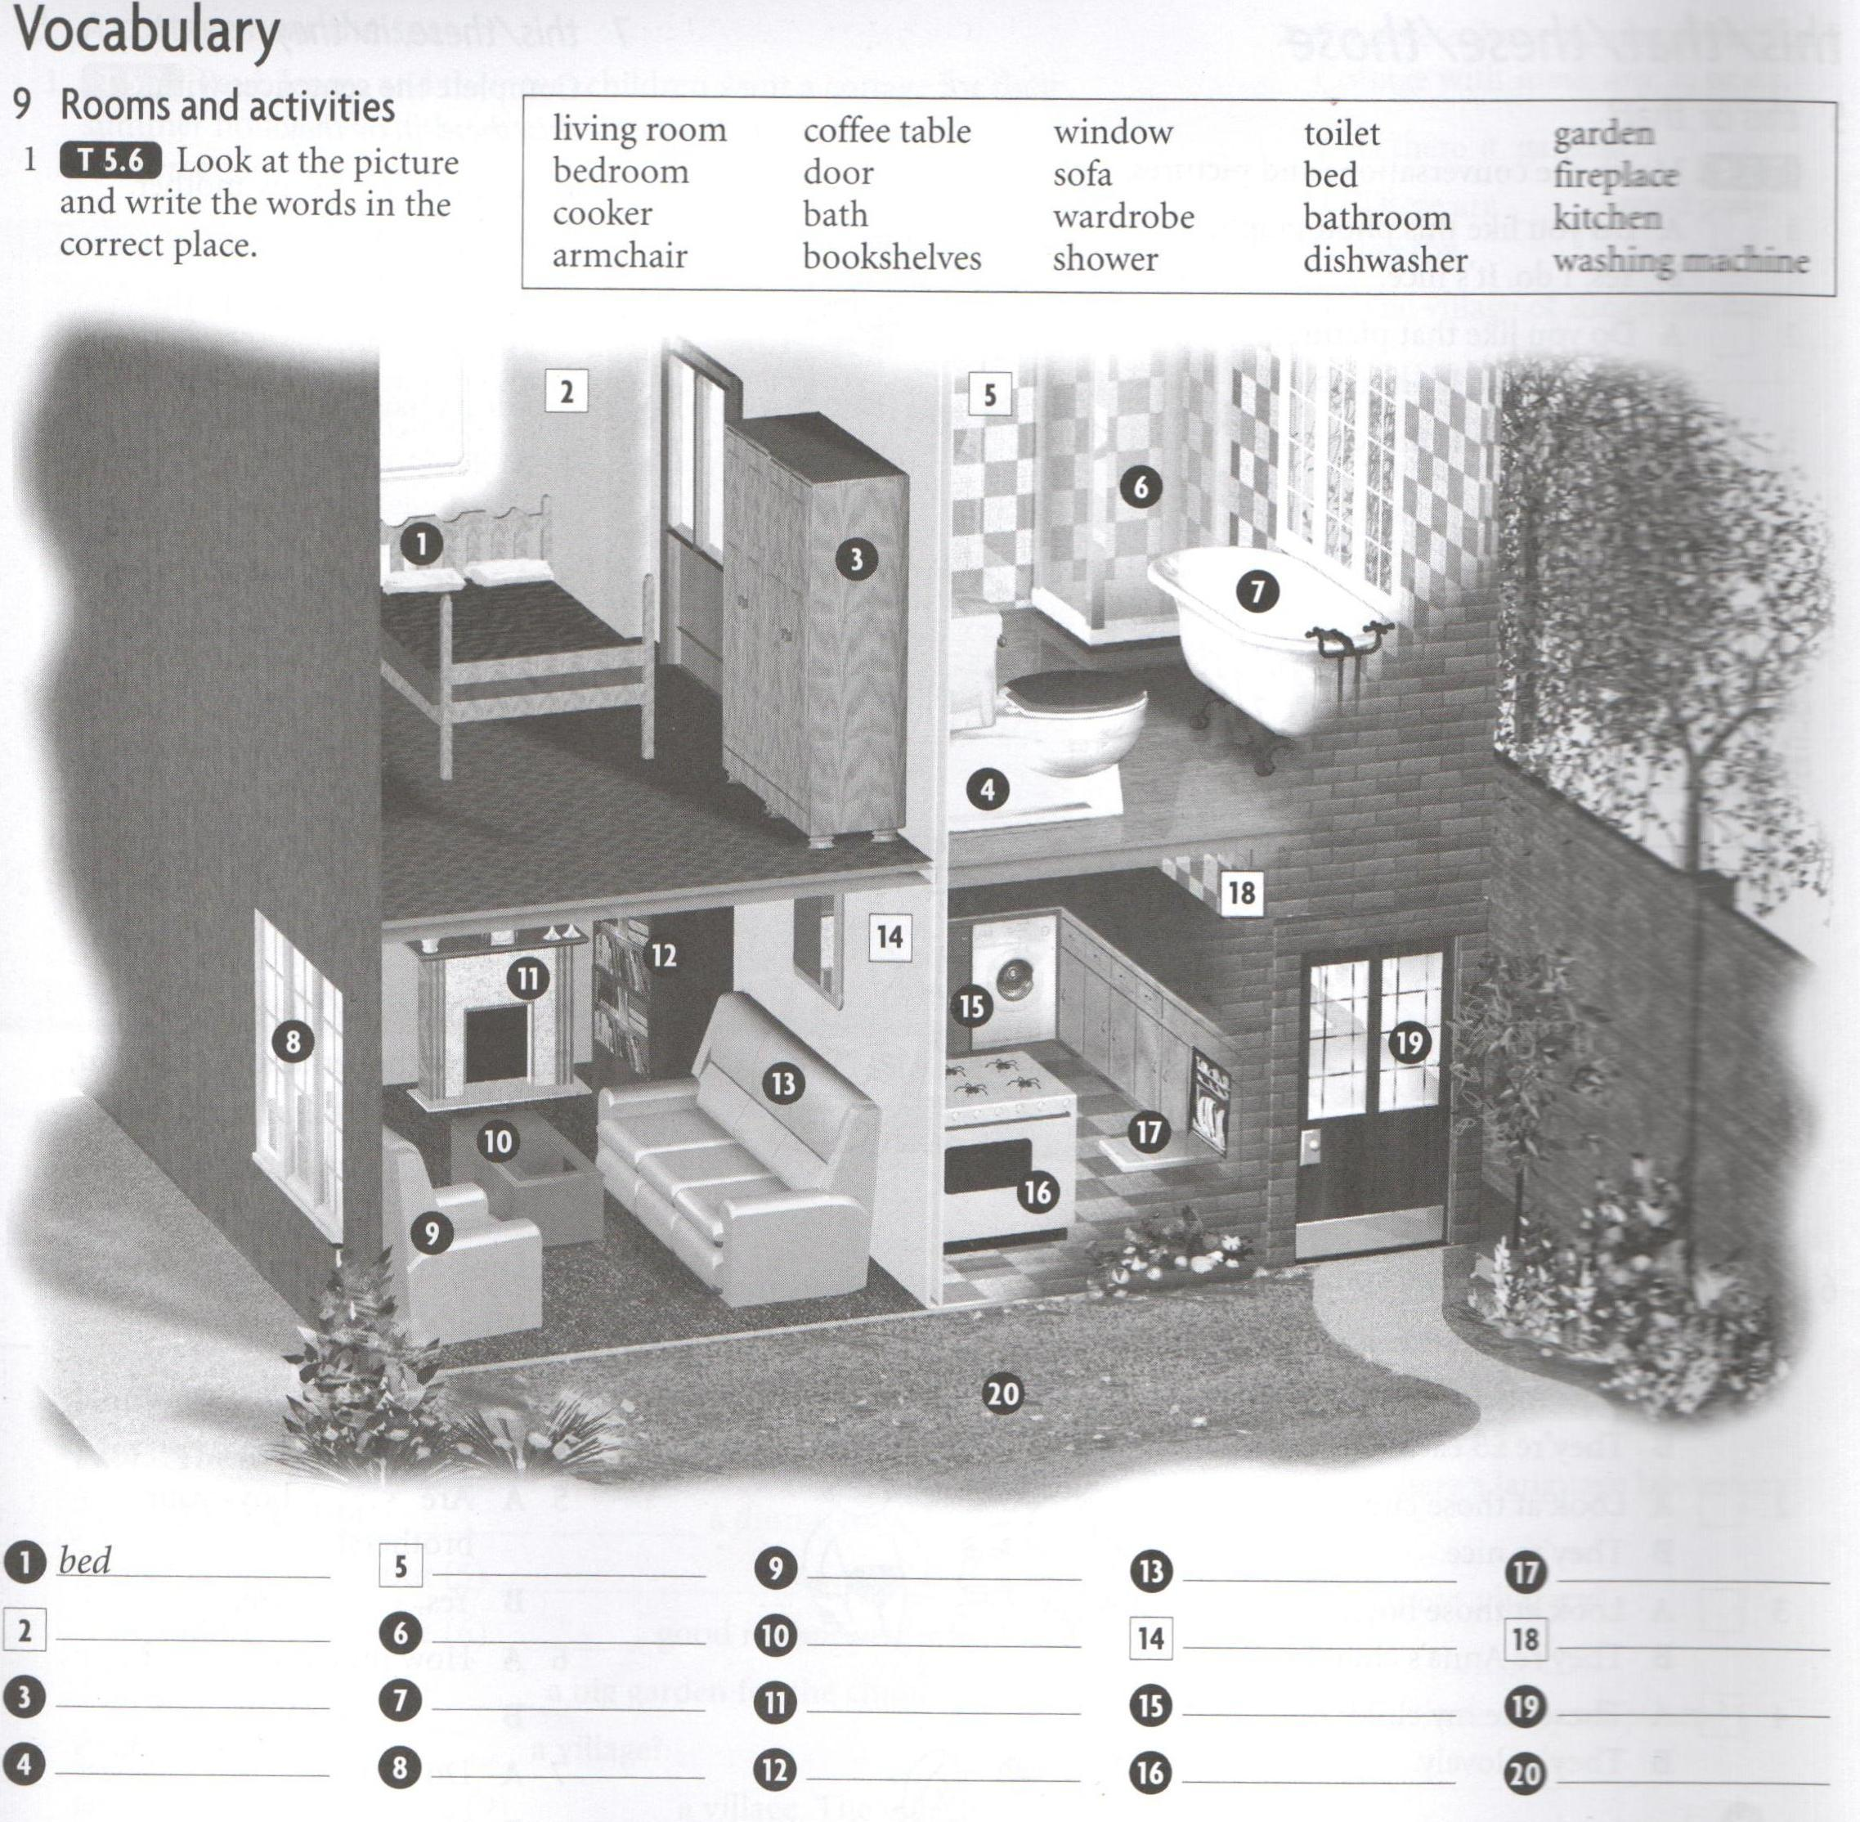

ПРИЛОЖЕНИЕ 30
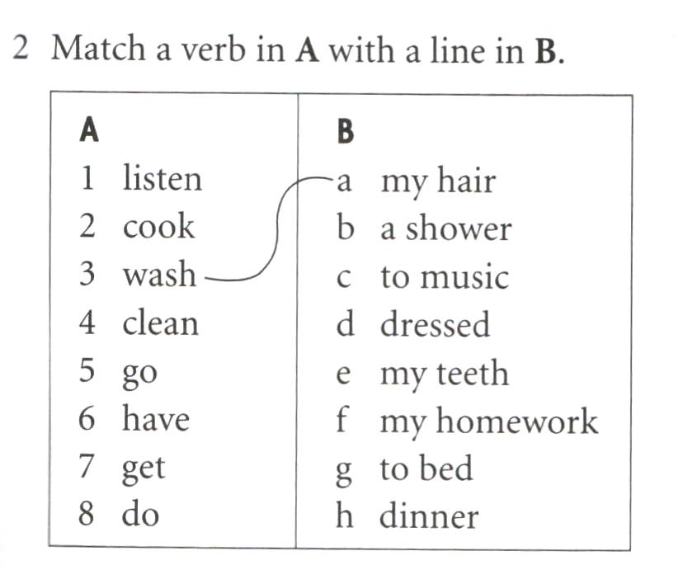

ПРИЛОЖЕНИЕ 31
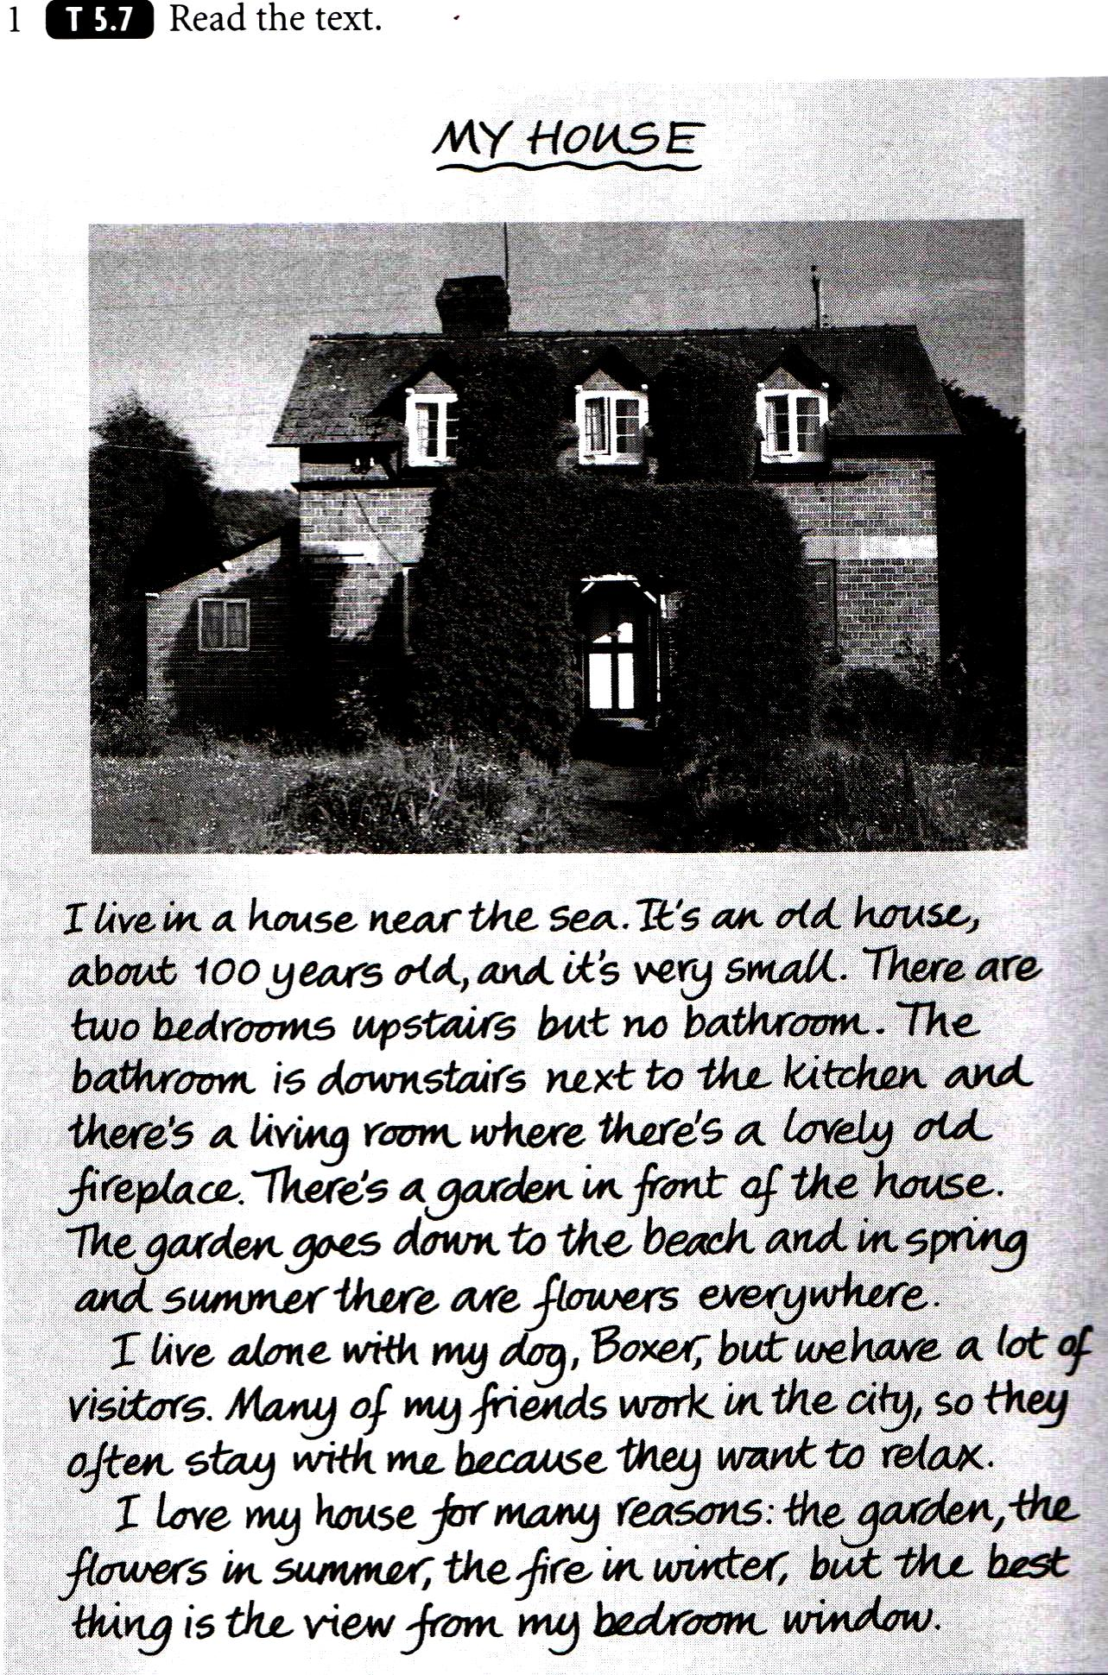

ПРИЛОЖЕНИЕ 32
(Варианты самостоятельной работы)

