**Дорожные знаки**

[](http://new.kafanews.com/images/img5554344c71ca08100450e38ee40d7a59.gif)

[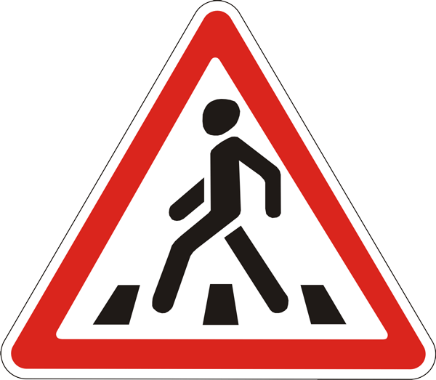](http://www.ustltd.com/img/images/1_32.gif)

[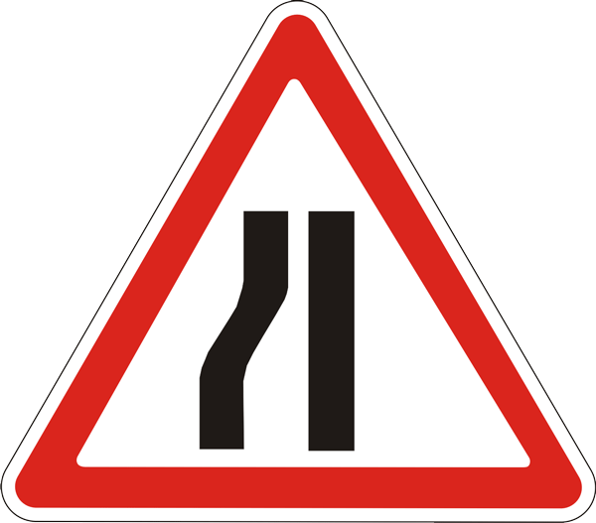](http://www.ustltd.com/img/images/1_5_3.gif)

[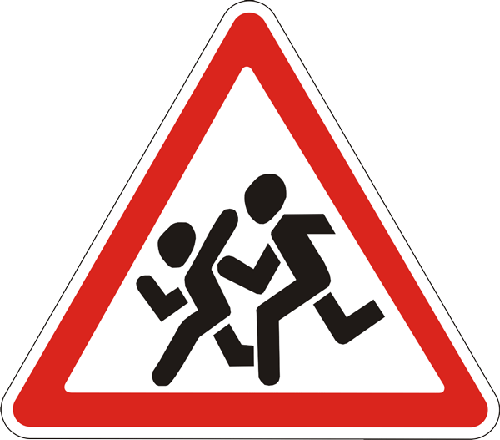](http://www.ustltd.com/img/images/1_33.gif)

[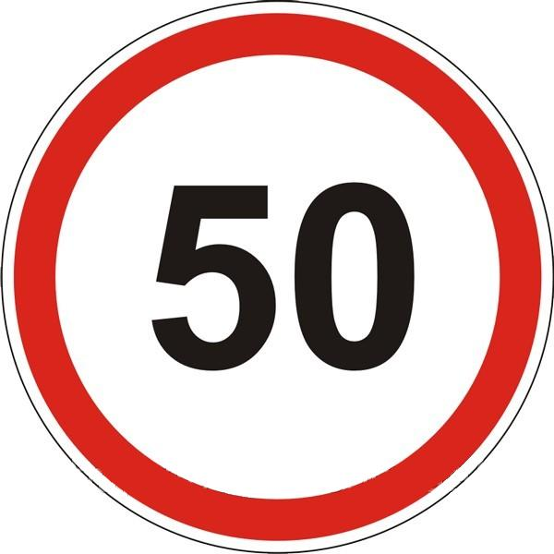](http://www.standart-m.com.ua/userfiles/image/obmezh_%20shvud(1).gif)

[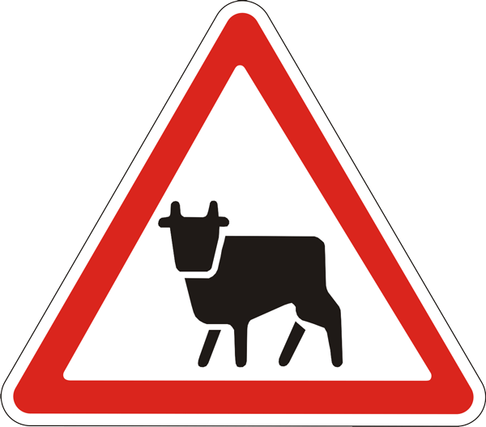](http://www.bressieenterprise.com/wp-content/uploads/2010/11/15.gif)

[](http://www.wien.gv.at/verkehr/verkehrszeichen/images/vorschriftszeichen-34-gr.jpg)

[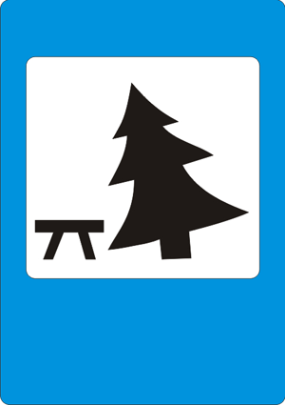](http://www.egeteka.ru/upload/medialibrary/9f4/9f4b32c2ffbd55f58a1e0e5e162dfbfe.gif)

[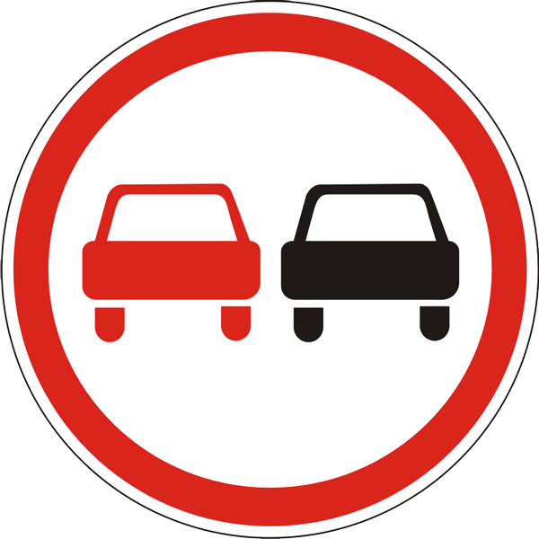](http://www.autobam.ru/linked/paras/large/news/158/obgon-znak.gif)

[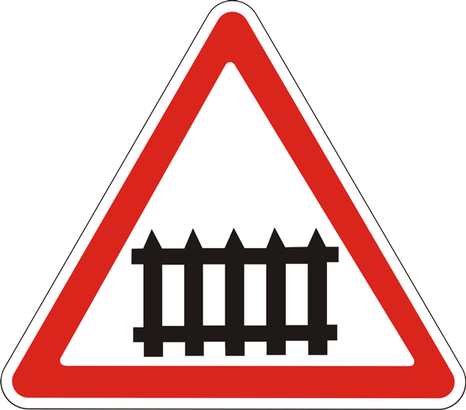](http://www.ustltd.com/img/images/1_27.gif)