**Приложение 1**

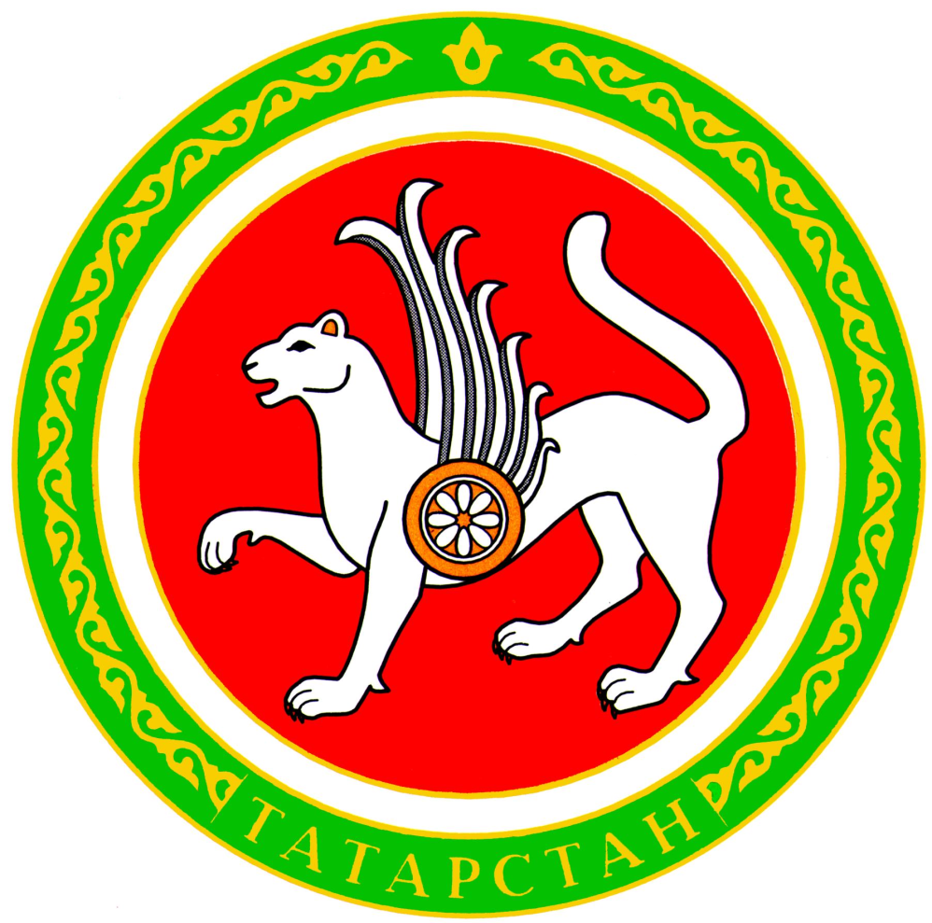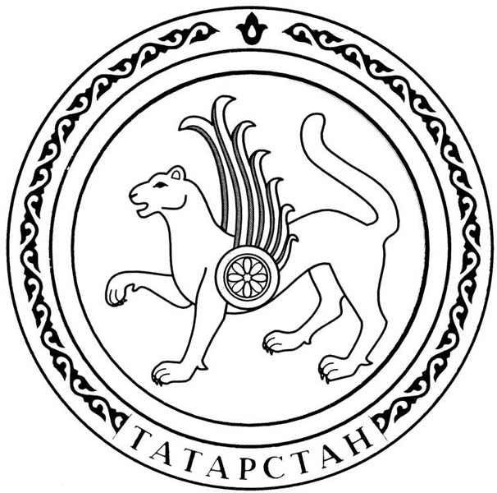

**Приложение 2**

|  |  |
| --- | --- |
|  |  |
|  |  |

|  |  |
| --- | --- |
|  |  |
|  |  |

**Приложение 3**

|  |  |
| --- | --- |
| **100 000 years ago** |  |
| **1236-1240** |  |
| **1399** |  |
| **1552** |  |
| **1708** |  |
| **1990, 30 August** |  |

1. Ivan the Terrible attacked Kazan.
2. Kazan became the centre of a Russian province.
3. First people came to the Middle Volga.
4. The Mongolian invasion.
5. The Declaration of State Sovereignty of the Republic of Tatarstan was signed.
6. Dmitry Donskoy destroyed Kazan.